**WIRELESS PASSENGER NOTIFICATION SYSTEM (PNS) FOR TRICYCLE TERMINAL AND STREET**

**Michael Troy R. Manalo Jean Aires C. Parado Kyl Justin V. Perez**

**Southern Luzon State University College of Engineering**

**June 2022**

### BIOGRAPHICAL SKETCH

|  |  |  |
| --- | --- | --- |
| **Name:** Michael Troy R. Manalo  **Birthdate:** January 30, 1999  **Birthplace:** Saudi Arabia  **Permanent Address:** 111 Felipe Loop, Sta. Barbara Homes Avida, Brgy. Isabang, Tayabas City, Quezon | | **275015316_1112413539545620_1253383392333207829_n** |
| **Contact Number:** (+63) 9561790132 |  |  |
| **Email Address:** [troymanalo797@gmail.com](mailto:troymanalo797@gmail.com) | | |
| **Educational Background:** |  |  |
| **School/University** | **Inclusive Years** | **Honor/Award** |
| Southern Luzon State University | 2018-Present | **\_** |
| Inter-Global College Incorporated | 2016-2018 | With Honors |
| Quezon National High School | 2012-2016 | **\_** |
| Saint Philomena School | 2007-2012 | **\_** |

**Academic Affiliations:**

Institute of Electronics Engineers of the Philippines – SLSU Student Chapter Member

2018 – 2022

Institute of Electronics Engineers of the Philippines – Quezon Student Chapter Member

2018-2022

### BIOGRAPHICAL SKETCH

|  |  |  |
| --- | --- | --- |
| **Name:** Jean Aires C. Parado **Birthdate:** June 13, 2000 **Birthplace:** Sta. Cruz, Laguna  **Permanent Address:** #83 G. Redor Street, Siniloan, Laguna | | |
| **Contact Number:** (+63) 9294938515 |  |  |
| **Email Address:** [airesparado@gmail.com](mailto:airesparado@gmail.com) |  |  |
| **Educational Background:** |  |  |
| **School/University** | **Inclusive Years** | **Honor/Award** |
| Southern Luzon State University | 2018-Present | **\_** |
| Siniloan Integrated National High School | 2016-2018 | With Honors |
| Siniloan National High School | 2012-2016 | **\_** |
| Siniloan Elementary School | 2007-2012 | **\_** |
|  |  |  |

**Academic Affiliations:**

Institute of Electronics Engineers of the Philippines – SLSU Student Chapter Member

2018 – 2022

Institute of Electronics Engineers of the Philippines – Quezon Student Chapter Member

2018-2022

### BIOGRAPHICAL SKETCH

**Name:** Kyl Justin V. Perez

**Birthdate:** March 9, 2000 **Birthplace:** San Fabian, Pangasinan

**Permanent Address:** Brgy. Duhat, Cavinti, Laguna

**Contact Number:** (+63)9278028222 **Email Address:** [kylperez@gmail.com](mailto:kylperez@gmail.com) **Educational Background:**

|  |  |  |
| --- | --- | --- |
| **School/University** | **Inclusive Years** | **Honor/Award** |
| Southern Luzon State University | 2018-Present | With Latin Honors |
| Cavinti Integrated National High School | 2016-2018 | With High Honors |
| Cavinti National High School | 2012-2016 | Valedictorian |
| Cavinti Elementary School | 2007-2012 | Valedictorian |

#### Academic Affiliations:

Institute of Electronics Engineers of the Philippines – SLSU Student Chapter Member

2018 – 2022

Institute of Electronics Engineers of the Philippines – Quezon Student Chapter Member

2018-2022

### CERTIFICATE OF ORIGINALITY

We hereby declare that this submission is our own work and that, to the best of our knowledge and belief, it contains no material previously published or written by another person nor material to which to a substantial extent has been accepted for award of any other degree or diploma of a university or other institute of higher learning, except where due acknowledgement is made in the text.

We also declare that the intellectual content of this thesis is the product of our work even though we may have received assistance from others on style, presentation, and language expression.

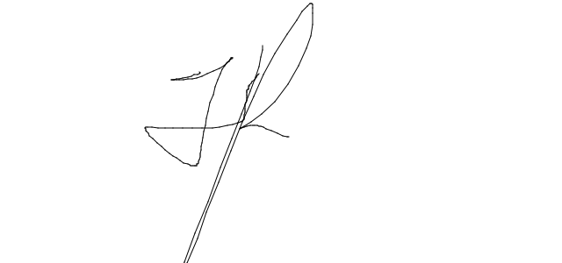

Michael Troy R. Manalo Researcher

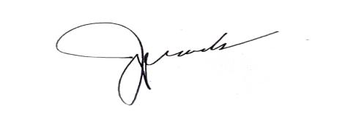

Jean Aires C. Parado Researcher

Kyl Justin V. Perez Researcher

Noted:

Engr. Pitz Gerald G. Lagrazon June \_\_ , 2022 Advisor

### **289923685_391508122964050_2108858259919049315_n**

### DEDICATION

*This technical research is humbly dedicated to all the valuable people who have been part of my journey:*

*To my mother in Heaven,* ***Mommy Glenda****,**whose love and care are incomparable and boundless, for being my motivation and inspiration in my education with her only wish for me to be successful in life;*

*To my* ***Lolo*** *in Heaven and* ***Lola*** *who have taken care of me and taught me about life when both of my parents were abroad;*

*To my sister,* ***Bles****, whom I have to support as it was one of my mother’s wish;*

*To my cousins,* ***Kuya Matthew****,* ***Ate Lara,*** *and* ***Ate Sandy****,**who have been supportive of me, for being an inspiration throughout my life;*

*To my* ***Tita Beverly*** *and* ***Tito Noel*** *who helped me during any problems, for being my second parents in life;*

*To all my* ***relatives*** *whom I have kept in touch with all these years, for motivating and giving me valuable teachings;*

*To my one true love,* ***Cathy****, whom I have spent my days with, during happiness and sadness, for always supporting me and bringing me joy every day;*

*To my* ***friends****,**whom I have spent my days with, for helping me forget all the stress and problems;*

*To my* ***college peers and friends****, with whom I have shared the same burden;*

*And to all the* ***people*** *who**have been part of my life, for believing in me.*

*My gratitude and love to all of you.*

### MTRM

**DEDICATION**

*This technical research is humbly dedicated to all the valuable people who have been part of my journey:*

*To my mother,* ***Jane Parado,*** *who supports me in every challenge I face, stands up for me no matter how tough life goes, and motivates me to keep things right, for being the person who I am indebted to for the rest of my life and for being the reason why I am striving to be successful in life with the goal of making her proud with tears of joy and spoiling her with all the good things that could make her laugh, smile, or even grin to any extent of happiness;*

*To my father,* ***Aries Parado,*** *to whom I will prove my worth someday, for assisting me in my studies;*

*To my beloved partner in life, the girl of my dreams, my one and only,* ***Angeline****, whom I am sharing my dreams with, for holding me through my ups and downs, for setting me to the right path, and for sending all my stress away instantly with just her presence and everlasting love;*

*To my* ***Tito Eric*** *who treats me as his own son, for helping me through tough times without any expectations;*

*To* ***my friends*** *who accept me even when I am eccentric at times, for supporting me as we grow into better persons;*

*To my* ***college peers and friends****,**with whom I shared my burdens and hardships;*

*And to all the* ***people*** *who have been part of my life and with whom I share my life experiences, for helping me at desperate times and offering aid during my worst days.*

*May God reward you with everything you need in life as He watches over all of you, guiding you to your dreams.*

*My gratitude and love to all of you.*

### JACP

**DEDICATION**

*Anything is possible when you have the right people to guide and support you.*

*To* ***Mama Gina*** *and* ***Daddy Billy****, my inspiration in doing my best, to whom this work is highly dedicated as it signifies another stepping stone towards my dream of becoming an engineer, for giving me consistent love and guidance;*

*To my* ***siblings*** *who keep supporting me in everything I do, for cheering me up when things go down;*

*To my* ***friends*** *(you know who you are) who keep on believing in me and in what I am capable of more than myself, for giving words of wisdom and for your huge presence in my life;*

*To my thesis mates,* ***Michael Troy*** *and* ***Jean Aires****, for the endless patience, hard work, and memories we had in this study and throughout college;*

*And above all else, our* ***Almighty GOD****, who made this technical study possible with His unending love,**for giving me strength and wisdom every day. All glory belongs to Him.*

*“I can do all things through Christ who strengthens me.” – Philippians 4:13*

### KJVP

### ACKNOWLEDGEMENT

The researchers would like to express their heartfelt gratitude to the following individuals for making this study possible by providing them direction, assistance, support, and inspiration:

**Engr. Pitz Gerald G. Lagrazon**, their research adviser, for providing helpful suggestions and comments that improved the research and for assisting the researchers towards the study’s completion;

**Engr. Ten M. Sacopla**, ECE Chairman, for sharing his knowledge about this project and for taking the time to proofread the entire document of the study;

**Engr. Zoren P. Mabunga**, **Engr. Ten M. Sacopla**, and **Dr. Renato R. Maaliw III,** panelists, for their constructive criticisms that aided in the development of this study;

**ECE Faculty,** for giving information that considerably aided the completion of this study;

**AVIDA Tayabas**, for allowing the researchers to conduct a survey on the places under their jurisdiction and for permitting the researchers to do their walk testing and actual testing of the prototype;

**Families of the researchers**, for their unconditional love and unwavering moral and financial support and for providing a home for the researchers to stay comfortably and conveniently during the prototype's creation and construction;

**College peers and friends**, for their unwavering support and sharing the journey with the researchers;

And finally, to **Almighty God** who never tires of showering peerless love and guidance upon the researchers, for pouring upon them many blessings, wisdom, hope, and strength in order to make this technical research feasible.

### TABLE OF CONTENTS

Page Title Page i

[Biographical Sketch ii](#_TOC_250027)

[Certificate of Originality v](#_TOC_250026)

[Approval Sheet vi](#_TOC_250025)

[Dedication vii](#_TOC_250024)

[Acknowledgement x](#_TOC_250023)

[Table of Contents xii](#_TOC_250022)

[List of Tables xvi](#_TOC_250021)

[List of Figures xvii](#_TOC_250020)

List of Appendices xx

[Abstract xxi](#_TOC_250019)

[Chapter I – Introduction 1](#_TOC_250018)

[Background of the Study 2](#_TOC_250017)

[Objectives of the Study 3](#_TOC_250016)

[Significance of the Study 3](#_TOC_250015)

Scope and Limitation 4

[Definition of Terms 5](#_TOC_250014)

Chapter II – Review of Related Literature and Studies 8

Related Studies 31

Conceptual Framework 37

Chapter III – Methodology 39

[Research Locale 39](#_TOC_250013)

[Respondents 39](#_TOC_250012)

[Research Design 40](#_TOC_250011)

Research Instruments 41

[Procedures/Data Collection 44](#_TOC_250010)

[Statistical Treatment 48](#_TOC_250009)

Gantt Chart 49

Chapter IV – Results and Discussion 50

[System Overview 50](#_TOC_250008)

Overall Design 52

Placement of Components Inside the Prototype 55

Actual Prototype 56

Pictorial Diagram 57

[System Flowchart 58](#_TOC_250007)

[Program Flowchart 63](#_TOC_250006)

Simulation Results 65

[Walk Testing Data 71](#_TOC_250005)

[Results of Data Gathering from Questionnaire 76](#_TOC_250004)

[Materials and Tools 78](#_TOC_250003)

Chapter V – Summary, Conclusions, and Recommendations 84

[Summary 84](#_TOC_250002)

[Findings 85](#_TOC_250001)

Conclusions 86

Recommendations 87

References Cited 88

[Appendices 93](#_TOC_250000)

### LIST OF TABLES

#### Table Page

* 1. Radio Modules Comparison in Terms of Range, Energy Usage, and Speed 25
  2. Survey Questionnaire Form for the Prototype’s Design, Functionality, and

Effectiveness 42

* 1. Transmission Distance and Transmission Time 43
  2. Rating Scale and Qualitative Description 48
  3. Gantt Chart 49
  4. Summary of the Radio Planner 2.1 Parameters for Simulation 69
  5. Transmission Time and Range Result 75
  6. Results of Data Gathering from Questionnaire 76
  7. Components of the System 79
  8. Software Tools 83

### LIST OF FIGURES

Figure Page

* 1. Parabolic Satellite 8
  2. Simple Data Communication System 10
  3. Data Communication System Using Remote Locations 10
  4. Types of Wireless Communication Systems 11
  5. Global Smartphones 12
  6. Zigbee Module 13
  7. Bluetooth Technology 14
  8. Wireless Technology 15
  9. Smartview Technology 16
  10. NB-IoT Overview 17
  11. Radio Technologies Graphical Comparison 18
  12. LoRa and LoRaWAN 19
  13. RA-02 LoRa Module 20
  14. nRF24 with Wireless Module 21
  15. CC1101 Wireless Module SMA Antenna Wireless Transceiver 22
  16. Two HC-12 Modules with an Antenna 22
  17. Raw RF Module 23
  18. Bluetooth Module HC-05 24
  19. NodeMCU WiFi ESP8266 Module - 4MB - Waveshare 16608 25
  20. Arduino UNO Rev3 27
  21. 20x4 LCD 28
  22. Pushbutton 29
  23. Potentiometer 30
  24. Powerbank 30
  25. Wireless Passenger Notification System (PNS) for Tricycle Terminal and Street’s Overall Design and Dimensions (Top to Bottom View) 52
  26. Wireless Passenger Notification System (PNS) for Tricycle Terminal and

Street’s Overall Design and Dimensions (Casing) 53

* 1. Wireless Passenger Notification System (PNS) for Tricycle Terminal and

Street’s Overall Design and Dimensions (Shield) 54

* 1. Placements of Components Inside the Prototype 55
  2. Actual Prototype of Wireless Passenger Notification System (PNS)

for Terminal Station and Street 56

* 1. Pictorial Diagram of Wireless Passenger Notification System (PNS) for Tricycle Terminal and Street 57
     1. System Flowchart 58
     2. System Flowchart 59
     3. System Flowchart 60
     4. System Flowchart 61
     5. System Flowchart 62
     6. Program Flowchart 63
     7. Program Flowchart 64
  2. RadioPlanner 2.1 Base Station Simulation Parameters 66
  3. RadioPlanner 2.1 Propagation Model Simulation Parameters 67
  4. RadioPlanner 2.1 Area Study Unit Simulation Parameters 68
     1. Testing Area Simulation 70
     2. Testing Area Simulation 70
  5. RSSI Walk Testing Results on the First Testing Location 72
  6. SNR Walk Testing Result on the First Testing Location 73
  7. RSSI Walk Testing Result on the Second Testing Location 74
  8. SNR Walk Testing Result on the Second Testing Location 75

### LIST OF APPENDICES

Appendix Page

1. Letters 94
2. Isometric View 98
3. Data Sheets 108
4. Programs 141
5. Photo Documentation 151
6. Billing Statement 167
7. Instruction Manual 169
8. Radio Planner 2.1 Results of Different Testing Areas 171
9. Walk Testing Results Databases 177
10. Plagiarism Results……………………………………………………………………. 181

K. English Critic …………………………………………………………………….. 183

#### Abstract

**Title** :Wireless Passenger Notification System (PNS) for Tricycle Terminal and Street

**Authors** : Michael Troy R. Manalo

: Jean Aires C. Parado

: Kyl Justin V. Perez

**Adviser** : Engr. Pitz Gerald G. Lagrazon

Public transportation is an important part of livelihood of most Filipinos. Every day, Filipinos use public transport for traveling to their workplace, school or university, leisure, and other recreational activities, especially for those who cannot afford private vehicles. This study was conducted to develop a way of communication between passengers and drivers that will ease some difficulties for both parties. The system allows passengers on a particular street to notify a tricycle terminal of how many tricycles should fetch them. Applied type of research method and experimental approach for testing the device using a survey questionnaire were employed in the study. A total of 30 individuals composed of 10 tricycle drivers and 20 local passengers served as respondents. Transmission range and time were gathered through simulations and series of walk testing. Using LoRa as the radio module gave a decent transmission range and obtained a working device that sends and receives data from each station. The PNS received a highly rated positive feedback among the chosen respondents in terms of appearance, usability, functionality, and reliability.

**Keywords:** *wireless communication, transportation, tricycle, passengers, long range, LoRa*

#### Chapter I INTRODUCTION

Nowadays, next to jeepneys, the tricycle or trike is the most common mode of public transportation in the Philippines. According to the 2016 public transportation profile in the Philippines, more than 55% of the country's registered motor vehicles were tricycles and motorcycles; 23% of which were around 1.2 million tricycles from a total of 5,175,303 tricycles and motorcycles (EGV, 2016).

Public transportation signifies a vital part of livelihood for most Filipinos. Every day, Filipinos use public transport for traveling to their everyday workplace, school or university, leisure, and other recreational activities, especially for those who cannot afford buying private vehicles. As noted in the Senate Bill 775 filed by Pangilinan (2019), in collaboration with transport advocacy group AltMobility PH, commuters who travel using public transportation services and active transport comprised 70% of the total trips in Metro Manila. This addressed that majority were using public transport which calls for a systematic and efficient mode of transport for drivers and passengers.

The tricycle or trike is a three-wheeled and gasoline-run motorized vehicle. Its design is made up of a motorcycle joined to a sidecar with multiple seating and a covered roof. The roof is often used as a baggage compartment and the back is often extended to serve the same purpose (FFE, 2016). In most cities and provinces in the Philippines, residents tend to rely on tricycles for them to travel point-to-point and transport the bulk

of their luggage. Unfortunately, in some locations around cities and provinces such as in some parts of Tayabas, Quezon, commuters are usually far from the vicinity of the tricycle terminal that it requires walking a certain distance to reach it.

#### Background of the Study

With a growing population that demands the public transport system, an organized way of commuting will be a huge help to commuters as well as drivers. A way of communication between passengers and drivers will ease some of the difficulties for both parties.

In some cities and towns, some commuters are far from the location of the terminals. This leaves them no choice but to hope that a vehicle (such as a tricycle) will pass by which takes up too much time. Otherwise, they will have to walk to the terminal which may be stressful especially if they are carrying some luggage.

These are sometimes caused by the wide area of coverage of specific terminals such as the Tricycle Operators’ and Drivers’ Association (TODA) with a limited number of terminals to cater to that boundary. To somehow ease the problem, some tricycle drivers roam around the vicinity of the boundary to locate passengers. Doing so may somehow solve the problem except when they cannot find passengers at all which can be a waste of their effort, time, and gasoline.

#### Objectives of the Study

The main objective of this technical research was to develop “Wireless Passenger Notification System (PNS) for Tricycle Terminal and Street”. The researchers intended to use it for the convenience of the tricycle operators and passengers in Tayabas, Quezon.

Specifically, it sought to achieve the following objectives:

1. To identify the appropriate materials/components used in designing wireless notification stations for point-to-point transportation;
2. To assess distance and time of transmission using the LoRa Module; and
3. To determine the effectiveness of the prototype.

#### Significance of the Study

The proposed study promoted a prototype that could ensure convenient and secure transportation, especially for passengers who have a hard time transporting their luggage and those who are far from the main road. The results of the study and the prototype will be beneficial to the following:

**Passengers** will benefit from the study as it focused on their main problem regarding safe, convenient, and reliable commuting.

**Tricycle drivers** will be beneficiaries of the study for it will aid them to be more organized. In some cases of implementation, traffic could be reduced and gasoline consumption would drop because they will not need to roam the streets in search of possible passengers.

**Government** will also benefit from the study as this idea can help them establish systematic transportation for their locality. It can bring the concept of removing random terminals scattered around the streets.

**Researchers** will learn in this study involving the technologies of wireless communication and how to apply them to society’s problems such as in the transportation sector.

#### Scope and Limitations

The study used a prototype that promotes convenience in transportation. The prototype provides wireless connectivity that notifies users at a certain location for transportation purposes. It uses LED lights and buzzers to notify users in both the master node and slave node of sent and received messages as well as LCD where some basic information about the number of service requests and acceptance of the tricycle are indicated. The testing of the prototype covered at least three days of deployment for testing and optimization, accumulating the expected number of respondents, and

introducing it to the locals. The effectiveness of the prototype was tested after the implementation through a survey among the respondents (the passengers and the trike drivers) to identify the flaws of the device and the satisfaction of the users.

The prototype was limited to a simple notification service and would not provide Internet-based access like Wi-Fi access. Only one slave and master node (two transceivers) stations were tested in the study. The prototype could cover a 500m to 1km transmission range and function, simultaneously. Second, the prototype is powered by a chargeable battery for the portability of the device. The prototype uses a pushbutton and a potentiometer for actuators of the system in sending and changing data.

#### Definition of Terms

The following terms are conceptually and operationally defined for the readers to have a better understanding of the research:

**Air interface** is the connection that transmits signals from one LoRa module to another.

**Data communication** is the communication between two modules or transceivers through data transmission.

**Data** are the information transmitted throughout the process of station communication.

**Deployment** is the implementation of the prototype in the area of testing.

**End nodes** are the end-to-end points for the device/prototype.

**ISM band (Industrial, Scientific, and Medical band)** is part of the radio spectrum that can be used for any purpose without a license in most countries.

**LoRa** stands for “long range” and it was the module used in the study and the prototype.

**Master node** is the head endpoint of the communication. It is the system in the tricycle terminal.

**Node** is the communication endpoint of the transmission.

**Packet** is a block of data transmitted across a network.

**Passengers** are individuals who use tricycle as a mode of transportation in the area of implementation of the prototype.

**Passenger Notification System (PNS)** is the device intended for tricycle drivers to be notified if there is a passenger on other stations and for passengers to relay the information that they are in need of a tricycle.

**Receiver** is the module or device that receives data information.

**Respondents** are the individuals to whom the prototype was intended, specifically the passengers, users, and the tricycle drivers.

**Slave node** is the supporting endpoint of the communication. It is the system in the passenger station.

**Telecommunications** are the exchange of signal transmission carrying the information from point-to-point stations.

**Terminals** refer to the places where tricycle drivers stay and wait for possible passengers which are normally located in populated areas.

**Transceivers** are devices or modules used to receive and transmit signals.

**Transmission distance** is the distance of the data transmitted from a point-to-point transmission.

**Transmission time** is the time taken for data to be transmitted from a node and to another node.

**Transmitter** is a module or device used to send data signals onto the receiver.

**Tricycle**, also calledtrike,is a three-wheeled, gasoline-run motorized vehicle.

**Tricycle driver** is one whooperates or drives a vehicle called a tricycle.

**Walk testing** is a method of collecting samples and measuring and assessing signal strength, signal-to-noise ratio, and range of the LoRa network.

**Chapter II**

### REVIEW OF RELATED LITERATURE AND STUDIES

Following the researchers' thorough study, this chapter covers the relevant literature and studies. For a better understanding and additional knowledge about the technology utilized to develop and construct the study, books and sources from the Internet were consulted. For better understanding of the investigation, the conceptual framework is also presented.

#### Related Literature

*Telecommunications*

As stated by Stark (2021), telecommunication is the application of science in transmitting of data through electronic means. Telecommunications have evolved through the years addressing issues such as severe loss caused by the noise and interventions when transmitting huge amounts of data over long distances. Today’s telecommunications system evolved into digital wherein the core components are now capable of transferring voice, data, radio, and television signals.

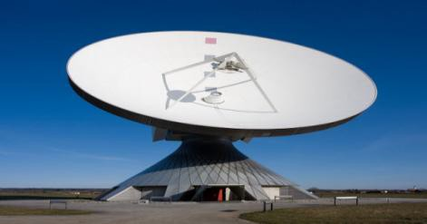

Source: *https://[www.360cities.net/es/image/parabolic-satellite-communication-](http://www.360cities.net/es/image/parabolic-satellite-communication-)*

*antenna-in-raisting*

#### Figure 2.1 Parabolic Satellite Antenna in Bavaria, Germany

Also, digital transmission was built to achieve high reliability with the business perspective that digital switching systems are much cheaper than the cost of analog systems. However, majority of the signals are analog forms such as voice, radio, and television communication that are converted into digital signals to be transmitted digitally. Some transmitted data skip this stage when the signals are already digital. In many circumstances, the method will proceed with the digitized signal processed in a source encoder which uses a series of formulae to remove redundant binary data. Next, the signal is moved in a channel encoder which introduces redundant information that will enable error detection and correction. The encoded signal will be modulated through a carrier wave that will make it suitable for transmission, as mentioned, with the additional steps of multiplexing allowing it to become part of a larger signal. The multiplexed signal will be delivered through a multiple-access transmission channel. The preceding process is reversed at the receiving end after transmission, then the information is extracted.

*Data Communications*

As studied by Thakur (2021), the interchange of data between a source and a receiver within a transmission medium such as a wired connection or air interface is called data communication. The data communication process revolves around a device sending data, known as the source, and a device that receives the data, known as the receiver. Data transmission's objective is to transport data and keep it safe throughout the process, not to generate data at the source and receiver. Datum refers to facts, information, statistics, and the like that are derived through computation or testing. The facts and

information acquired are dependent on the process or procedures of extracting it. Data can take on different forms, such as numbers, text, bits, and bytes. A rudimentary data communication system is depicted in the diagram.

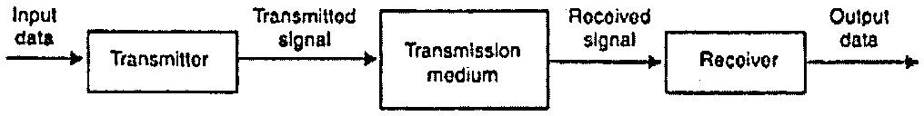

Source: *https://ecomputernotes.com/computernetworkingnotes/communication- networks/what-is-data-communication*

#### Figure 2.2 Simple Data Communication System

Moreover, through data transmission circuits, a data communication system may collect data from far places and then output processed results to remote sites. Figure 2.2 illustrates the comprehensive diagram of data communication networks. There are a lot of emerging data communication techniques that are currently commonly used either to improve or to replace older data communication techniques with better options of results and capabilities.

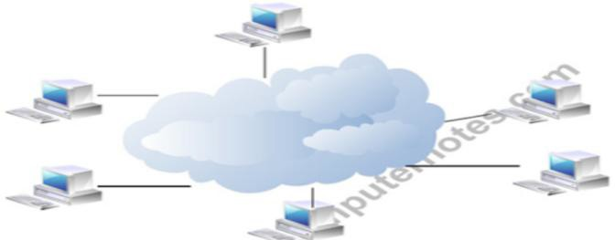

Source: *https://ecomputernotes.com/computernetworkingnotes/communication- networks/what-is-data-communication*

#### Figure 2.3 Data Communication System Using Remote Locations

*Wireless Communications*

Teja (2021) stated that wireless communication is the most common communication technology in the present era, because of its much better capability of transferring data from one point to another without using connections such as cables, wires, or any kind of physical medium.

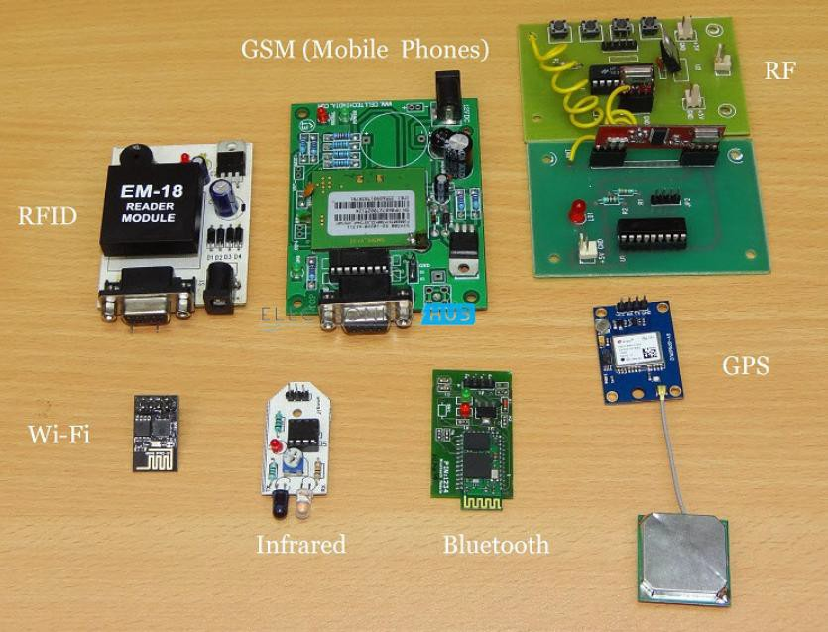

Source: *https://[www.electronicshub.org/wireless-communication-introduction-types-](http://www.electronicshub.org/wireless-communication-introduction-types-) applications/*

#### Figure 2.4 Types of Wireless Communication Systems

Furthermore, the transmission of information from a transmitter to a receiver has a limited distance in most common communication systems. But through the advent of wireless communication, the transmission between the sender and a receiver can now be between a few meters, like a TV remote control, and between a few thousand kilometers, such as satellite communications and cellular communications.

##### LoRa Versus Other Wireless Technologies

*Cellular*

As researched by BEHRTECH (2021), cellular networks become the go-to wireless technology at present because of its established and reliable connection that supports the transfer of different varieties of information, such as phone calls, videos, data, photos, video calls, streaming apps, etc. The downside of this technology revolved around the extreme cost of operations and high-power requirements.

These downsides become an incompatibility for IoT applications, which require low-power transmission since most devices for IoT use battery-operated sensors in transmission. However, cellular is well-suited for special cases that require high bandwidth and better connectivity, such as in transportation and logistics like linked cars or fleet management, and other applications such as traffic routing, in-car infotainment, fleet telematics, advanced driver assistance systems (ADAS), advanced driver assistance systems (ADAS), and others.

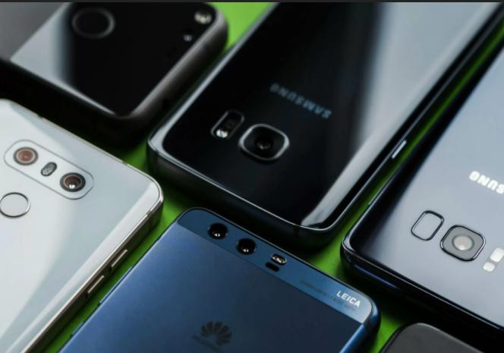

Source: *https://[www.techspot.com/news/74480-global-smartphone-shipments-](http://www.techspot.com/news/74480-global-smartphone-shipments-) reached-345-million-q1-down.html*

#### Figure 2.5 Global Smartphones

*Zigbee*

According to BEHRTECH (2021), Zigbee is a radio technology based on the IEEE 802.15.4, with its low-power but short-range capability frequently used in the application of improving the coverage in mesh topologies through passing sensor data across many sensor nodes. Zigbee offers better data output than the most common LPWAN but has the drawback of lower power efficiency caused by its mesh design.

Zigbee is similar to Z-Wave, Thread, etc. that operate in mesh protocols and are better applied on IoT solutions with a range of 100m and the same node distribution of vicinity within each node. Usually, it is used as supplementary in Wi-Fi technology for application in home automation including home sensor networks, such as security, smart lighting, energy management, and HVAC controls.

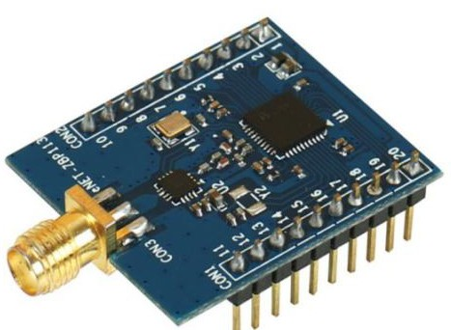Before the widespread usage of LPWAN, mesh networks have been used in industrial settings creating different remote monitoring systems. However, the fixed network setup that can be created in this technology hampers its potential scalability, together with the problems of managing geographical distances and locations.

Source: *https://[www.tindie.com/stores/chimer\_li/](http://www.tindie.com/stores/chimer_li/)*

#### Figure 2.6 Zigbee Module

*Bluetooth*

As cited by Kumari (2017), the Bluetooth technology was invented by Ericsson back in 1994 as a standard wireless technology standard for transmitting data over short distances utilizing the short-wavelength UHF radio waves (range: 2.4 to 2.485 GHz) from stationary and mobile devices, which is not known as Industrial, Scientific, and Medical (ISM) short-range radio frequency spectrum, an internationally unlicensed (but not uncontrolled) frequency for transmitting data.

In addition, it transmits data via a frequency-hopping spread spectrum. Data are separated into packets, which are then sent out on one of 79 channels. With adaptive frequency-hopping, each channel has a bandwidth of 1 MHz and 800 hops per second (AFH). BLE has a channel spacing of 2 MHz and can accommodate 40 channels.

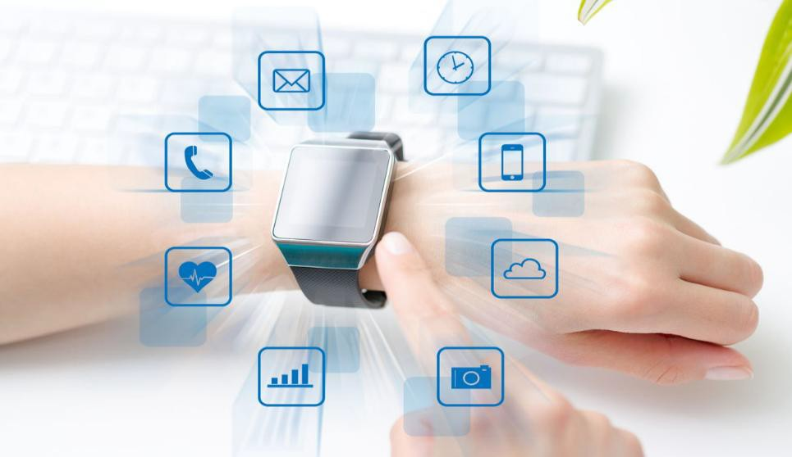

Source: *https://techspirited.com/advantages-disadvantages-of-bluetooth-*

*technology*

#### Figure 2.7 Bluetooth Technology

*WiFi*

As studied by Uy (2021), Wi-Fi is a wireless technology and a networking standard based on IEEE 802.11. This standard involves the connection of devices wirelessly or using the air interface as the medium described as wireless local area network (LAN) protocol in the industry.

Wi-Fi is an internet connection through a wireless-capable device such as a phone, tablet, or laptop from the user’s perspective. Wi-Fi is the most widely utilized method of wireless data communication in a fixed place. It is a trademark of the Wi-Fi Alliance, a non-profit organization dedicated to the advancement of wireless LAN technologies and devices.

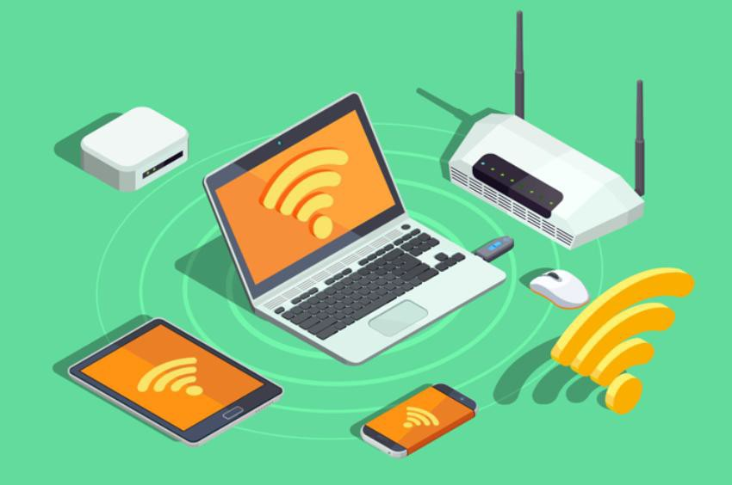

Source: *https://[www.mobileappdaily.com/future-of-5g-technology](http://www.mobileappdaily.com/future-of-5g-technology)*

#### Figure 2.8 Wireless Technology

*Sigfox*

Gabriel (2019) stated that Sigfox is wireless communication with its long-range capabilities primarily used for applications of the Internet of Things (IoT) and Machine- to-Machine (M2M) with low throughput. It uses specific base stations with software- defined radios for Sigfox network protocol and transmission using binary phase-shift keying (BPSK) modulation.

In addition, the Sigfox network was created to provide for effective communication while consuming minimal power. Low power consumption ensures that distant devices can operate for an extended period with little or no battery charging or maintenance. Sigfox facilitates IoT connectivity over vast distances, allowing transmission with a small number of base stations. The Sigfox network employs a cellular-style technique to allow remote nodes to communicate with base stations through the Internet.

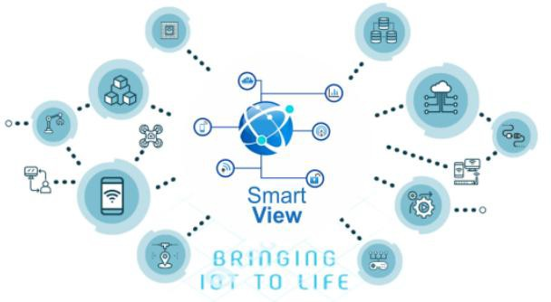

Source: *<https://partners.sigfox.com/companies/smartview-technology>*

#### Figure 2.9 Smartview Technology

*NB-IoT*

As published by Avsystem (2020), NB-IoT (Narrowband IoT), also known as LTE Cat NB, is a wireless technology created in the cellular standards to enable the Internet of Things devices with their architecture to be connected to mobile networks. This technology falls off in the low-power wide-area technology (LPWA) that addresses the power problems of the former cellular technologies.

There are hundreds of different Internet of Things applications available right now. Their diversity necessitates an equally diverse network selection. LTE or the 5G wireless communications standard, for example, is best for crucial machine-to-machine (M2M) connectivity, such as remote device operation. LAN or WiFi connections are sufficient for short-range networks, such as computer networks or connecting smart equipment at home.

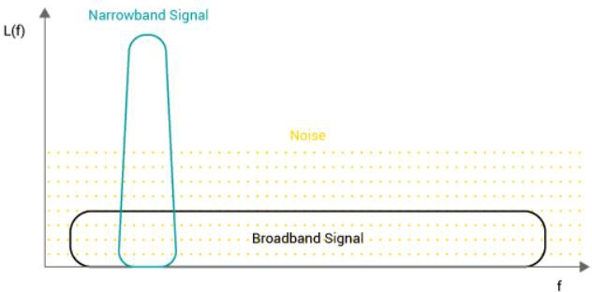

Source: *https://[www.avsystem.com/blog/narrowband-iot/](http://www.avsystem.com/blog/narrowband-iot/)*

**Figure 2.10 NB-IoT Overview**

**Radio Technology Comparison Summary**

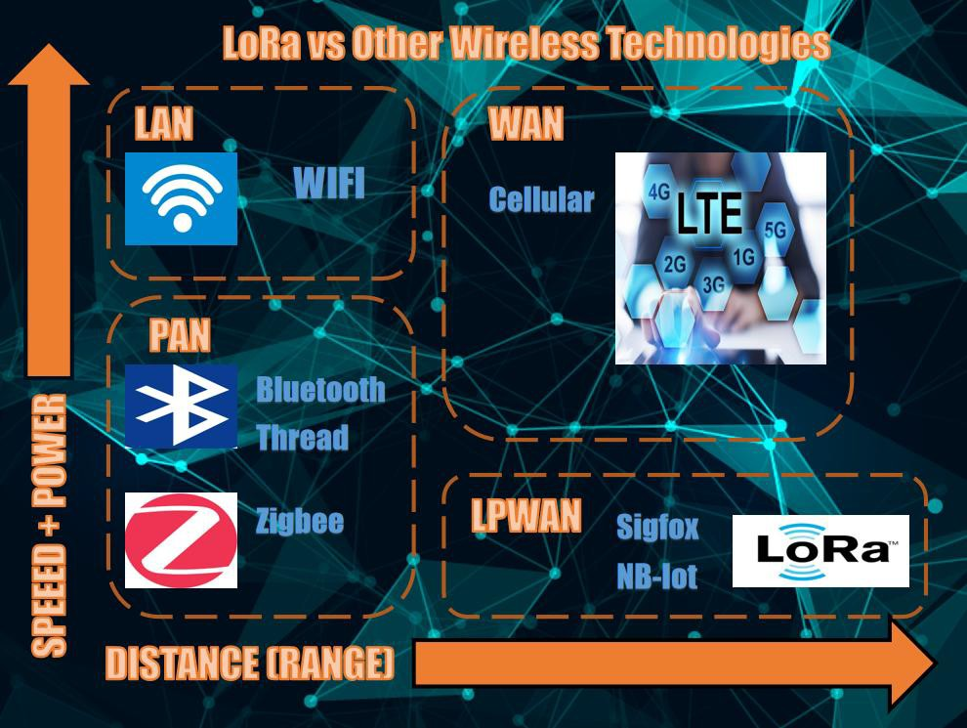

**Figure 2.11 Radio Technologies Graphical Comparison**

Figure 2.11 illustrates the comparison of different wireless technology in terms of speed, bandwidth, and distance or range. WAN and LPWAN have better range than other technologies, well-suited to the description of the current study. WAN, especially the cellular technologies, has better speed and bandwidth than the LPWAN, but LPWAN has better range and uses low power which makes it the best technology to be applied in this study. NB-IoT uses licensed frequency and costly, making it inappropriate for the study. LoRa technology is ideal in the study with its technology having a standard, more accessible prototyping modules, can be used in long-range communication, and uses low power.

##### LoRa vs Other Radio Modules

*LoRa and LoRaWAN*

According to Semtech (2020), LoRa (Long Range) is a low-power, wide-area network RF modulation technology (LPWANs). LoRa is a well-known module that refers to the ability of the technology to transport data over extraordinarily long distances. LoRa, which was developed by Semtech to standardize LPWANs, allows for long-range communications of up to three miles (5km) in urban areas and up to 10 miles (15km) in rural areas line of sight. LoRa-based systems’ ultra-low power requirements are a key characteristic, which built battery-operated devices for this technology to last up to 10 years.

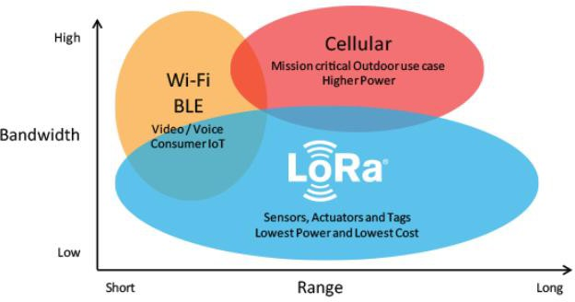

Source: *https://[www.semtech.com/lora](http://www.semtech.com/lora)*

#### Figure 2.12 LoRa and LoRaWAN

In addition, LoRa uses the LoRa spread spectrum which is a patented modulation of Semtech which is based on the chirp spread spectrum (CSS). As indicated in The Things Network (2021), CSS technology is how information is encoded into radio waves using chirp pulses, similar to how dolphins and bats communicate. Seneviratne (2019) indicated that LoRa modulated transmission is resistant to interference and can be received over long distances. From this technology, LoRa can provide long-range and low-power consumption, low data rate, and secured transmission along with its end nodes. It can be used in different networks either public, private, or a hybrid of these networks that can exceed the range capability of cellular networks. LoRa technology is mostly used in Internet of Things (IoT) applications due to its efficiency in integrating with other networks, low cost, and being low-powered.

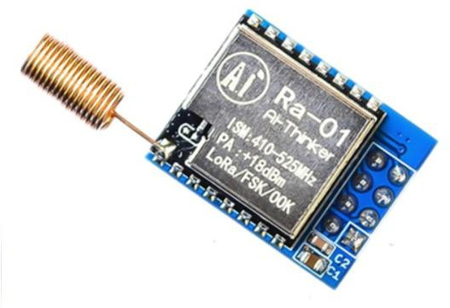

Source: *https://[www.joom.com/en/products/5f378f84d784b201066ae1fb](http://www.joom.com/en/products/5f378f84d784b201066ae1fb)*

#### Figure 2.13 RA-02 LoRa Module

As indicated by Olsson (2017), LoRaWAN™ is a Low Power Wide Area Network (LPWAN), a protocol intended for wireless devices that runs on LoRa modules or chips. LoRaWAN specifications are intentionally created to improve LoRa’s capability in range, with the addition of secured duplex communication, location services, and

mobility between the networks around each node, either within regional, national, or global networks. It provides more freedom to users, developers, and businesses.

*nRF24*

There are numerous wireless radio modules on the market that are regularly utilized in microcontrollers like Arduino and Raspberry Pi. The most well-known of these is nRF24. According to the website The Bright Side (2015), the device called Nordic nRF24 is a silicon-integrated radio transceiver that works at 2.4 GHz in the ISM (Industrial, Scientific, and Medical) band. The most used nRF24 is the nRF24L01.These boards provide proprietary wireless networks between nodes and do not support WiFi 801.11 or Bluetooth both in the 2.5GHz band.

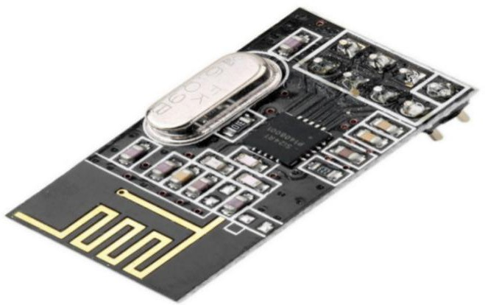

Source: *https://alltopnotch.co.uk/product/nrf24l01-wireless-module-2-4g-transceiver/*

#### Figure 2.14 nRF24 with wireless module

*CC1101*

As mentioned in [Elecrow](http://www.elecrow.com/) (2021), CC1101 is a radio module intended for ISM and SRD (short-range devices) running in the sub-1GHz bands designed for low- powered wireless applications. The frequencies this module uses are 315, 433, 868, and

915 MHz, where some lie within the ISM frequency band, but can also be easily programmed for operation on other frequency ranges such as 300-348 MHz, 387-464 MHz, and 779-928 MHz bands for medium to long-range distances.

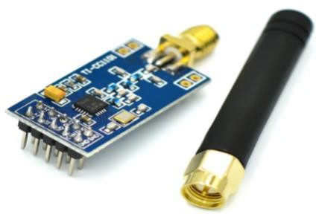

Source: *https://[www.aliexpress.com/item/32290705850.html](http://www.aliexpress.com/item/32290705850.html)*

#### Figure 2.15 CC1101 Wireless Module SMA Antenna Wireless Transceiver

*HC12*

One of the most used radio modules next to nRF24 especially for the customized projects in Arduino is the HC12. In accordance with Hughes (2016), HC-12 is a half- duplex wireless serial communication module that works at 100 mW and with a multi- channel wireless transceiver, at 100 channels to be exact, in 433.4 to 437 MHz capable of transmitting in 1km.

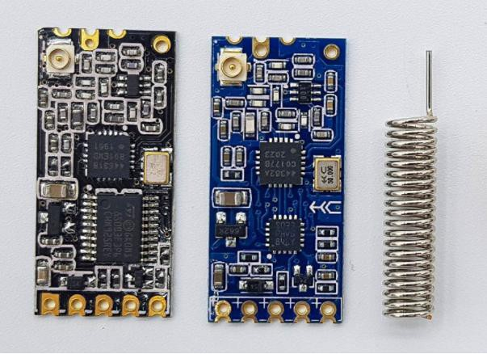

Source: *https://wolles-elektronikkiste.de/en/hc-12-radio-module*

#### Fig. 2.16 Two HC-12 Modules with an Antenna

*Raw RF Module*

It is the generic RF module used in any microcontroller at the frequency of 433.92 MHz. It is the radio modules mostly found in starter Arduino kits that come in pairs, a transmitter and a receiver, and can be bought for a cheap price at around 100 pesos or less, both with the receiver and the transmitter. In addition to these, it was also stated in Random Nerd Tutorials (2019) site that these modules have only a variable range, mostly a very short range because it only uses ASK modulation. These modules only work in simplex mode or the unidirectional transmission mode.

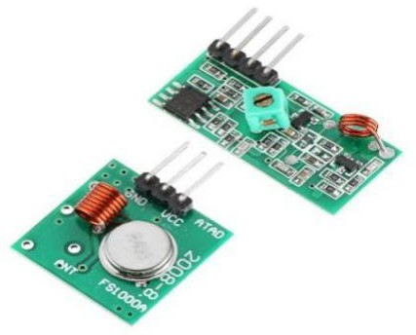

Source: *https://robu.in/product/433mhz-tx-rx-module/*

#### Figure 2.17 Raw RF Module

*Bluetooth Module HC-05*

According to [ElectronicWings (2022),](http://www.electronicwings.com/) Bluetooth module HC-05 is a wireless module with IEEE 802.15.1 interchangeable protocol built for wireless Personal Area Network or PAN. It uses the radio technology of frequency-hopping spread spectrum (FHSS) in sending data over the air. It is widely applied in consumer applications for wireless communications and has a range of fewer than 100 meters depending on factors such as the transmitter and receiver, atmospheric conditions, geographical

conditions, and obstructions. The module can be used in either slave or master configuration.

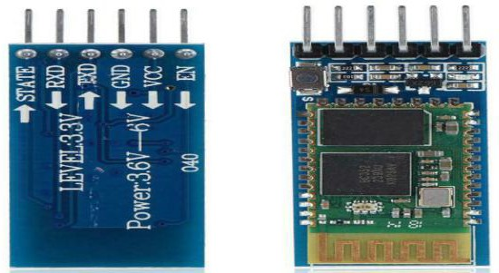

Source: *https://[www.ebay.com/itm/1-5PCS-HC-05-Wireless-Bluetooth-Module-BT-](http://www.ebay.com/itm/1-5PCS-HC-05-Wireless-Bluetooth-Module-BT-) Transceive-Serial-Module-Commander-/333573175403*

#### Figure 2.18 Bluetooth Module HC-05

*Wi-Fi Modules*

As mentioned in RS Components Corporation (2021), Wi-Fi or wireless fidelity modules are electronic modules used in a lot of devices to access wireless communication to the Internet. The most used Wi-Fi module is the ESP8266 module which is a wireless transceiver commonly applied for Internet of Things or IoT applications. As stated in the datasheets from [ElectronicWings](http://www.electronicwings.com/) (2021), it works on 2.4 GHz Wi-Fi 802.11 b/g/n, supports WPA/WPA2, and transmits in pulse-width modulation (PWM). Tones (2021) added that it comes with factory-installed firmware that allows to control it with standard “AT commands”. This makes the customization easier for programming of controlling devices over the Internet. This module can also work stand-alone which means it can be used to work on its own or be a microcontroller like Arduino.

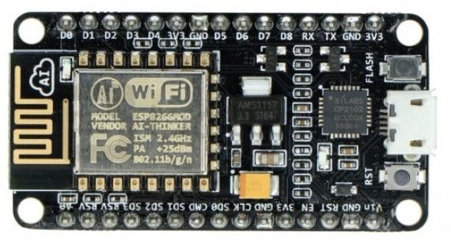

Source: *https://botland.store/esp8266-wifi-modules/15136-nodemcu-wifi- esp8266-module-4mb-waveshare-16608-5904422343002.html*

#### Figure 2.19 NodeMCU WiFi ESP8266 module - 4MB - Waveshare 16608

***Radio Modules Comparison Summary***

#### Table 2.1 Radio Modules Comparison in Terms of Range, Energy Usage, and Speed

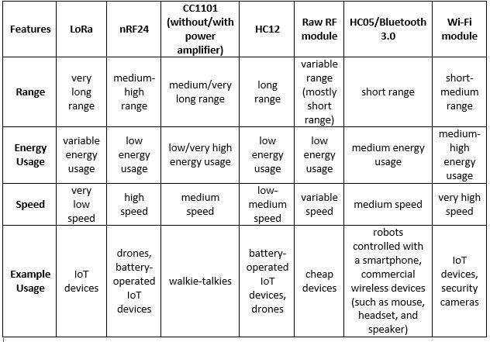

Table 2.1 summarizes the features of different accessible and cheapest radio modules in the market depending on their range, energy usage, speed, and example applications.

*ISM Band*

The Industrial, Scientific, and Medical (ISM) frequency bands are radio frequency bands designated for RF purposes other than telecommunications, which is defined by the ITU Radio Regulations or RR (2012 edition) in Article 5 in footnotes 5.138, 5.150, and

5.280. Individual countries’ designation differs depending on their national radio regulations. As stated in Military & Aerospace Electronics (2019), more modulation schemes and communication platforms use ISM bands in the past few years knowing that a lot of emerging potentials for technologies such as The Internet of Things (IoT) and Industry 4.0 applications will more likely rely upon low-power and much better for long-range communications. Some of these new technologies include Thread, Z-wave, LoRa, and NB-IoT.

As mentioned in the RP2-1.0.1 LoRaWAN® Regional Parameters released by LoRa Alliance® (2020), the available bands or channels in the Philippines were 915 – 918 MHz, 868 – 869.2 MHz, 869.7 – 870 MHz, and 433.05 – 434.79 MHz, in Channel Plans in accordance with AS923-3, EU863-870, EU863-870, and EU433, respectively.

*LPWAN*

Qadir et al. (2018) claimed that as the underlying networks for Internet of Things (IoT) applications, low-power wide-area (LPWAN) technologies are strongly suggested. Wide-range coverage, long battery life, and affordable data rates are among the appealing qualities they offer. Their article examined contemporary technological trends, focusing

on the services offered and the issues encountered. The industrial concepts for LPWA adoption were discussed. In contrast to previous research in the sector, their study focused on the requirement for integration between different LPWA technologies and suggested the best LPWAN solutions for a variety of IoT application and service use cases.

*Arduino*

As cited in Arduino’s (2021) website, Arduino is an open-source electronics component comprised of their hardware and software, in the form of different types of Arduino boards and the Arduino IDE to program the contents for the microcontroller. Sets of instructions can be programmed in the microcontroller to perform something such as simple blinking of light, automation using a variety of sensors, etc. Arduino is well-known for creating thousands of projects, from simple household items to large scientific projects. Contributions are created from all around the world to improve the applications on Arduino from different sectors such as professionals, programmers, hobbyists, and students.

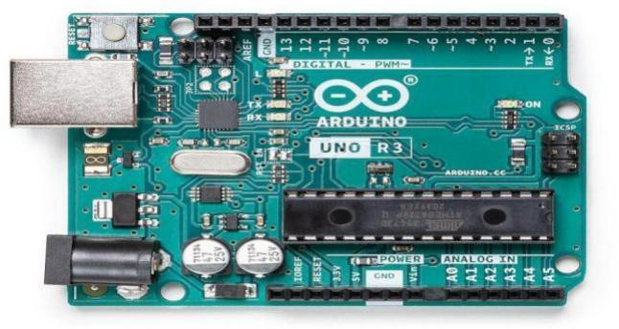

Source: *https://[www.bing.com/search?q=Arduino&qs=n&form=QBRE&sp=-](http://www.bing.com/search?q=Arduino&qs=n&form=QBRE&sp=-) 1&pq=arduin&sc=8-6&sk=&cvid=7FA313AFD47A4705B0A69E3AF2A8FB37*

#### Figure 2.20 Arduino UNO Rev3

*Liquid Crystal Display*

As indicated by Dunmor (2015), a liquid crystal display (LCD) is an electrical device that displays output by changing the liquid’s optical characteristics on each layer using an electric voltage that varies on the symbols to be presented. This technology is used in multiple electronic devices such as games, digital cameras, televisions, projectors, computer monitors, and billboards. There are also different types of LCD panels specifically used for Arduino or other microcontrollers depending on what type of project to create.

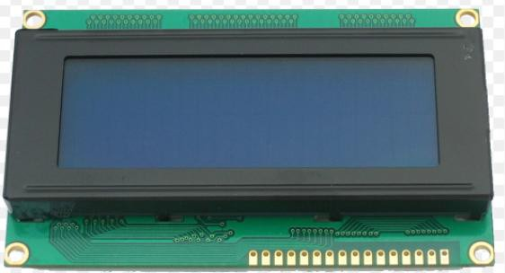

Source: *https://[www.inventelectronics.com/product/20x4lcd/](http://www.inventelectronics.com/product/20x4lcd/)*

#### Figure 2.21 20x4 LCD

*Push Button*

As published by Khatri (2015), a push-button is a mechanical component used as an actuator in different applications, commonly made of plastic and metal. The component works as an on and off button with the operation of remaining off or in an open position when not pressed, and will only allow current through it or close the circuit when it is pressed. Most push buttons are made up of four legs, two on each side, that

allow them to control two lines of a circuit. Figure 2.22 shows a push-button that has two legs on each side that are internally joined.

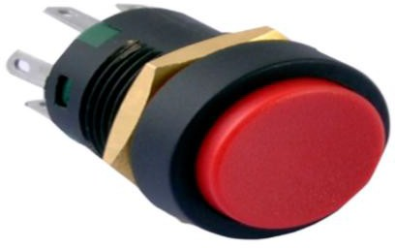

Source: *https://[www.alsamra.com/giffex-products.html](http://www.alsamra.com/giffex-products.html)*

#### Figure 2.22 Push Button

*Potentiometer*

According to GFG (2021), a potentiometer is an electrical device that detects both the EMF (electromotive force) and the internal resistance of a cell. It is also used to compare different cells’ EMFs. It can also be used as a variable resistor in most applications.

The component potentiometer is made of a long wire with a consistent cross area. The wire is usually made of manganin or constantan. The wire is sometimes divided into several parts and each component is connected to the end through a thick metallic strip. Copper strips are most commonly used. One meter of wire is used for each item. There are six bits of wire for the most part and the total length of the wire is six meters. The wire length varies from 4m to 10m for the most part. The potentiometer’s precision improves as the wire length increases.

‘

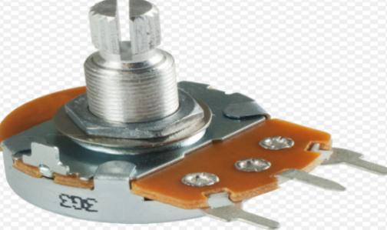

Source: *https://[www.tubesandmore.com/products/potentiometer-alpha-linear-pc-mount-](http://www.tubesandmore.com/products/potentiometer-alpha-linear-pc-mount-) marshall*

#### Figure 2.23 Potentiometer

*Power Bank*

As studied by Madaan (2013), a portable energy source that may be carried in one’s pocket or backpack is known as a power bank. It has an integrated Lithium-Ion battery that stores energy and can be used to charge portable devices such as smartphones and tablets as needed.

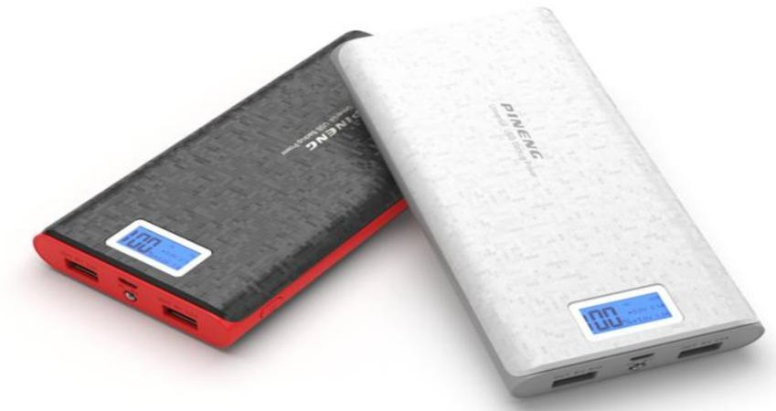

Source: https://[www.mdexstore.com/power-bank](http://www.mdexstore.com/power-bank)

#### Figure 2.24 Power Bank

**Related Studies**

*Wireless Data Communications System for a Transportation Vehicle*

As studied by Hettich (2005), the invention was for diverse selection of vehicles like airplane, bus, cruise ships, or railway. An information source containing data content such as text, audio, and video media; a plurality of wireless interfaces; a plurality of individually identifiable electronic devices coupled to the plurality of wireless interfaces; and a wireless local area network (LAN) access point were all part of the wireless communication system. The information source was connected to the wireless LAN access point, also wirelessly connected to many wireless interfaces. The wireless LAN access point could receive data content from the information source, convert it to a wireless transmission format, and selectively distribute the formatted data content to the plurality of wireless interfaces so that it could be reached by at least one of individually identifiable electronic apparatus.

*Method for Requesting Transportation Service****s***

Hall (2017) disclosed using mobile communications devices that can track geographic location as a method for acquiring transportation services safely and efficiently. Transportation for individuals and groups may be available; new customers may be efficiently served; and the position of the requester and the transportation provider can be viewed in real-time on mobile devices.

*Enhanced Transit Location Systems and Methods*

Hanzcor’s (2021) electronic apparatus or invention was a wireless device for communication purposes mainly used for transportation, using electronic devices as medium. The said device could decode the encoded data and receive signal number one sent by the second electronic device attached to a vehicle. The second device could give feedback (sends second signal) and transmit data to the first device, wherein the first device determines the location and position of the vehicle with its attached second device. In summary, this electronic apparatus has multiple devices on multiple locations that contribute data to its first device (database).

*Locating and Tracking System and Method Based on LoRa Transmission*

As proposed by Dacai (2017), the invention was a locating and tracking communication system and procedure based on LoRa transmission. The electronic apparatus included a positioning and display device whereas the locating product included a micro control unit and LoRa-based wireless locating module while the micro control unit was connected to the LoRa-based wireless locating module. The display product included a mobile terminal or a GPRS product and a LoRa RF module arranged on the mobile terminal or the GPRS product which is connected to the mobile terminal or the GPRS product. The wireless locating module based on LoRa could exchange information with the LoRa RF module in a wireless communication mode. When compared to existing locating and tracking devices based on Bluetooth and

GSM, the invention's locating and tracking system could improve locating distance and precision, reduce power consumption, and improve stability.

*Localization Tracking System Based on LoRa Transmission*

Dacai’s (2017) utility model was a location tracking system based on LoRa transmission which included a location product and a demonstration product, wherein the location product included a small control unit based on LoRa’s wireless locating module while the demonstration product included a mobile terminal or GPRS product. In comparison to typical location and tracking software based on Bluetooth and GSM, the utility model could enhance positioning distance and precision, reduce and utilize consumption, and maintain stability.

*LoRa Wireless Module, Data Transmission System, and Data Transmission Method*

In the study by Yue (2018), the invention included a LoRa wireless module in an electronic apparatus used for long distance transmission of data. The main control chip, a security unit, and a LoRa radio frequency unit made up the LoRa wireless module, with the security unit and the LoRa radio frequency unit integrated into the main control chip. Target data are collected by a data acquisition device and sent to the security unit. The security unit then encrypts the target data and sends the encrypted data to the main control chip, and the main control chip calls a LoRa protocol stack and sends the encrypted data out through the LoRa radio frequency unit. The LoRa wireless module given by the application encrypts the data using hardware encryption and sends the encrypted data out via the LoRa radio frequency unit embedded in the main control chip,

considerably improving data security.

*LoRa and GPRS-Based Remote Data Transmission Communication Technology*

Fang (2017) developed a communication control invention that discloses a LoRa and GPRS-based remote data transmission communication technology, solving the problems of low efficiency and high cost caused by performing remote data transmission using GPRS separately as well as the problem caused when a LoRa communication technology is used for data transmission.

Data from various sensors are obtained using the LoRa and GPRS-based remote data transmission communication technology. Using LoRa radio frequency technology and LoRa point-to-point communication technology, data are then sent to a terminal. Data are mainly transmitted remotely by adopting a plurality of LoRa modules and GPRS.

The LoRa modules have the advantage of being able to acquire data at one time, repeatedly in a segmented manner, and continuously in a segmented manner. They also have the advantages of simple structure, far communication range, less consumption of power, and portability.

*LoRa Image Acquisition Transmission System*

Xiaoming’s (2017) utility model was related to the technical field of radio communication, specifically image sensors that use the LoRa technique. The concrete technical scheme included a LoRa image acquisition transmission system. The LoRa image sensor transmits signals through the CAM bus with the micro-controller which transmits signals through the SPI bus with the LoRa radio frequency module. This system used an integrated structure for image acquisition, compression, handling, transmission, and unified processing in power supply, etc. Cost was greatly reduced, the volume was smaller, and the stability was better. The spread spectrum wireless communication technology is used by both the LoRa gateway and the Endpoint for a LoRa image sensor. The star topology structure between the LoRa image sensor and the LoRa gateway addresses the system’s real-time communication requirements, allowing for seamless roaming communication across different LoRa gateways.

*GPS Position Tracking System and Tag Using LoRa Communication*

Jong Ha (2020) came up with a method for tracking location using a LoRa communication network in addition to the existing 3G/4G network. A GPS module calculating location information using GPS information received from a GPS satellite; a LoRa module performing LoRa communication; a control module wirelessly transmitting the location information calculated by the GPS module to the outside through the LoRa module; and a battery supplying driving power to the GPS module, the LoRa

module, and the control module are all examples of modern take on technology/inventions.

*Large Data Transmission Method, Terminal, and Server in LoRa Communication System*

Quan (2018) provided a method for tracking a location using a LoRa communication network in addition to the existing 3G/4G network. A GPS module calculating location information using GPS information received from a GPS satellite; a LoRa module performing LoRa communication; a control module wirelessly transmitting the location information calculated by the GPS module to the outside through the LoRa module; and a battery supplying driving power to the GPS module, the LoRa module, and the control module were the components of the invention. The server end reassembles the communications after the brief messages have been received completely. The server breaks the huge data into short messages of a fixed length that can be delivered by the LoRa communication system in the downstream direction and transmits the short messages to the LoRa terminal in a continuous way using the SX1301. The terminal reloads the packets after receiving them completely from the server. The innovation enables huge data transmission in the LoRa communication system while ensuring that normal application message transmission is not significantly disrupted.

#### Conceptual Framework

**INPUT PROCESS OUTPUT**

* Ease of transportation away from the terminal
* Requesting a ride especially for those away from the terminal
* Principles and theories about wireless communications, LoRa and LoRaWAN, and proragation method
* Power supply unit, transceiver modules, microcontrollers, and programming IDE
* Studying related literature and studies for understanding of concepts
* Planning, choosing the proper materials, and designing the prototype
* Collecting materials and components needed
* Assembling the prototype
* Installing the system
* Testing the prototype on-site, operating, evaluating, and troubleshooting

**Passenger Notification System (PNS)**

**Figure 2.25 Conceptual Framework**

Figure 2.25 shows the different inputs and processed involved in the research. The study started with identifying a problem that can be solved through research and innovation, which in this case was to improve a reliable and convenient mode of transportation when requesting a ride, especially for those that are away from the terminal

and when drivers are finding passengers. Researching concepts and theories about wireless communications, LoRa and LoRaWAN, and propagation methods helped the researchers in creating a solution for the problem. This was done through reading texts, learning about the topics from webinars, studying programming languages for scripting, and understanding the concepts from the related literature and studies. Planning for the prototype involved choosing the appropriate materials for the prototype and the design of its structure. Choosing the proper materials for the prototype had been important in building a more efficient prototype that could attain the planned features. Assembling the prototype included the construction of the hardware (the electronic circuit and the power supply unit) and the software (the programmed script in the IDE). Testing of the prototype on-site, operation, evaluation, and troubleshooting addressed the problems, flaws, and unexpected features encountered on the prototype and its system. The output of this research will help in improving the transportation system and also help future researchers in creating new ideas regarding this topic.

**Chapter III**

### METHODOLOGY

This chapter presents the methods and procedures used in conducting the research to utilize and provide the readers an essential view of how the research was done and how data were collected to develop conclusions. The sources of information used as reference for the study are also cited. This section also informs about the essential parts of the study, namely research locale, respondents, research design, research instrument, procedures/data collection, and statistical treatment.

#### Research Locale

The development of the prototype and testing of the system of the transmission module/device was conducted at the residence of one of the researchers in Avida Isabang Tayabas City, Quezon. The geographical area was suited based on definite tests on Radio Planner 2.1. The researchers then proceeded to configure and test the prototype and the transmission system in the determined location.

#### Respondents

Tricycle drivers and passengers are the key characters in systematic transportation. In this study, the researchers used purposive sampling which is a type of

non-probability sampling based on the objectives of the study and the characteristics of the population. Convenience sampling was also used. This is a type of non-probability sampling which involves the sample being drawn from that part of the population that is available and willing to participate in the study. The research was conducted among 30 selected respondents for the researchers to know/discern all the certain advantages, disadvantages, and limitations of the prototype. The definite quantity of the respondents was 10 tricycle drivers and 20 local passengers.

#### Research Design

The design used in this study was applied type of research. Applied research complemented the researchers’ study since it aimed to find a solution for an immediate problem facing the society. Upon identifying the problem, the study was planned in creating experiments to conduct a series of testing. The overall/final performance of the prototype was determined through conducting trials and tests involving observation and analysis of different succeeding outputs. Surveying for improvement and capability testing of the prototype were also considered in the study.

The LoRa module was the key component in producing both the master and slave nodes of the transmission system. Other peripherals like antenna, LCD, power supply, micro-controller, and other components were used to have a user-friendly device.

The researchers constructed the device for convenient use of passengers and tricycle drivers as it projects data digitally which allows viewing of both groups in their separated modules (slave node and master node).

#### Research Instrument

The researchers used the following tools and resources for the experimentation and gathering of data for the study:

*Laboratory Instruments*

* Radio frequency tools such as Google Earth and RadioPlanner 2.1 Simulator were used in modeling the radio propagation of the transmission. These were used to lessen the trial and error for the prototype’s network coverage and to simulate the best spot to deploy the PNS.
* Arduino IDE was used to create the algorithms, sketches, and codes for the construction of the prototype and the system.

*Questionnaire*

The researchers used a structured type of questionnaire based on the objectives of the study. It was composed of two (2) parts. The first part was the letter of consent

for the selected respondents containing greetings and indicating the researchers’ course and title of the study. The second part contained the checklist that the respondents filled out with their name, occupation, signature, and date as well as the series of questions regarding the design, functionality, and effectiveness of the prototype. The respondents were asked to answer the questionnaire respectively and carefully by putting a check sign on the blank spaces corresponding to their responses. There was a total of 15 questions from five (5) questions each in the three categories. The choices were based on the Likert rating scale format with 5 being the highest and 1 being the lowest with equivalent descriptive ratings of strongly agree, agree, fairly agree, disagree, and strongly disagree.

Table 3.1 presents the survey containing questions anchored on the objectives of the study utilized by the 30 respondents upon evaluation of the prototype. The rating scale consisted of 5, 4, 3, 2, and 1 equivalent to Strongly Agree (SA), Agree (A), Fairly Agree (FA), Disagree (D), and Strongly Disagree (SD), respectively. Questions were divided into sub-parts on the following aspects: design, functionality, and effectiveness.

#### Table 3.1 Survey Questionnaire Form for the Prototype’s Design, Functionality, and Effectiveness

|  |  |  |  |  |  |
| --- | --- | --- | --- | --- | --- |
| DESIGN | | | | | |
| STATEMENT | 5 | 4 | 3 | 2 | 1 |
| 1. The design of the prototype is durable/robust. |  |  |  |  |  |
| 2. The prototype itself can be used conveniently or accessed easily. |  |  |  |  |  |
| 3. The design of the prototype is built water-resistant. |  |  |  |  |  |
| 4. The prototype is easy to use and configure. |  |  |  |  |  |
| 5. Information in the LCD is clearly shown and can be read. |  |  |  |  |  |

|  |  |  |  |  |  |
| --- | --- | --- | --- | --- | --- |
| FUNCTIONALITY | | | | | |
| STATEMENT | 5 | 4 | 3 | 2 | 1 |
| 1. The transmission of the prototype works properly. |  |  |  |  |  |
| 2. In using both the transceiver, the LCD shows and sends information accurately. |  |  |  |  |  |
| 3. The actuators are seamlessly in sync with the LCD and sending information. |  |  |  |  |  |
| 4. The prototype sends information in long range. |  |  |  |  |  |
| 5. The prototype can transmit data without using cellular or Wi-Fi modules. |  |  |  |  |  |
| EFFECTIVENESS | | | | | |
| STATEMENT | 5 | 4 | 3 | 2 | 1 |
| 1. The prototype gives ease to passengers and tricycle drivers in terms of cost. |  |  |  |  |  |
| 2. Transportation can be accessed in far-flung streets and stationed in tricycle terminals. |  |  |  |  |  |
| 3. The device lessens human effort or promotes convenience for both passengers and tricycle drivers. |  |  |  |  |  |
| 4. The prototype can be used in various places. |  |  |  |  |  |
| 5. The device minimizes common problems encountered in transportation. |  |  |  |  |  |

*Table for Data Collection*

#### Table 3.2 Transmission Distance and Transmission Time

|  |  |  |  |  |  |  |
| --- | --- | --- | --- | --- | --- | --- |
| **Distance of Transmission** | **Transmission Time (seconds)** | | | | | |
| **Trials** | | | | | **Remarks** |
| **1** | **2** | **3** | **4** | **5** |
| 50 m |  |  |  |  |  |  |
| 100 m |  |  |  |  |  |  |
| 300 m |  |  |  |  |  |  |
| 500 m |  |  |  |  |  |  |
| 800 m |  |  |  |  |  |  |
| 1000 m |  |  |  |  |  |  |

Table 3.2 shows the table used to log distance and time of transmission between the point-to-point PNS. The time it took for data from the sensor to be received was checked five times for each distance indicated in the table.

#### Procedures/Data Collection

These are the procedures and plans for data collection done by the researchers in this study:

#### Information Gathering

Wireless communication has been a huge technology vastly used all around the world and has been quickly improving with the emergence of innovations and new technologies. The researchers gathered data and information concerning wireless communications which were used in conceptualizing the project. Due to the pandemic, majority of the data gathered by the researchers were from the Internet, such as eBooks, websites, and online articles. The researchers also attended some webinars about telecommunications to gather ideas for the prototype.

#### Prototype and System Planning

* 1. Prototype Planning

The researchers considered the following features in setting up a functional and effective Passenger Notification System:

* + 1. Wireless non-cellular connectivity
    2. Low-powered
    3. Transmission not requiring an internet connection
  1. Selection of Materials

The researchers chose which components such as in microcontroller and transmission module would be more effective for the project.

#### Radio Propagation and Network Coverage Simulation

* 1. Go to https://[www.wireless-planning.com/radioplanner](http://www.wireless-planning.com/radioplanner) and install the 7-day free trial of Radio Planner 2.1. The user manual on this website may help with how to use the simulation software.
  2. Fill out the necessary information under the project information tab and settings.
  3. Under the base station network, create a base station using the LoRa base station template and input the necessary information such as the coordinates of the location of the base station to be simulated and the frequency of the base station. Another method of creating a base station is to navigate the map and find manually the location of deployment. Right-click and choose to create a base station with the LoRa base station template, then fill out the necessary information.
  4. Under the created base station, a sector parameter will be automatically created. The prototype will only be having one sector with an omnidirectional radiation pattern. Input the necessary parameters of the prototype such as Tx power, Rx threshold, cable length, antenna height, antenna gain, and antenna model.
  5. Check some important parameters in the propagation model such as propagation model type and clutter loss.
  6. Customize the graphical results of the simulation in the Area Study Details section of the simulator.
  7. Simulate and adjust the parameters depending on the preferred network coverage. Choose the most efficient place for the site.
  8. Import the simulation as a kml file for Google Earth.

#### Circuit Designing and Construction

* 1. Determine the components, materials, and appropriate circuits needed in constructing the device.
  2. Design the circuitry and incorporate the most suitable microcontroller and length of antenna for the prototype and the system. Double-check the connections and wirings.
  3. Create a program following the desired output.
  4. Save and test the program.

#### Process of Requesting a Tricycle

* 1. The passenger will use the pushbutton and potentiometer of the PNS to initiate a request for a ride to the terminal. An LED will light up when the message is already sent.
  2. The data will be sent to the PNS at the tricycle terminal. The buzzer will beep if data is received, and the data can be seen on the LCD.
  3. The driver to pick up the passenger will transmit a signal to the PNS of the passenger to indicate that s/he will be fetched.
  4. The driver will arrive at the place where the passenger requested.

#### Testing the Functionality

* 1. Check the circuits of the prototype if properly installed and connected.
  2. Open/start the prototype.
  3. Check if there is data transmitted between the two wireless devices.
  4. Do several trials to check the PNS data transmission.

#### Testing the Effectiveness

* 1. Place the master node at a specific place. It will be stationed at the tricycle terminal or place that serves as the tricycles’ waiting place for passengers.
  2. Conduct drive testing or walk testing for the LoRa network of the two devices.
  3. Use the potentiometer to check if there is data being transmitted for a specific interval of distance as the slave node goes far from the master node.
  4. Gather the following data: transmission time, transmission distance, RSSI, SNR, and the sample’s coordinates.
  5. Record the data accordingly in Table 3.2 (see the table in Data Collection under Research Instrument).

#### Statistical Treatment

The study employed weighted mean as a statistical treatment. Mean was applied to check the average transmission time of the prototype in a specific transmission range. Weighted mean formula was used for the computation of acceptability and satisfaction rating of the respondents on the Wireless Passenger Notification System (PNS) for Tricycle Terminal and Street. Data were analyzed through the Likert scale in the questionnaire.

where:

1-5 = scale f= frequency

*WM* = 1f + 2f + 3f + 4f + 5f

*N*

N= total number of respondents

#### Table 3.3 Rating Scale and Qualitative Description

|  |  |  |
| --- | --- | --- |
| **Scale** | **Range Interval** | **Qualitative Description** |
| 5 | 4.19 – 5.00 | Highly Acceptable (HA) |
| 4 | 3.39 – 4.19 | Acceptable (A) |
| 3 | 2.59 – 3.38 | Fairly Acceptable (FA) |

|  |  |  |
| --- | --- | --- |
| 2 | 1.79 – 2.58 | Not Acceptable (NA) |
| 1 | 1.00 – 1.79 | Highly Not Acceptable (HNA) |

Table 3.3 shows the rating scale used to determine the qualitative description for each of the criteria stated on the questionnaire for the Wireless Passenger Notification System (PNS) for Tricycle Terminal and Street.

#### Table 3.4 Gantt Chart

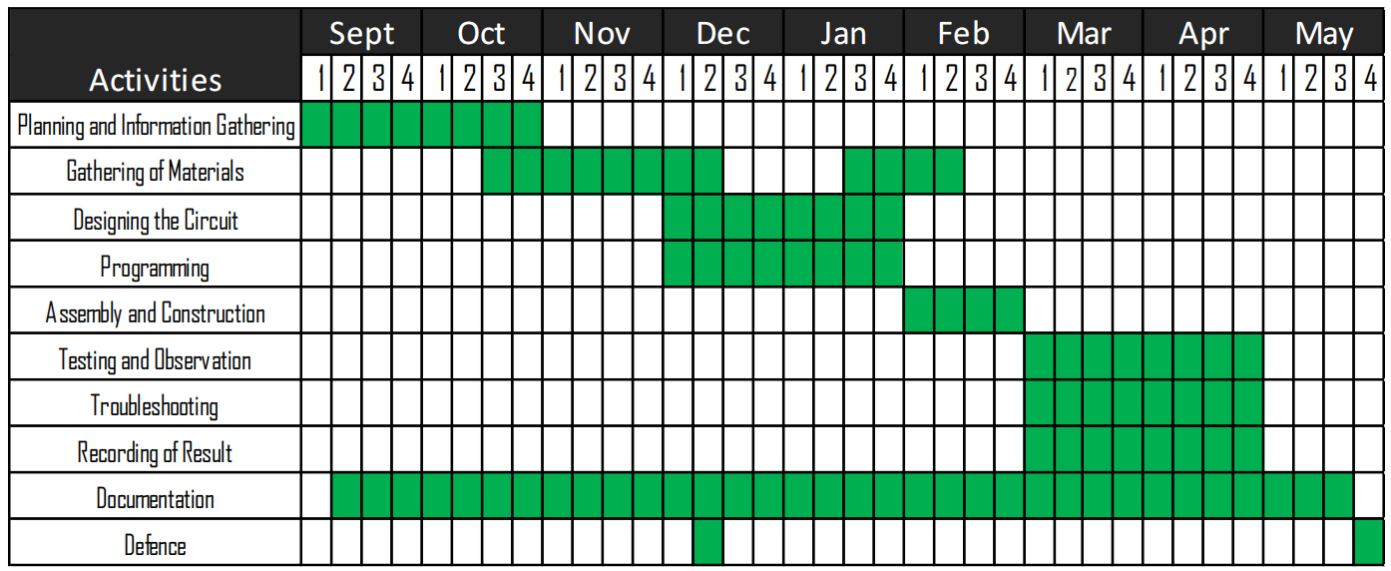

The time frame for the prototype and system construction is shown in Table 3.4. It specifies the time covered in various phases of the study: planning, gathering information on the factors considered in constructing the prototype and the system, costing of the components, gathering and canvassing materials, circuit and program designing of the application and the system, assembly and construction of the prototype, installing the system, and collecting data as well as observations. It also displays the span of documentation and the duration of the defense.

**Chapter IV**

### RESULTS AND DISCUSSION

This chapter presents all the important data acquired from various tests that served as the foundation for the completion of the Wireless Passenger Notification System (PNS) for Tricycle Driver and Street. The basic principles of the design system are presented through visual presentations of a block diagram, system flowchart, program flowchart, and schematic diagrams. Data gathered are presented in tables along with their discussions and analysis.

#### System Overview

Wireless Passenger Notification System (PNS) for Tricycle Driver and Street is a two-way communication device serving as a station that focuses on passengers from a specific street to request-a-ride to the drivers on a tricycle terminal. The device contains radio and transmission components, the control unit system, inputs and display, and the station structure.

LoRa module, a radio module based on spread-spectrum modulation techniques derived from chirp spread spectrum (CSS) technology, was used in the device for distributing the information from a PNS station to another PNS station. Data from the PNS stations were encapsulated into packets sent in a matter of low transmission time and

deep penetration through obstacles. To cover a better range in exchange for lower bandwidth and throughput, 433 MHz was used in this study. The included 2 dBi omnidirectional antenna in the module was utilized for the prototype connected at 1.7m from the module and 3m above the ground.

Arduino UNO R3 served as the main processor of the device for taking of data input from the users and sending wirelessly as output into another device.

Inputs from the users were accessed using a push button and potentiometer. The 20x4 LCD displayed both the number of requested tricycles and accepted or the available number of tricycles following the passenger’s request. Adjusting the potentiometer changed the values on the LCD while the push button acted as the actuator for sending the entered values to the other devices. The LED was used as the indicator on a PNS if a station transmitted a message and a buzzer if it received a message. A rechargeable power bank served as the power supply of the device.

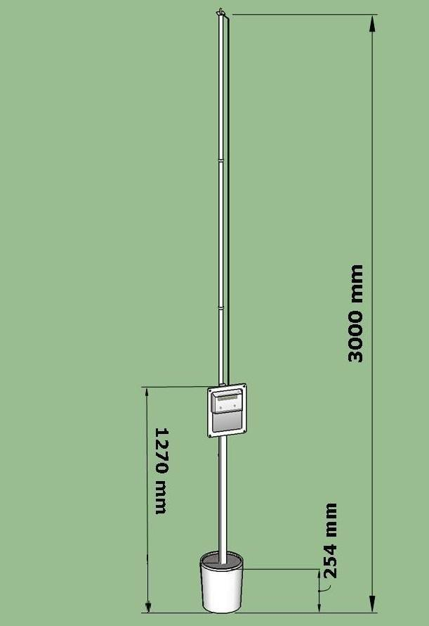

#### Figure 4.1 Wireless Passenger Notification System (PNS) for Tricycle Terminal and Street’s Overall Design and Dimensions (Top to Bottom View)

Figure 4.1 displays the overall design of the prototype (top to bottom) for both the master node and slave node. The bottom part of the prototype shows the bucket- shaped platform used to support the PVC pipes and wood towers. Its dimension is 254 mm in length. Second, the wood tower is used to hold and mount the casing of the prototype. Its dimension is 1270mm in length. Lastly, the dimension of the PVC pipes used to hold the antenna is 3000mm. The materials used are plastic, wood, and cement. The structure is colored white.

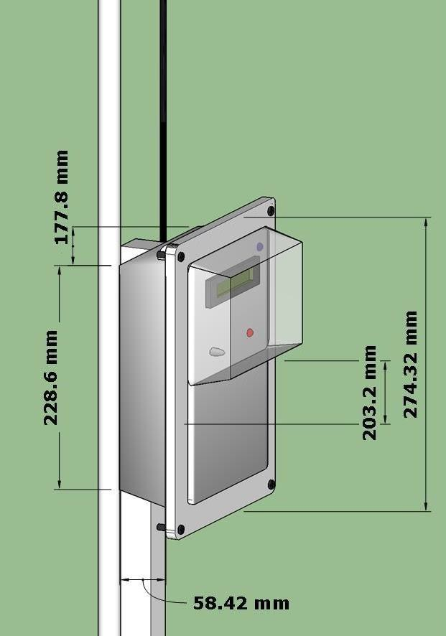

#### Figure 4.2 Wireless Passenger Notification System (PNS) for Tricycle Terminal and Street’s Overall Design and Dimensions (Casing)

Figure 4.2 displays the overall design of the prototype’s casing for both the master node and slave node. As for the front structure or cover of the prototype, it serves as a mount for the LCD, potentiometer, and push button. Its dimensions are 274.32mm x

203.2mm in length and width. Second, the dimensions of the rear or back of the prototype are 228.6mm x 177.8mm in length and width. Lastly, for its right side, the dimension is

58.42mm.

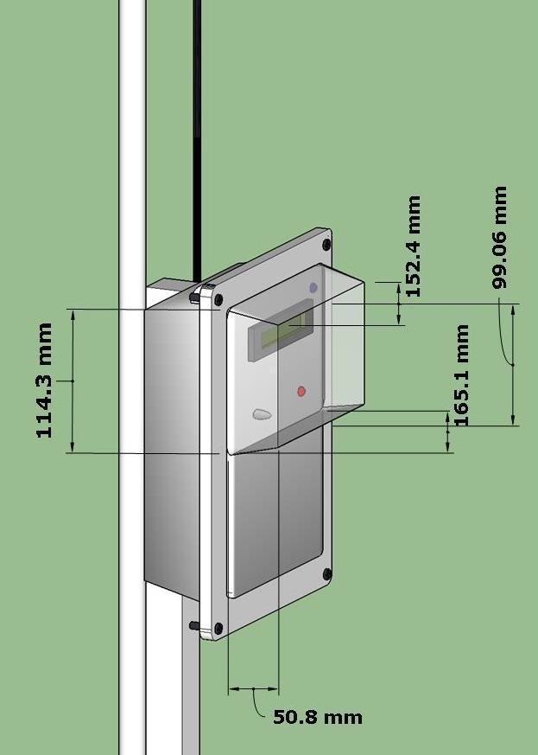

#### Figure 4.3 Wireless Passenger Notification System (PNS) for Tricycle Terminal and Street’s Overall Design and Dimensions (Shield)

Figure 4.3 displays the overall design of the prototype’s shield for both the master node and slave node. The shield part of the prototype is used to protect the mounted components on the casing. Its dimensions in the front part are 99.06mm x

152.4mm for length and width. The dimensions of the rear are 114.3mm x 165.1mm in length and width. Lastly, for its right side, the dimension is 50.8mm.

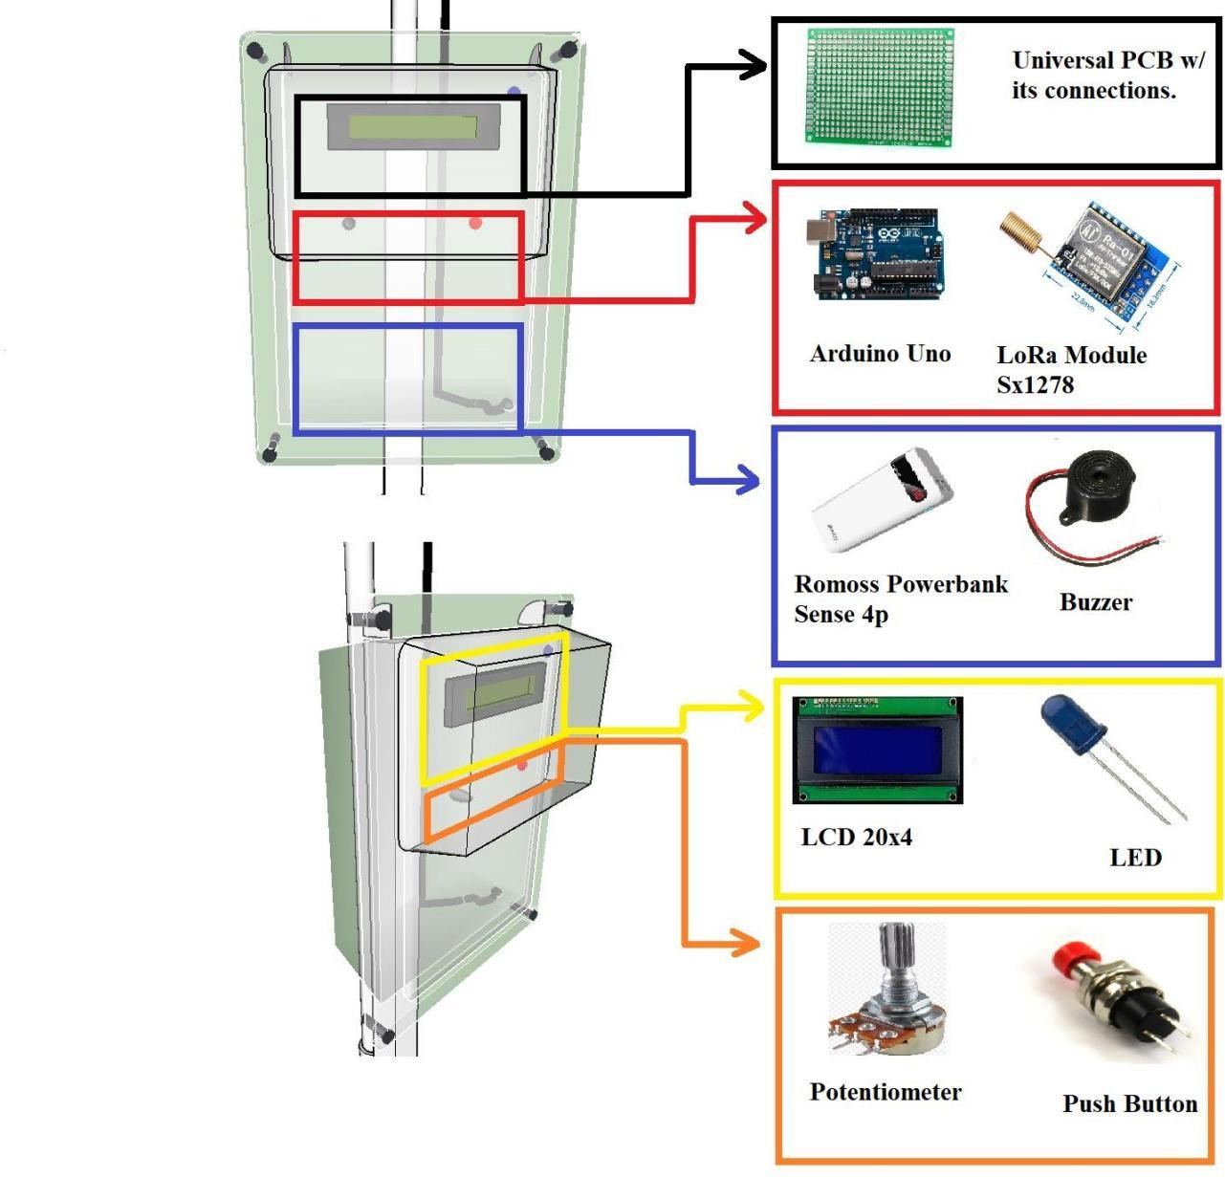

#### Figure 4.4 Placements of Components Inside the Prototype

Figure 4.4 displays the positioning or placements of components inside the casing. All components are strapped in a cage-like plastic making them fixed and secured. The top part of the prototype is a PCB that holds connections of the components. Below the PCB on the right side and situated in the center is the Arduino Uno. The LoRa module is also in the center part and situated on the left side of the prototype. Below are the Romoss Sense 4p power bank on the right side and the buzzer on the bottom left side.

In addition, components mounted in front of the casing are the 20x4 LCDs above the two components. Then, the actuators, push button, and potentiometer are at the center part of the front casing.

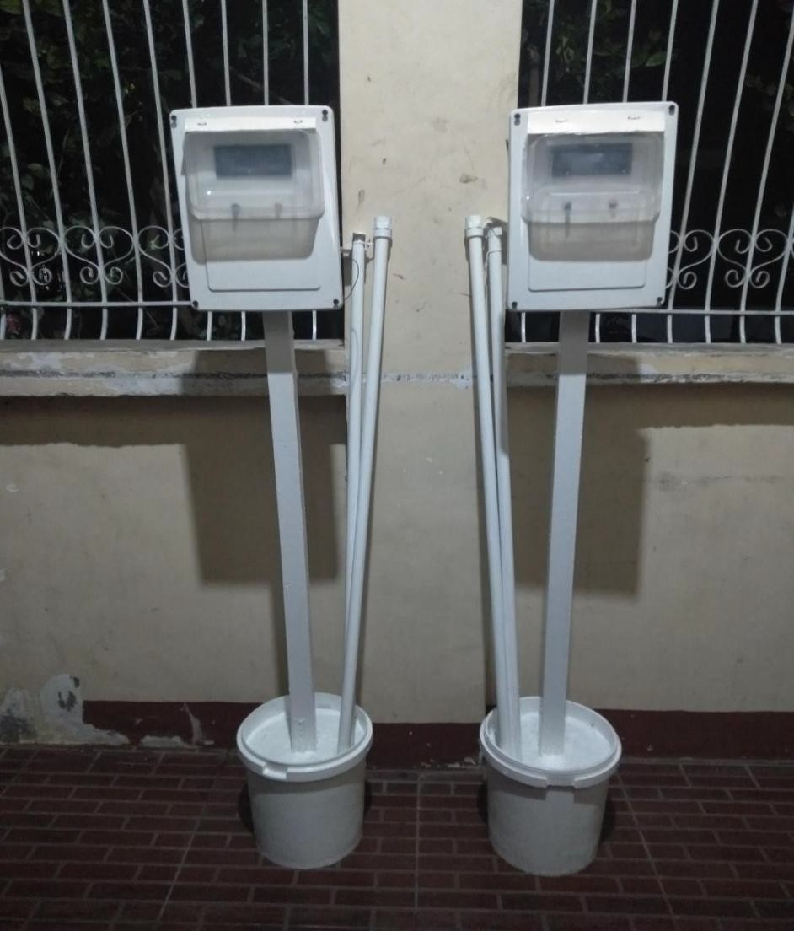

#### Figure 4.5 Actual Prototype of Wireless Passenger Notification System (PNS) for Terminal Station and Street

Figure 4.5 shows the actual appearance of the two Wireless Passenger Notification Systems (PNS), the slave and the master node. Together with the prototype are the four (4) PVC pipes used for the antenna and the bucket-shaped platforms below.

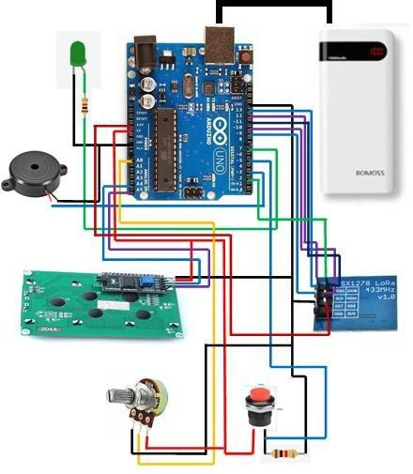

#### Figure 4.6 Pictorial Diagram of Wireless Passenger Notification System (PNS) for Tricycle Driver and Street

Figure 4.6 shows the pictorial diagram of the system of the Wireless Passenger Notification System (PNS) for Tricycle Driver and Street. Since the device used a duplex data communication, the components of the pictorial diagram are similar for both the slave and master nodes. What differs between the slave and the master node was their algorithm where it was most common that the station for the passenger or the slave node will initiate the course of communication between devices.

A potentiometer operates either the passenger’s request or the number of available tricycles from the terminal. The push button serves as the send button for the prototype whenever data is ready to be sent. Arduino UNO R3 processes these data and actions as inputs. Each action on the potentiometer can be viewed on the LCD. When the push button is pressed, the data will be dispatched as packets through the LoRa transceiver module and will be forwarded wirelessly through the antenna to be received by the other device through their antenna and LoRa module. The LED will light up when data is sent successfully. The buzzer will buzz if it receives data from the first device. The second device’s Arduino will process and verify the data received which will be successfully printed on the second device’s LCD. The sending and receiving of data take the same process and system within both devices.

#### System Flowchart

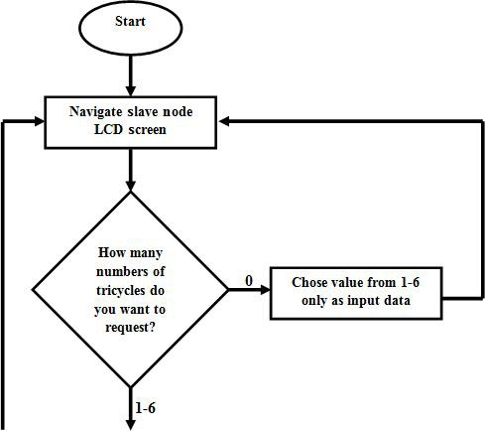

**Figure 4.7.1 System Flowchart**

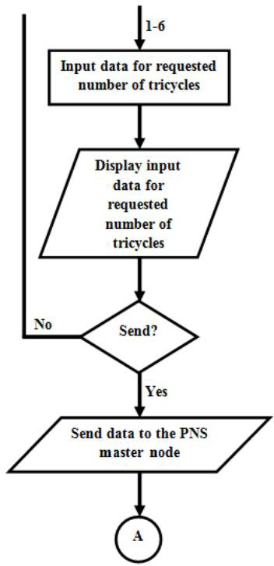

**Figure 4.7.2 System Flowchart**

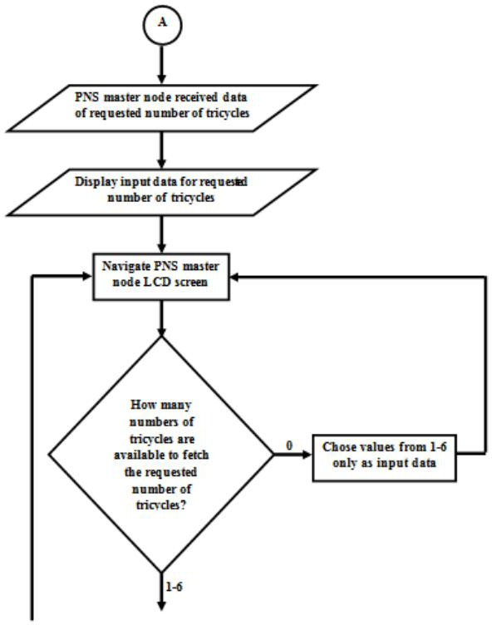

**Figure 4.7.3 System Flowchart**

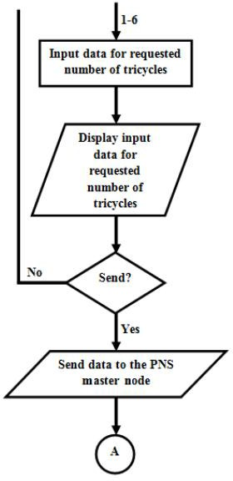

**Figure 4.7.4 System Flowchart**

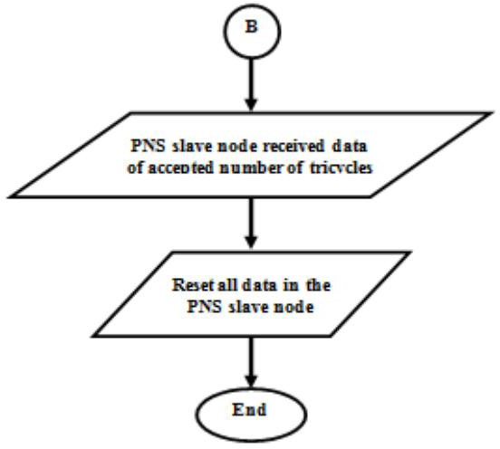

**Figure 4.7.5 System Flowchart**

The system flowchart in Figure 4.7 shows the step-by-step procedure of how the Wireless Passenger Notification System (PNS) for Tricycle Drivers and Street works. Initially, both master and slave devices must be turned on. The system starts with a user configuring the slave node device. The user will be prompted how many tricycles s/he will request from the tricycle terminal. A value from 1 to 6 indicating the number of tricycles will only be accepted and the system will not be accepting a 0 value. The value is displayed on the LCD screen. The send button will send the value entered to the master node. An LED indicator will light up if the value is sent successfully.

If the master node receives a value from the slave node, the buzzer will make a beep sound and the value for the requested number of tricycles will be seen on the master node’s LCD. The user of the master node also needs to navigate the device’s buttons to indicate to the passenger the number of tricycles available in reference

To their request. Inputs must be from 1 to 6 to be valid and 0 value will not be accepted, too. The send button will direct the value to the passenger node and the LED will light up. The buzzer will buzz at the PNS slave node when it receives the data from the master node and the transmitted value will show in the LCD. This means that the value they received from the master node will be the number of tricycles available to pick them up. The system will end up with all values being reset.

#### Program Flowchart

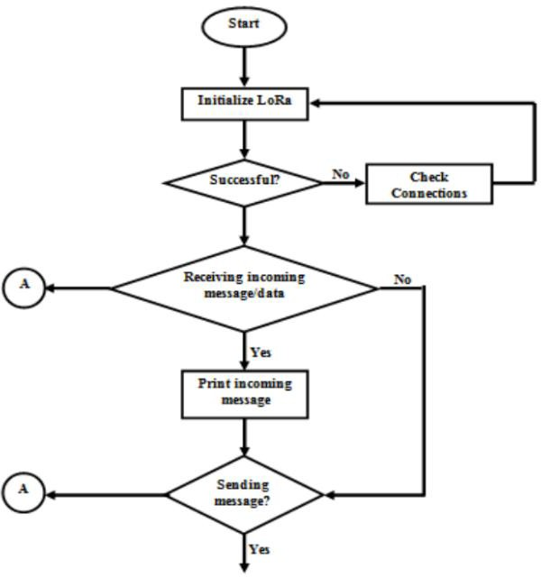

**Figure 4.8.1 Program Flowchart**

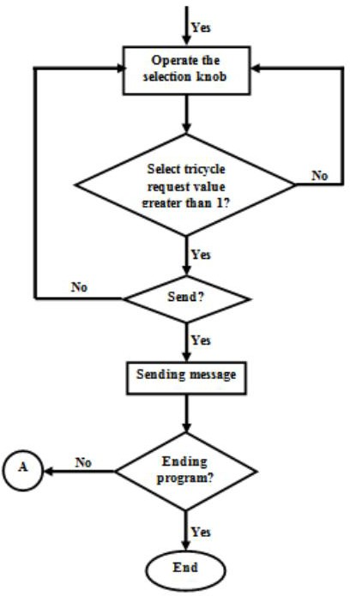

**Figure 4.8.2 Program Flowchart**

Figure 4.8 shows the program flowchart exhibiting how the Wireless Passenger Notification System (PNS) for Tricycle Driver and Street functions. The program was identical for both PNSs except that the navigation that can be configured on the slave node is the number of tricycles requested compared to the master node’s accepted number of tricycles in response to the request of the message from the slave node. The program starts with initializing the LoRa module. If it fails, checking the connections and circuitry of the device might help to fix it. With PNS having a duplex transmission feature, the program executes both receiving and transmitting. The program will always check if there is an incoming message. If there is no incoming message, the program can directly go with the transmitting algorithm. Otherwise, if there is an incoming message, it will be flashed on the display screen and can proceed to the transmitting algorithm. For the transmission algorithm, the selection knob is operated to indicate the response value. Only a value greater than 1 is accepted and using the send button will transmit the value to the other device.

#### Simulations Results

As part of the planning stage, the researchers used radio frequency simulation tools in this study before deploying and testing the actual prototype. Radio Planner 2.1 is a radio planning tool for different technologies such as 3GPP networks from 2G to 5G, land mobile radio networks, radio and television broadcast networks, air-to- ground communication systems, microwave frequencies, and network-based on wireless IoT technologies such as LoRa and SigFox. This helped in checking the possible radiation pattern from the devices.

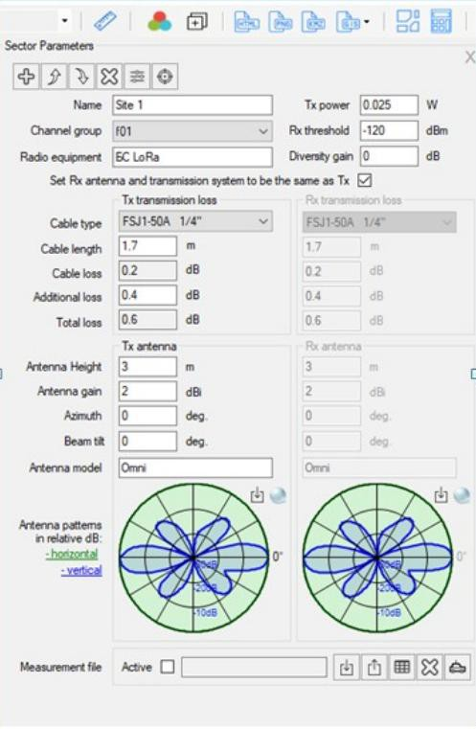

#### Figure 4.9 Radio Planner 2.1 Base Station Simulation Parameters

Figure 4.9 shows the parameters used for the simulation of the Wireless Passenger Notification System (PNS) for Tricycle Driver and Street. A pre-set configuration for LoRa was used as a network for the base station under the unlicensed frequency of 433 MHz.

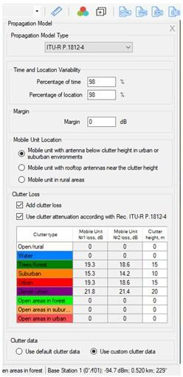

#### Figure 4.10 Radio Planner 2.1 Propagation Model Simulation Parameters

Figure 4.10 has the Radio Planner 2.1 interface for the propagation model parameters of the simulation. The free feature has only the option for ITU-R P.1812-4 Propagation Model Type. “Mobile unit with antenna below clutter height in urban or suburban environments” is used under the Mobile Unit Location. Clutter loss is added as well as the clutter attenuation according to ITU-R P.1812-4 Propagation Model Type.

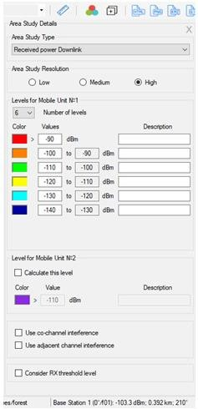

#### Figure 4.11 Radio Planner 2.1 Area Study Unit Simulation Parameters

For the graphical representation of the received strength, the researchers customized the colors for each level in the Area Study Unit section of the Radio Planner 2.1 as shown in Figure 4.11. Red is used for the level above -90 dBm, orange for -100 to -90 dBm, green for -110 to -100 dBm, yellow for -120 to -110 dBm, light blue for -130 to -120 dBm, and dark blue for -130 dBm and -140 dBm. Area study resolution will be better off at the high settings for better pixelation of the simulated propagation.

#### Table 4.1 Summary of the Radio Planner 2.1 Parameters for Simulation

|  |  |
| --- | --- |
| **Parameters** | **Value** |
| **Base Station** | |
| Frequency | 433 MHz |
| Tx Power | 25 mW |
| Radio Equipment | LoRa |
| Rx Threshold | -120 dBm |
| Cable Length | 1.7 m |
| Antenna Height | 3 m |
| Antenna Gain | 2 dBi |
| Antenna Model | Omni |
| **Propagation Model** | |
| Propagation Model Type | ITU-R P.1812-4 |
| Mobile Unit Location | Mobile unit with antenna below clutter height in urban or suburban environments |
| Add clutter loss | Checked |
| Use clutter attenuation according to ITU-R P.1812-4 | Checked |
| **Area Study Details** | |
| Area Study Resolution | High |
| Number of Levels | 6 |

Table 4.1 summarizes the parameters the researchers used to perform the simulation of the Wireless Passenger Notification System (PNS) for Tricycle Driver and Street.

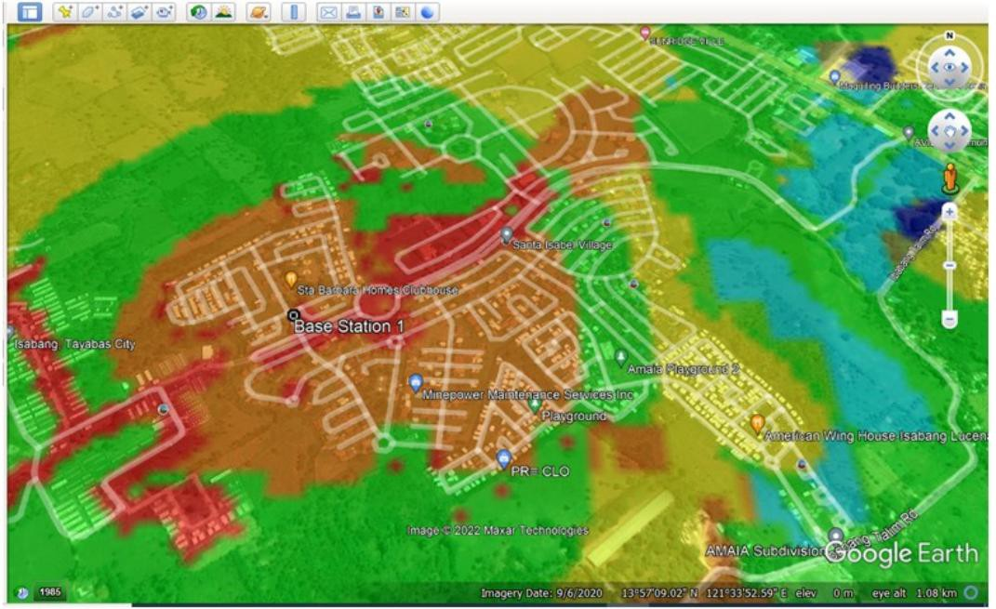

#### Figure 4.12.1 Testing Area

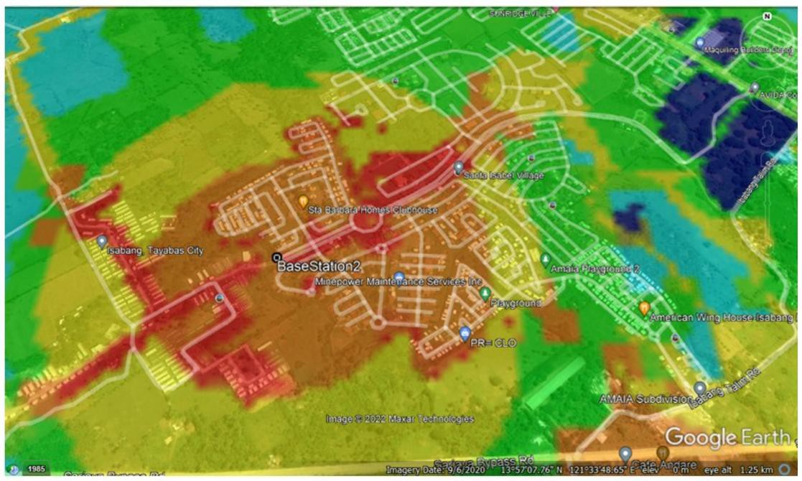

**Figure 4.12.2 Testing Area**

The researchers conducted eight simulations in the possible testing area for the actual simulation, found in Appendix H. Figure 4. 12 displays the simulations of the two chosen test areas for the walk testing. Base station 1 is plotted at coordinate 13.95237500 N, 121.56165278 S while base station 2 is plotted at coordination 13.95163611 N, 121.56087500 S.

#### Walk Testing Data

Walk testing showcases if the system and prototype are functioning well and effective. This assesses the connectivity of the prototype in response to the testing location. The data gathered in the walk testing included the latitude and longitude, displacement and actual distance from the base station, transmission time, Received Signal Strength Indicator (RSSI), and Signal to Noise Ratio (SNR).

The global positioning system was used in the walk testing to gather the latitude and longitude, Google Earth for calculating the displacement and actual distance, and the sketch for walk testing in Appendix I to collect the RSSI and SNR. One trial for transmission time was tested as the average transmission time from slave node to master node and sending back from the master node to the slave node. Three trials were performed for every test location except for the special locations from Table 3.1 with five trials each.

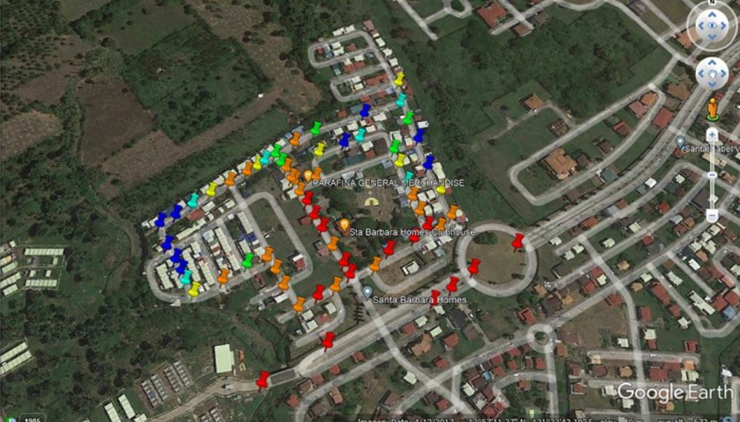

#### Figure 4.13 RSSI Walk Testing Result on the First Testing Location

Figure 4.13 displays the RSSI results of the walk testing on the first testing site located at coordinates 13.95237500 N, 121.56165278 S, similar to the first location on the simulator. The color representation of each location resembles the customization for the RF Planner 2.1 simulation where red signifies the level above -90 dBm, orange for - 100 to -90 dBm, green for -110 to -100 dBm, yellow for -120 to -110 dBm, light blue for -130 to -120 dBm, and dark blue for -130 dBm and -140 dBm. The geographical feature of the walk testing coverage on the first testing area included a lot of two to three-floor houses which depicts the common classification or sub-urban clutters for the radio propagation.

According to the LoRa documentation master file (2022), RSSI is the value of received signal power in milliwatts that signifies how good a receiver can read or hear data coming from a transmitter, which is measured in dBm. The typical LoRa

RSSI values are within -120 dBm wherein -30 dBm signifies that the signal is extremely strong while less than -120 is a weak signal. In the walk testing on the first test area, 77.78% of the RSSI levels were greater than or equal to -120 dBm.

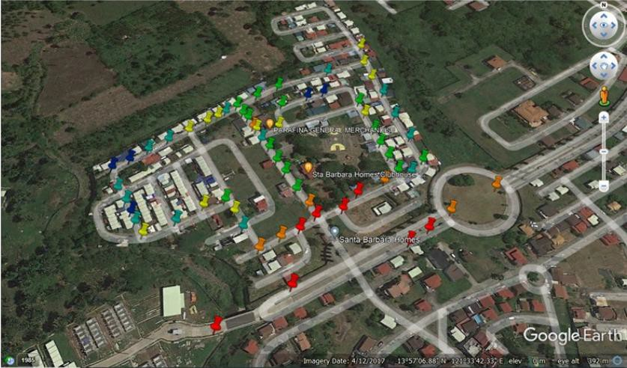

#### Figure 4.14 SNR Walk Testing Result on the First Testing Location

On the same testing site, Figure 4.14 shows the SNR results of the walk testing. The following are the colors and their represented SNR values: red signifies the level above 5 dB, orange for 5 to 0 dB, green for 0 to -5 dB, yellow for -5 to -10 dB, light blue for -10 to -15 dB, and dark blue for less than -15 dB.

According to the LoRa documentation master file (2022), SNR is the ratio of the received power signal over the noise power level. LoRa SNR values are typically between -20 dB and +10 dB whereas values closer to +10 dB indicates that the incoming data or signal is less corrupted. SNR values greater than 0 specify that the

received signal functions above the noise floor while received signals with SNR under 0 function below the noise floor. LoRa can demodulate signals that are -7.5 dB to -20 dB below the noise floor. From the walk testing, 63.49% of the SNR values were above -7.5 dB.

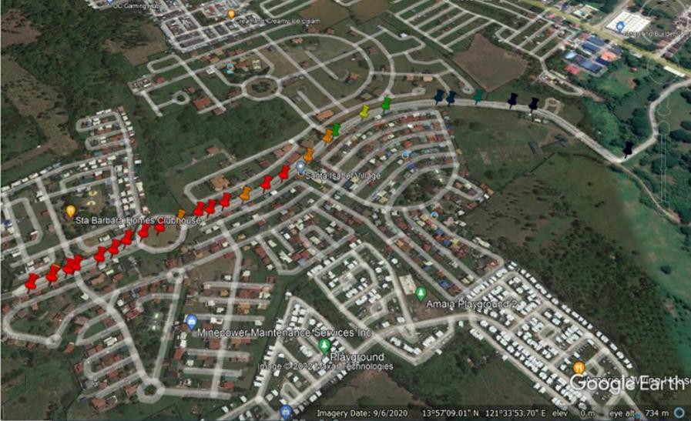

#### Figure 4.15 RSSI Walk Testing Result on the Second Testing Location

The walk testing on the second testing area was intended to measure the prototype’s range and transmission time. Figure 4.15 displays the RSSI results of the walk testing on the second testing site located at coordinates 13.95163611 N, 121.56087500 S, similar to the second location of the simulation. The color representation was alike to the first walk testing with the addition of black if the prototype cannot receive any signal. In the walk testing for the second test area, 78.57% of the RSSI levels were greater than or equal to -120 dBm.

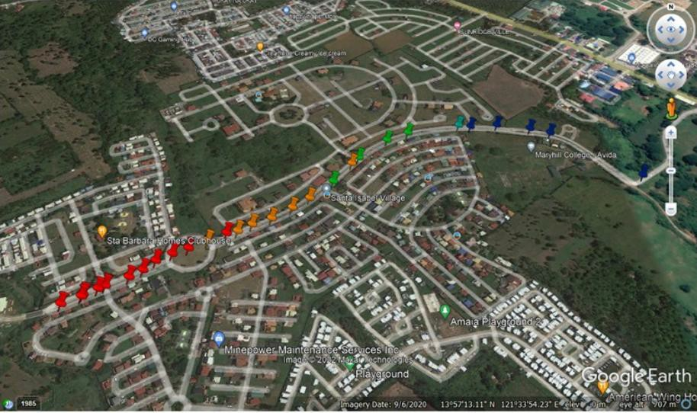

#### Figure 4.16 SNR Walk Testing Result on the Second Testing Location

The walk testing on the second testing area was intended to measure the prototype’s range and transmission time. Figure 4.16 displays the SNR results of the walk testing on the second testing site. The color representation was alike to the first walk testing. In the walk testing for the second test area, 78.57% of the SNR levels were greater than or equal to -7.5 dB.

#### Table 4.2 Transmission Time and Range Result

|  |  |  |  |  |  |  |
| --- | --- | --- | --- | --- | --- | --- |
| **Distance of Transmission (m)** | **Transmission Time (s)** | | | | | |
| **Trials** | | | | | **Average** |
| **1** | **2** | **3** | **4** | **5** |
| 50 | 2.12 | 1.23 | 2.87 | 1.46 | 1.76 | 1.888 |
| 100 | 3.53 | 2.13 | 2.76 | 2.45 | 1.70 | 2.514 |
| 300 | 6.36 | 3.64 | 5.63 | 8.21 | 5.52 | 5.872 |
| 500 | 6.81 | 6.12 | 6.49 | 8.67 | 7.93 | 7.204 |
| 800 | 20.64 | 24.43 | 26.67 | 21.23 | 21.94 | 22.982 |
| 1000 | No Data Received | | | | | |

Table 4.2 presents the transmission time for each distance between the PNS gathered during the walk testing in the second test location. The transmission time spiked above 10 seconds around 700-meter distance and above 20 seconds within the 800-meter mark. The last location where the prototype received data was in the 13.95546111 N, 121.5676722 S coordinate which was 845.76 meters displacement away from the master node (870 m actual distance) with an average of 30.23 seconds transmission time.

#### Results of Data Gathering from Questionnaire

**Table 4.3 Results of Data Gathering from Questionnaire**

|  |  |  |  |  |  |  |  |
| --- | --- | --- | --- | --- | --- | --- | --- |
|  | Number of Frequency | | | | | Weighted Mean | Qualitative Description |
| 5 | 4 | 3 | 2 | 1 |
| I. DESIGN | | | | | | | |
| 1. The design of the prototype is durable/robust. | 28 | 2 | 0 | 0 | 0 | 4.93 | Highly Accepted  (HA) |
| 2. The prototype itself can be used conveniently or accessed easily. | 24 | 6 | 0 | 0 | 0 | 4.8 | Highly Accepted  (HA) |
| 3. The design of the prototype is built water-resistant. | 25 | 5 | 0 | 0 | 0 | 4.83 | Highly Accepted  (HA) |
| 4.The prototype is easy to use and configure. | 22 | 7 | 1 | 0 | 0 | 4.7 | Highly Accepted  (HA) |
| 5.Information in the LCD is clearly shown and can be read. | 29 | 1 | 0 | 0 | 0 | 4.97 | Highly Accepted (HA) |
| II. FUNCTIONALITY | | | | | | | |
| 1. The transmission of the prototype works properly. | 26 | 4 | 0 | 0 | 0 | 4.87 | Highly Accepted (HA) |
| 2. In using both the transceiver, the LCD shows and sends information accurately. | 26 | 4 | 0 | 0 | 0 | 4.87 | Highly Accepted  (HA) |

|  |  |  |  |  |  |  |  |
| --- | --- | --- | --- | --- | --- | --- | --- |
| 3. The actuators are seamlessly in sync with the LCD and sending information. | 24 | 6 | 0 | 0 | 0 | 4.8 | Highly Accepted (HA) |
| 4. The prototype sends information in long range. | 24 | 6 | 0 | 0 | 0 | 4.8 | Highly Accepted  (HA) |
| 5. The prototype can transmit data without using cellular or Wi-Fi modules. | 27 | 3 | 0 | 0 | 0 | 4.9 | Highly Accepted (HA) |
| III. EFFECTIVENESS | | | | | | | |
| 1. The prototype gives ease to passengers and tricycle drivers in terms of cost. | 25 | 5 | 0 | 0 | 0 | 4.83 | Highly Accepted (HA) |
| 2. Transportation can be accessed in far- flung streets and stationed in tricycle terminals. | 28 | 2 | 0 | 0 | 0 | 4.93 | Highly Accepted (HA) |
| 3. The device lessens human effort or promotes convenience for both passengers and tricycle drivers. | 26 | 4 | 0 | 0 | 0 | 4.87 | Highly Accepted (HA) |
| 4. The prototype can be used in various places. | 26 | 4 | 0 | 0 | 0 | 4.87 | Highly Accepted  (HA) |
| 5. The device minimizes common problems encountered in transportation. | 26 | 4 | 0 | 0 | 0 | 4.87 | Highly Accepted  (HA) |
| Average Weighted Mean | | | | | | 4.86 | Highly Accepted  (HA) |

Table 4.3 shows results gathered from the questionnaire, aiming to address the objective of the study to evaluate the design, functionality, and effectiveness of the prototype. The respondents were 10 tricycle drivers 20 passengers from Avida Isabang, Tayabas City. Based on the gathered data, the researchers tallied the number of frequencies and computed the weighted mean for each of the criteria resulting to the average weighted mean. The researchers used Table 3.3 (in Chapter III) to determine

the qualitative description based on the range interval as groundwork for the

interpretation of the 30 respondents. In addition, Likert scale was used for the respondents’ options on a scale of 5 to 1, with 5 as the highest rating and 1 as the lowest.

According to the results in terms of effectiveness, the respondents strongly agreed to the Wireless Passenger Notification System for Tricycle Terminal and Street. Most of the respondents agreed that the prototype was effective and convenient. Second, for functionality, the respondents also strongly agreed as the prototype worked, functioned consistently, and transmitted data. For the last criterion which is design, the respondents likewise strongly agreed as it was built durable and the information displayed was clear.

In addition, the Wireless Passenger Notification System for Tricycle Terminal and Street was highly rated based on the gathered data. In terms of design, functionality, and effectiveness, it performed seamlessly. As it was aimed for the convenience of the respondents, the overall criteria were highly rated.

#### Materials and Tools

This part shows the hardware (components and materials) and the software used by the researchers in the creation and operation of the prototype.

#### Hardware

This contains the physical components and materials for the system.

#### Table 4.4 Components of the System

|  |  |  |
| --- | --- | --- |
| **Component** | **Specification** | **Function** |
| **ARDUINO UNO** | * Microcontroller: ATmega328 * Operating Voltage: 5V * Input Voltage (recommended): 7-12V * Input Voltage (limits): 6- 20V * Digital I/O Pins: 14 (of which 6 provide PWM output) * Analog Input Pins: 6 * DC Current per I/O Pin: 40 mA * DC Current for 3.3V Pin: 50 mA * Flash Memory: 32 KB of which 0.5 KB used by bootloader * SRAM: 2 KB   (ATmega328)   * EEPROM: 1 KB   (ATmega328)   * Clock Speed: 16 MHz | A microcontroller board based on the ATmega328,  Arduino is an open-source, prototyping platform and its simplicity makes it ideal for hobbyists to use as well as professionals.  It is connected to the LCD, the LORA module, the pushbutton, the potentiometer, the LED, and the buzzer. It is the main component that runs the system. |

|  |  |  |
| --- | --- | --- |
|  | * Display Format: 20 Characters x 4 Lines | The 20x4 LCD display is essentially a larger version (in terms of number of rows and columns) of the 162 LCD display, which have already been used by the researchers in a lot of projects.  It can display 20 columns of characters on four rows, making it ideal for presenting vast amounts of text without having to scroll. It displays the Options and the value to be adjusted by the actuator. |
|  | * Dot Matrix (w x h): 5 x 8 Dots |
|  | * Character Size (w x h):   2.95 x 4.75 mm |
|  | * Character Pitch (w x h):   3.55 x 5.35 mm |
|  | * LCD Driver IC: Sitronix ST7066U (or equivalent) |
|  | * Interface: 4-bit Parallel and 8-bit Parallel * LCD Module Dimensions (w x h x d): 98 x 60 x 13.6 (MAX) mm |
| **20x4 LCD SCREEN** | * Viewing Area (w x h): 77 x   25.2 mm |
|  | * Dot Size (w x h): 0.55 x   0.55 mm |
|  | * Dot Pitch (w x h): 0.6 x   0.6 mm |
|  | * Driving Method: 1/16 Duty |
|  | * Operating Temperature: - 20 ~ 70°C |
| **LoRa Module** | * Operating Voltage: 3.3V * Half-Duplex SPI Communication * Operating Frequency: 433Mhz * Modulation Technique FSK, GFSK, MSK,GMSK, LoRa | The LoRa SX1278 works with SPI communication protocol so it can be used with any micro controller that supports SPI. |

|  |  |  |
| --- | --- | --- |
| **PUSH BUTTON** | * Current Rating: 0.5 Amps * Brand: DIYhz * Switch Style: Metal, Push Button Switch * Material: Plastic, Metal * Actuator Type: Push Button * Controller Type: Push Button * Color: Red | The push button was used to send signal between the two prototypes. |
| **POTENTIOMETER** | * Type: Single Linear (Type B);Features : Knurled Shaft;Shaft Diameter : 6mm / 0.23" * Shaft Length: 13.5mm / 0.53";Thread Dia : 7mm / 0.27";Base Height : 8mm / 0.31" * Base Diameter: 15mm / 0.6";Material : Metal w Electronic Parts * Weight: 36g; Package: 5 x Potentiometer | The potentiometer was used as the actuator that adjusts the value presented in the LCD. |
| **BUZZER** | * Rated Voltage: 6V DC * Operating Voltage: 4-8V DC * Rated Current: <30mA * Sound Type: Continuous Beep * Resonant Frequency:   ~2300 Hz   * Small and neat sealed package * Breadboard and Perf board friendly | The buzzer served as an indicator of data transferred. |

|  |  |  |
| --- | --- | --- |
| **LED** | * Max. Forward Voltage: 1.8-2.1V * Max. Reverse Voltage: 5V * Max. Forward Current: 220mA * Max. Reverse Current: 10 UA * Foot Type: long foot * Size: 5mm | The LED Lights up for every transmission of data. |
| **POWER BANK** | * Brand: Romoss * Power Bank Capacity Size: 10001 - 20000mAh | The power bank served as the power supply for the prototype. |

The components used in the system are listed in Table 4.4. The image and name of the components are displayed in the first column. The components’ specifications are listed in the second column. The explanation of how the component was utilized in the system and prototype appears in the third column.

#### Software

Software is the program which commands the specific components to perform specific tasks. It functions as the hardware’s brain and the conduit for user applications to the system.

**Table 4.5 Software Tools**

|  |  |
| --- | --- |
| **SOFTWARE** | **DESCRIPTION** |
| **ARDUINO IDE** | Arduino IDE is a software application used to program the LCD, LoRa module, the indicators, and the actuators. |
| **Google Earth** | Google Earth is a software that replicates the Earth based on 3D representations of satellite imageries.  This was used in the study as the mapping tools of the simulation and walk testing results. |
| **Radio Planner 2.1** | A simulation software from Center of Telecommunication Technologies, LLC that simulates different wireless technologies’ radio propagation, this was used in the study to simulate possible radio propagation of different parameters in a specific location. |

**Chapter V**

### SUMMARY, CONCLUSIONS, AND RECOMMENDATIONS

This chapter discusses the summary, findings, and conclusions obtained by the researchers upon undertaking the necessary tests, observations, analysis, and interpretations of results as obtained from the investigations in the study. Recommendations were also formulated for further improvement and development of the study.

#### Summary

“Wireless Passenger Notification System (PNS) for Tricycle Driver and Street” aimed to develop a system and device that can notify tricycle terminals that a passenger is waiting on a certain street. The research was conducted among 30 selected respondents based on purposive and convenience sampling to evaluate the overall performance and quality of the prototype. Specifically, these respondents were 10 tricycle drivers and 20 local passengers. This study covered a period of nine (9) months, starting from the latter part of September 2021 up to May 2022.

#### Findings

After obtaining the desired results from the whole process of the study, the researchers came up with the following findings:

In designing the prototype, a lot of factors were considered in choosing the materials, such as the type of LoRa module to be used, available and legal frequency to be used in a specific area, antenna type and specifications, microcontroller, and other materials like for the exterior and structural design. Choosing what works for a location was crucial to the prototype’s effectiveness.

The main function of the Wireless Passenger Notification System (PNS) for Tricycle Driver and Street was to send data to their end-to-end nodes. Checking which location was most suited to place the nodes had been vital to conduct a walk test that included measuring the parameters Received Signal Strength Indicator (RSSI) and Signal to Noise Ratio (SNR) of the prototype’s LoRa network. These parameters varied on the location and simulating radio propagation aided in improving the preparations in choosing a better testing area.

With a master node PNS at coordinates 13.95237500 N, 121.56165278 S, the result for the walk testing for the first test location showed 77.78% of the RSSI levels were greater than or equal to -120 dBm while 63.49% of the SNR values from the walk testing were above -7.5 dB. The second test location was used for range testing where master node PNS was stationed at coordinates 13.95163611 N, 121.56087500 S.

In this walk testing, 78.57% of the RSSI levels measured were greater than or equal to -120 dBm while 78.57% of the SNR levels were greater than or equal to -7.5 dB. The transmission time for the first 700 meters was less than 10 seconds and increased to 20 seconds within the 800-meter distance. The prototype received its last data 845.76 meters displacement away from the master node (870 m actual distance) with an average of 30.23 seconds transmission time.

Thirty (30) people sampled the prototype deployed in Tayabas, Quezon to check its functionality, efficiency, and convenience in using it. Most of the respondents agreed that the prototype was effective and easy to use.

#### Conclusions

Based on the findings, it was concluded that a device which can assist in transportation by notifying tricycle terminals when a passenger requests for a tricycle on a certain street has been developed. Operating the device was easy to understand making the prototype usable for people of almost all ages.

The range and transmission time of the prototype depended on the materials used and the location of deployment. Factors considered were choosing the LoRa module for configurations with and without LoRaWAN, the unlicensed frequency with a bigger range with lower bandwidth or with a smaller range and higher bandwidth, high-gain antenna or low-gain antenna, Arduino or Raspberry Pi, etc.

Simulating and walk testing had been useful in determining the best location to deploy the PNS and it enabled determining if the prototype and its system were effective and functioning well.

#### Recommendations

For the improvement and development of the study, the following are hereby recommended:

1. Improvements can be done with the modification of using a better antenna, higher antenna height, and LoRa module to improve the functionality of the prototype and its parameters such as transmission range and time.
2. Future researchers who might want to immerse in this kind of technical research in the future could study the application of LoRaWAN in this prototype to maximize the transmission range and time of the LoRa technology.
3. A more complex network architecture may be created using multiple slave nodes and master nodes that will cater to more requesting stations for passengers and multiple terminals.
4. User experience may be enhanced by improving the button and screen operability. The use of a better screen such as a touchscreen LCD with a good UI can give ease to the device’s user. A guide on how to use the prototype must also be printed on the device so that new users can quickly understand how the device works.
5. Solar energy can be used as the power source of the device so that the recharging of the battery can be automated using solar panels.

#### Reference Cited

Arduino. (2019, October 05). Arduino and RF transmitter receiver module. Retrieved December 08, 2021, from [https://www.electronicshub.org/arduino-rf-transmitter-](https://www.electronicshub.org/arduino-rf-transmitter-receiver-module/) receiver-module/

AVSystem. (2020, June 09). What is narrowband IoT? NB-IOT Overview. Retrieved April 14, 2022, from https://[www.avsystem.com/blog/narrowband-iot](http://www.avsystem.com/blog/narrowband-iot)

Balinski, R. (2015). Modes of transportation in the Philippines. Retrieved December 08, 2021, from <http://preparetoserve.com/blog/modes-of-transportation-in-the-> philippines/

Behrtech. (2021, September 07). 6 leading types of IoT wireless technologies and their best use cases. Retrieved April 14, 2022, from https://behrtech.com/blog/6-leading- types-of-iot-wireless-tech-and-their-best-use-cases/

Dacai. (2017, April 5). Localization tracking system based on LoRa transmission.

Retrieved December 11, 2021, from https://worldwide.espacenet.com/patent/search/family/058442673/publication/CN2 06077690U?q=CN206077690U

Dacai. (2017, January 4). Locating and tracking system and method based on LoRa transmission. Retrieved December 11, 2021, from https://worldwide.espacenet.com/patent/search/family/057717305/publication/CN1 06303970A?q=CN106303970A

Dunmur, D. (2015). Liquid crystal display. Retrieved April 17, 2022, from https://[www.britannica.com/technology/liquid-crystal-display](http://www.britannica.com/technology/liquid-crystal-display)

Elecrow. (2021). 433MHz RF Transceiver CC1101 module. Retrieved December 08, 2021, from https://[www.elecrow.com/433mhz-rf-transceiver-cc1101-module-p-](http://www.elecrow.com/433mhz-rf-transceiver-cc1101-module-p-) 374.html

Electro Wings. (2018). ESP8266 WIFI module: Sensors & modules. Retrieved December 08, 2021, from https://[www.electronicwings.com/sensors-modules/esp8266-wifi-](http://www.electronicwings.com/sensors-modules/esp8266-wifi-) module

EVG. (2016). Elaia Green Vehicles. Retrieved December 08, 2021, from https://[www.egv.ph/](http://www.egv.ph/)

Fang. (2017, May 31). LORA and GPRS-based remote data transmission communication technology. Retrieved December 11, 2021, from https://worldwide.espacenet.com/patent/search/family/058957889/publication/CN1 06781403A?q=CN106781403A

FFE. (2017). Filipino icon: Tricycle and pedicab. Retrieved December 08, 2021, from <http://ffemagazine.com/filipino-icon-tricycle-pedicab/>

Flores, J. L. (2013). 5 modes of transportation found only in the Philippines. Retrieved December 08, 2021, from https://[www.skyscanner.com.ph/news/5-modes-](http://www.skyscanner.com.ph/news/5-modes-) transportation-found-only-philippines

Gabriel. (2019, August 30). An introduction to Sigfox technology – Basics, architecture and security features. Retrieved April 14, 2022, from https://circuitdigest.com/article/what-is-sigfox-basics-architecture-and-security- features

Gajjar. (2017). Capacitive sensor. Retrieved December 11, 2021, from https://[www.sciencedirect.com/topics/computer-science/capacitive-sensor](http://www.sciencedirect.com/topics/computer-science/capacitive-sensor)

GFG. (2021, September 27). Potentiometer - Definition, working principle, types.

Retrieved April 17, 2022, from https://[www.geeksforgeeks.org/potentiometer-](http://www.geeksforgeeks.org/potentiometer-) definition-working-principle-types/

Hall. (2017, June 22). Method for requesting transportation services. Retrieved December 11, 2021, from https://worldwide.espacenet.com/patent/search/family/040844988/publication/US2 017180936A1?q=US2017180936A1

Hanczor. (2021, March 4). Enhanced transit location systems and methods. Retrieved December 11, 2021, from https://worldwide.espacenet.com/patent/search/family/074679315/publication/US2 021061326A1?q=US2021061326A1

Hettich. (2005, February 17). Wireless data communications system for a transportation vehicle. Retrieved December 11, 2021, from https://worldwide.espacenet.com/patent/search/family/026851783/publication/US2 005039208A1?q=US2005039208A1

Hughes. (2016). Understanding and implementing the HC-12 wireless transceiver module

- projects. Retrieved December 08, 2021, from https://[www.allaboutcircuits.com/projects/understanding-and-implementing-the-hc-](http://www.allaboutcircuits.com/projects/understanding-and-implementing-the-hc-) 12-wireless-transceiver-module/

Jong Ha. (2020, August 5). GPS position tracking system and tag using LoRa communication. Retrieved December 11, 2021, from https://worldwide.espacenet.com/patent/search/family/072041649/publication/KR2 0200093276A?q=KR20200093276A

Khatri. (2018, January 26). Push button LED circuit. Retrieved April 17, 2022, from https://circuitdigest.com/electronic-circuits/push-button-led-circuit/

Kumari. (2017, July 23). Introduction to Bluetooth technology: How it works? Retrieved April 14, 2022, from https://[www.electronicsforu.com/videos-](http://www.electronicsforu.com/videos-) slideshows/bluetooth-technology

Lora.readthedocs.io. (2022). Signal-to-Noise Ratio (SNR). Retrieved June 9, 2022, from https://lora.readthedocs.io/en/latest/#rssi

Madaan. (2013). Power Bank – Power on-the-go (part 1) | electronic design. Retrieved April 17, 2022, from https://[www.electronicdesign.com/technologies/portable-](http://www.electronicdesign.com/technologies/portable-) power-management/article/21196452/power-bank-power-onthego-part-1

Malig, J. (2010). Motorcycles rule Philippine roads | ABS-CBN news. Retrieved December 8, 2021, from https://news.abs-cbn.com/lifestyle/10/14/10/motorcy

cles-rule-philippine-roads

Olsson. (2017). LoRa and LoRaWAN. In *Exploring LoRa and LoRaWAN A suitable protocol for IoT weather stations?* (pp. 1-61). Gothenburg, Sweden: Chalmer's University of Technology.

Pangilinan. (2019). Press release - Pangilinan bats for Magna Carta for dignified commuting. Retrieved December 08, 2021, from [http://legacy.senate.gov](http://legacy.senate.gov/)

.ph/press\_release/2019/0728\_pangilinan1.asp

Parida. (2011, January 11). A review of Solar Photovoltaic Technologies. Retrieved December 11, 2021, from https://[www.sciencedirect.com/science/article/abs/pii/S1364032110004016](http://www.sciencedirect.com/science/article/abs/pii/S1364032110004016)

Pendergast, R., Santos, R., Dragon, Anderson, J., Javier, Dark, . . . Togepi. (2021, September 22). RF 433mhz transmitter/receiver module with Arduino. Retrieved December 08, 2021, from https://randomnerdtutorials.com/rf-433mhz-transmitter- receiver-module-with-arduino/

PH RS. (2021). Wi-Fi modules. Retrieved December 08, 2021, from https://ph.rs- online.com/web/c/semiconductors/communication-wireless-module-ics/wi-fi- modules/

Qadir et al. (2018). Low power wide area networks. Retrieved December 8, 2021, from https://core.ac.uk/download/pdf/211504586.pdf

Quan. (2018, December 21). Large data transmission method, terminal and server in lora communication system. Retrieved December 11, 2021, from https://worldwide.espacenet.com/patent/search/family/064686908/publication/CN1 09067892A?q=CN109067892A

Rlogiacco. (2015, September 23). Nrf24 walk through – Introduction. Retrieved December 08, 2021, from https://rlogiacco.wordpress.com/2015/09/21/nrf24-walk- through-introduction/

Semtech. (2020). What are Lora® and Lorawan®? Retrieved December 08, 2021, from https://lora-developers.semtech.com/documentation/tech-papers-and-guides/lora- and-lorawan

Stark. (2021). Telecommunication. Retrieved December 08, 2021, from https://[www.britannica.com/technology/telecommunication](http://www.britannica.com/technology/telecommunication)

Teja. (2021, October 06). What is a sensor? Different types of sensors, applications. Retrieved December 08, 2021, from https://[www.electronicshub.org/different-](http://www.electronicshub.org/different-) types-sensors/

Teja. (2021, September 09). Wireless communication: Introduction, types and applications. Retrieved December 08, 2021, from https://[www.electronicshub.org/wireless-communication-introduction-types-](http://www.electronicshub.org/wireless-communication-introduction-types-) applications/

Thakur. (2020, August). Data Communication - What is data communication? Retrieved December 08, 2021, from https://ecomputernotes.com/computernetworkingnotes/communication- networks/what-is-data-communication

The Things Network. (2021). Frequency plans by country. Retrieved December 08, 2021, from https://[www.thethingsnetwork.org/docs/lorawan/frequencies-by-country/](http://www.thethingsnetwork.org/docs/lorawan/frequencies-by-country/)

The Things Network. (2021, April 29). What are Lora and Lorawan? Retrieved December 08, 2021, from https://[www.thethingsnetwork.org/docs/lorawan/what-is-](http://www.thethingsnetwork.org/docs/lorawan/what-is-) lorawan/

Thread Group Org. (2022). Thread certified products. Retrieved April 14, 2022, from https://[www.threadgroup.org/What-is-Thread/Thread-](http://www.threadgroup.org/What-is-Thread/Thread-) Benefits#:~:text=Thread%20is%20a%20low-power%20and%20low- latency%20wireless%20mesh,of%20failure%20and%20include%20the%20ability

%20to%20self-heal.

Uy. (2021, June 17). Understanding wi-fi and how it works. Retrieved April 14, 2022, from https://[www.lifewire.com/what-is-wi-fi-2377430](http://www.lifewire.com/what-is-wi-fi-2377430)

Xiaoming. (2017, July 14). LoRa image acquisition transmission system. Retrieved December 11, 2021, from https://worldwide.espacenet.com/patent/search/family/059293845/publication/CN2 06332736U?q=CN206332736U

Yue. (2018, June 22). LoRa wireless module, data transmission system and data transmission method. Retrieved December 11, 2021, from https://worldwide.espacenet.com/patent/search/family/062592319/publication/CN1 08200573A?q=CN108200573A

**APPENDICES**

# APPENDIX A

## Letters

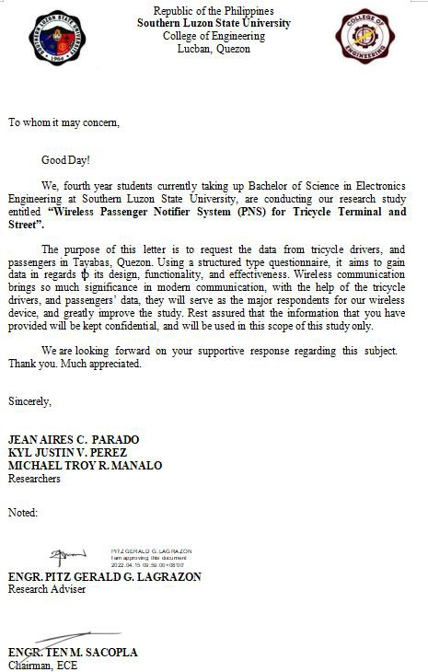

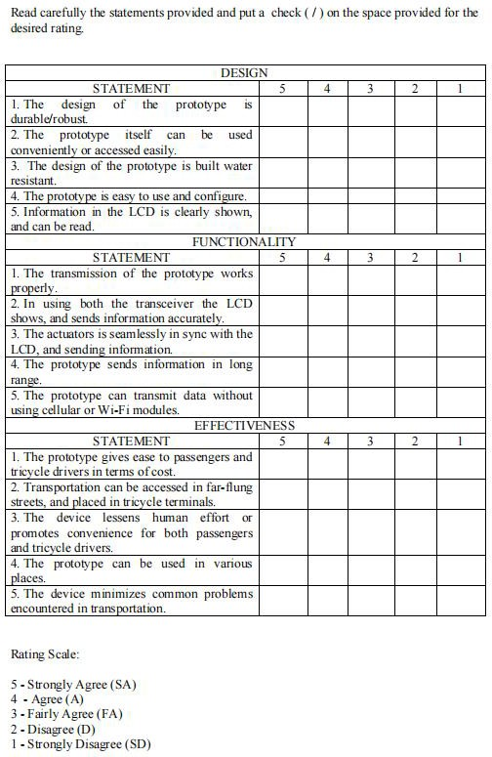

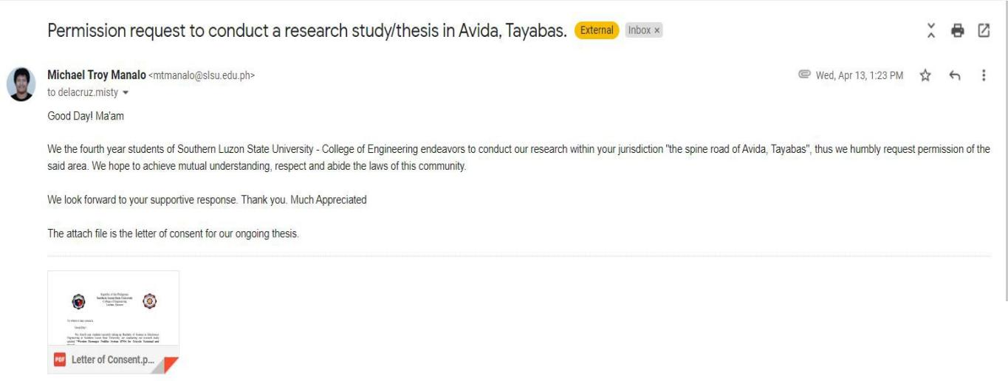

Figure A.1 Letter of Request for Data Gathering



Figure A.2 Letter of Approval

# APPENDIX B

## Isometric View

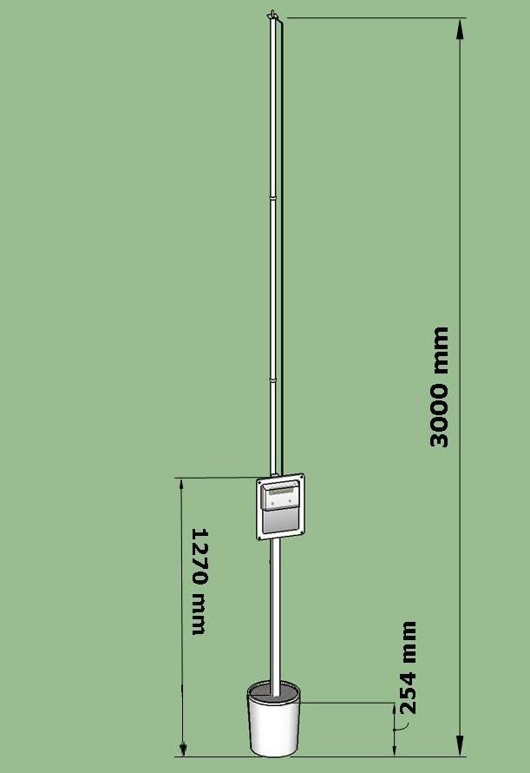

**Figure B.1 Overview Design of the Prototype (Top to Bottom)**

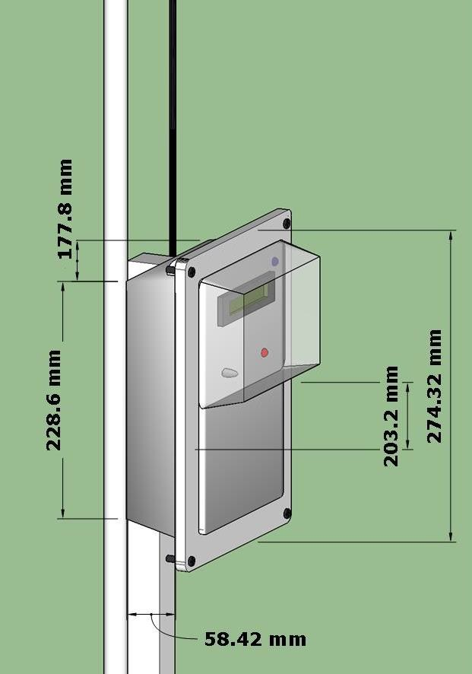

**Figure B.2 Overview Design of the Prototype (Casing)**

**Physical Dimensions of the Prototype**

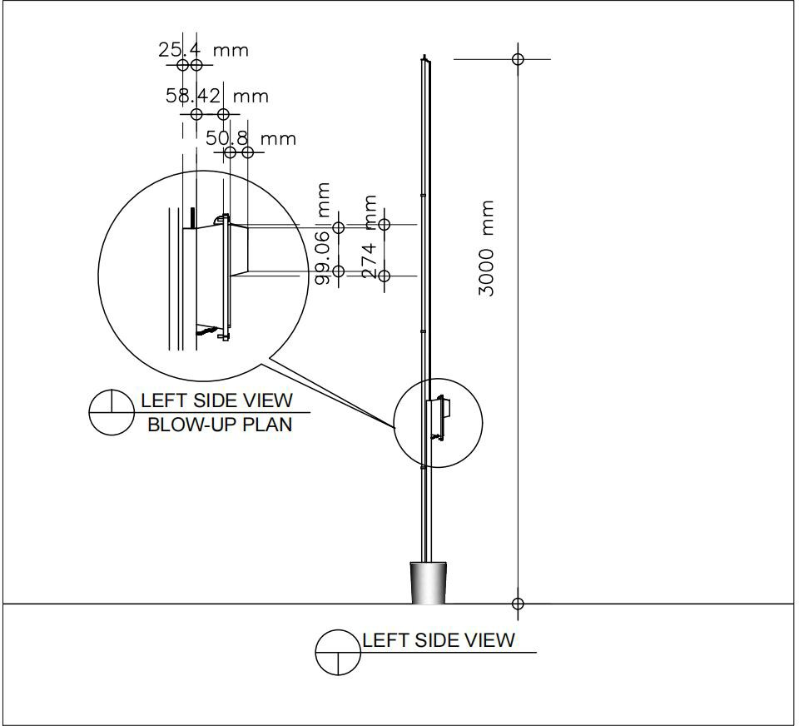

**Figure B.3 Left Side View**

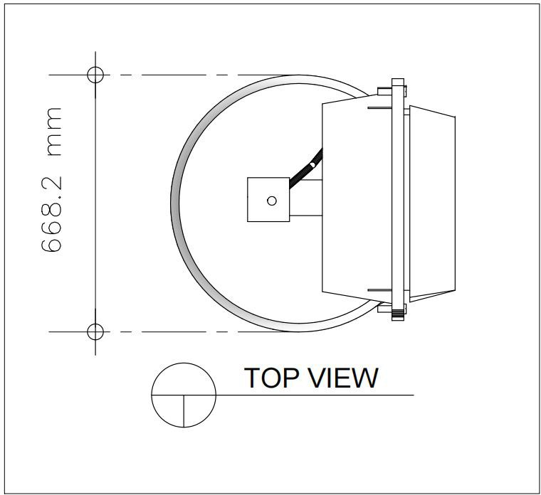

**Figure B.4 Top View**

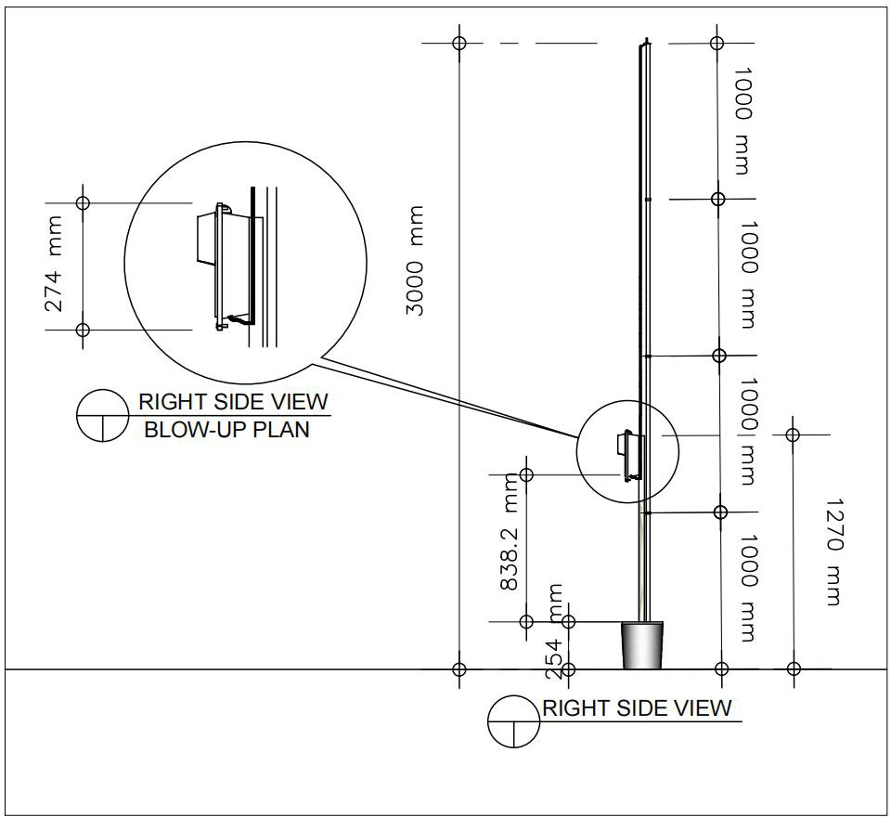

**Figure B.5 Right Side View**

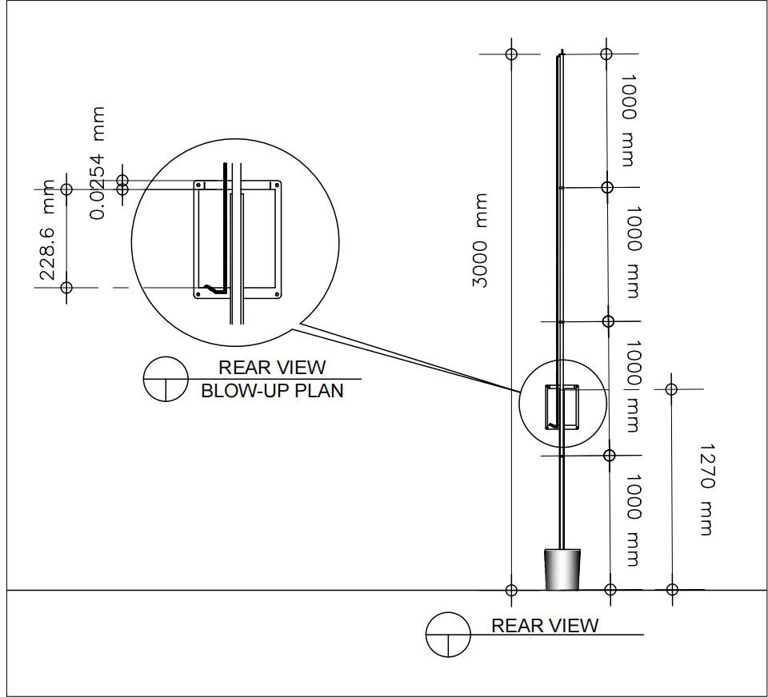

**Figure B.6 Rear View**

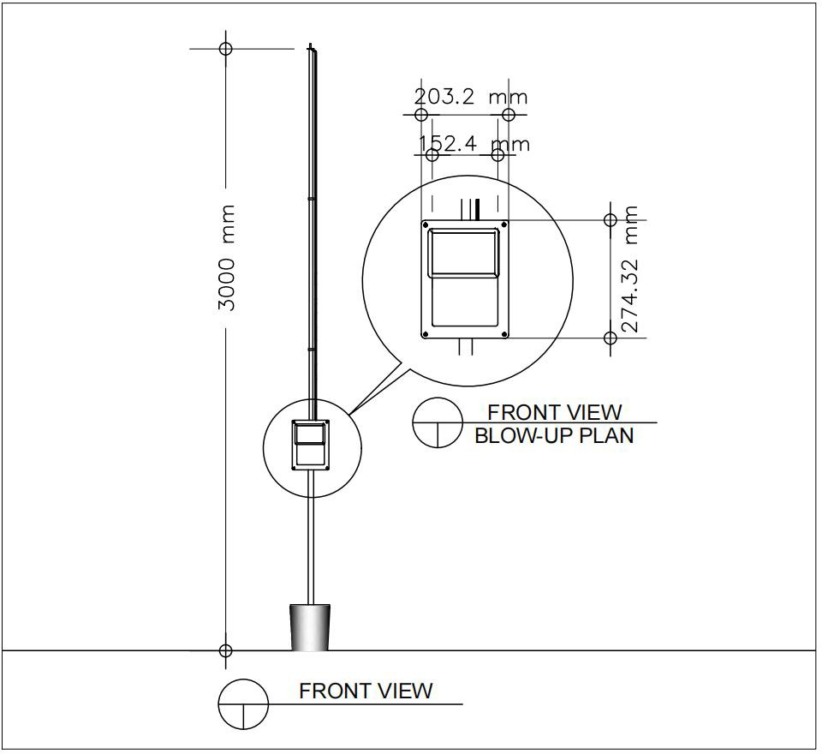

**Figure B.7 Front View**

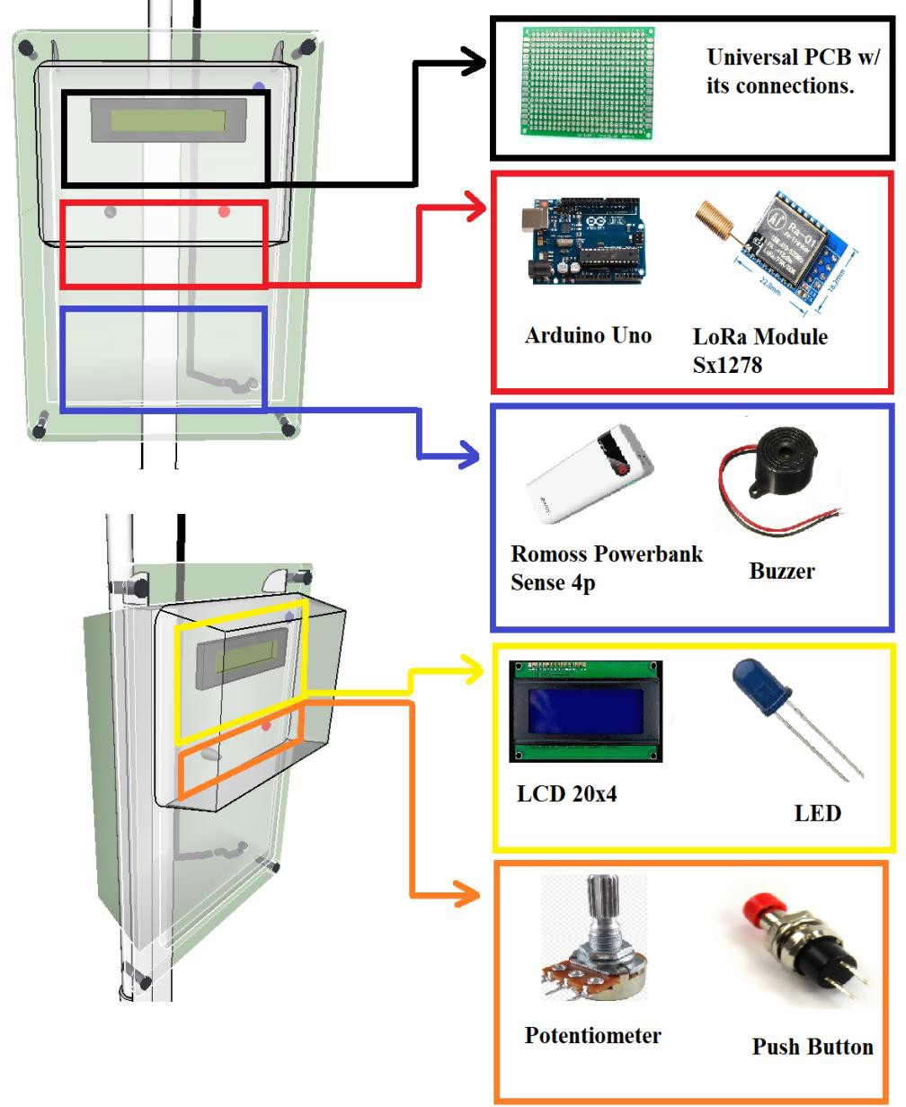

**Figure B.8 Placement of Components Inside the Prototype**

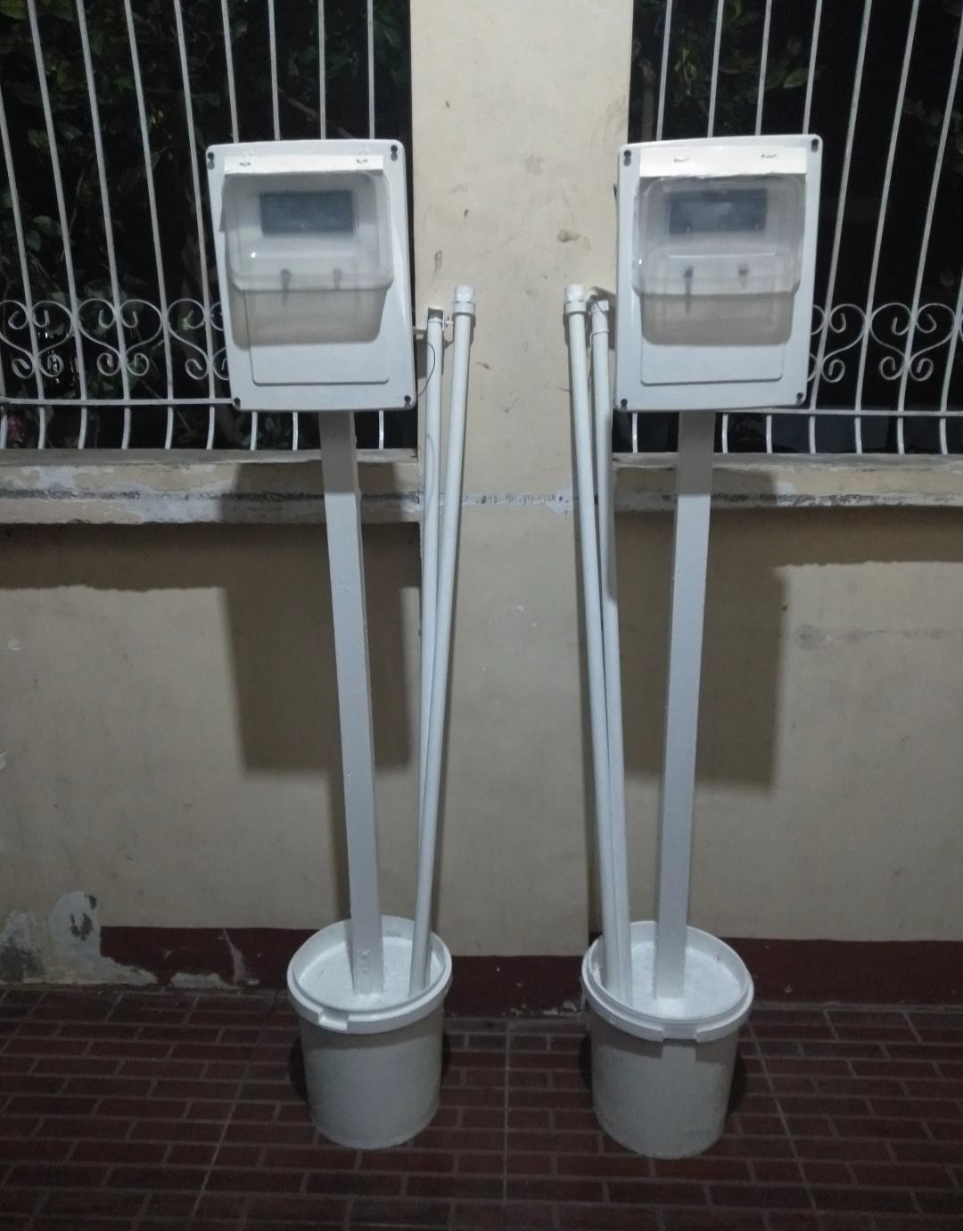

**Figure B.9 Actual Wireless Passenger Notification System (PNS) for Tricycle Terminal and Street**

# APPENDIX C

## Data Sheets

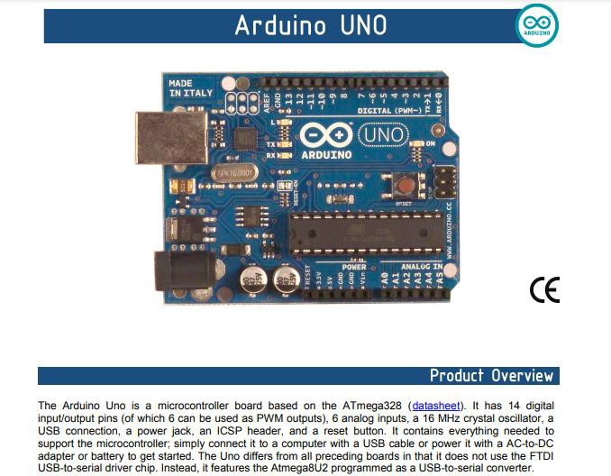

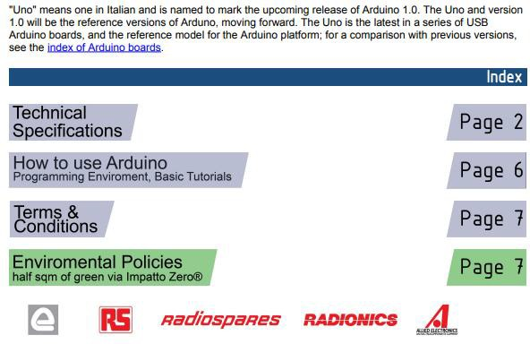

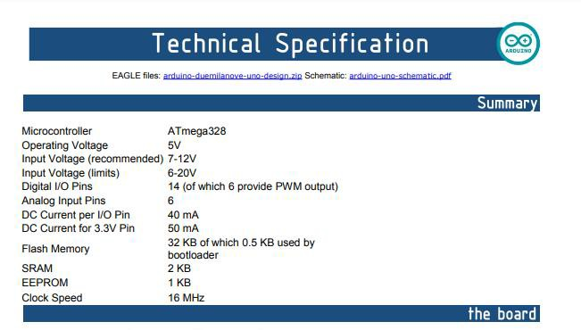

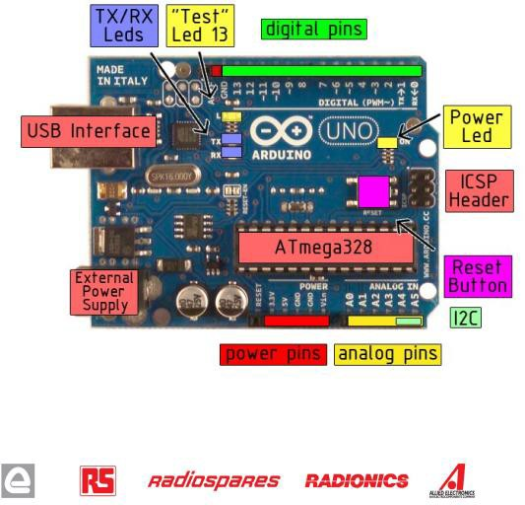

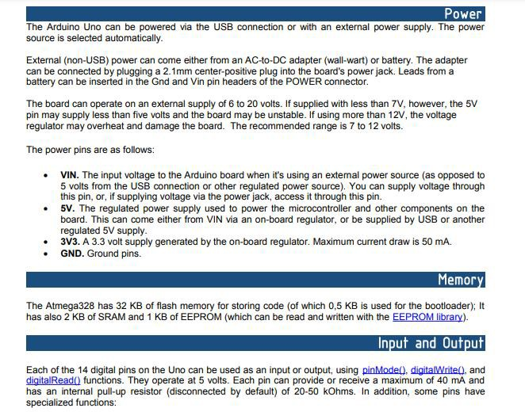

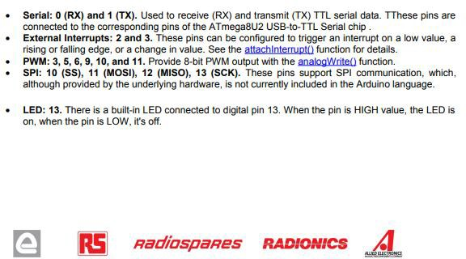

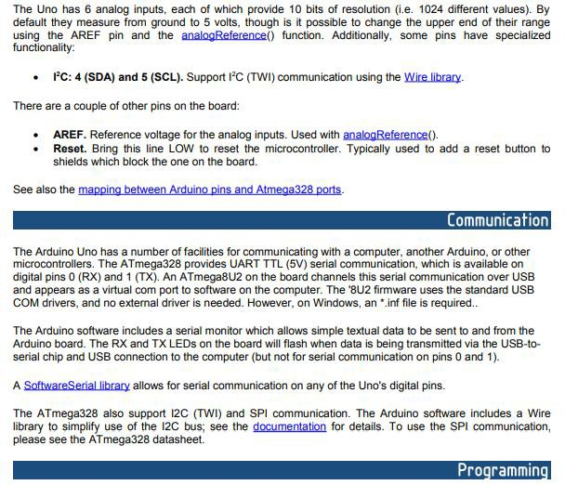

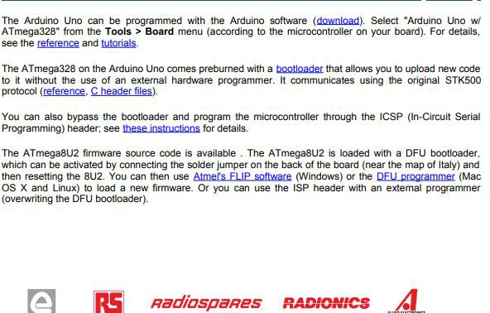

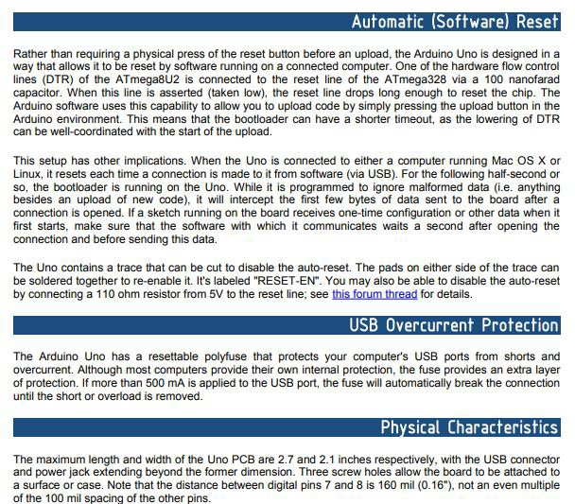

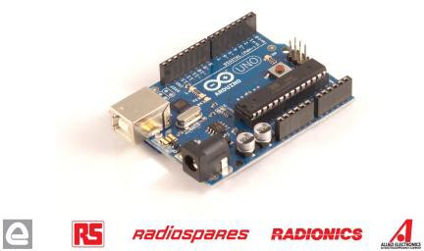

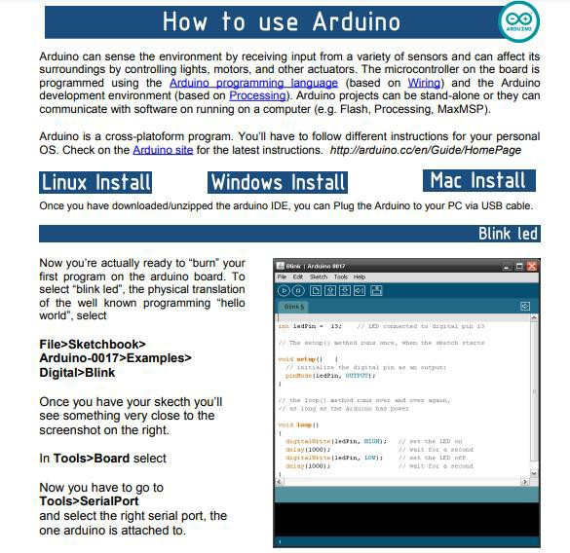

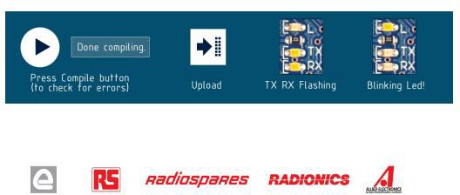

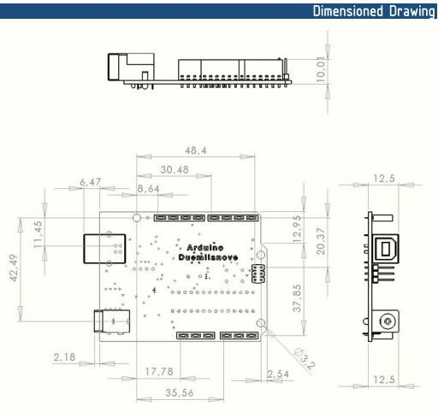

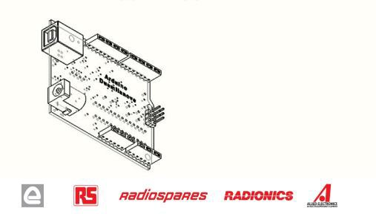



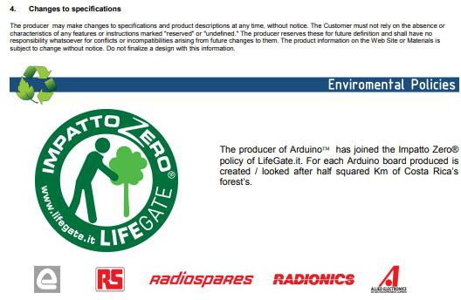

**Potentiometer’s Data Sheets**

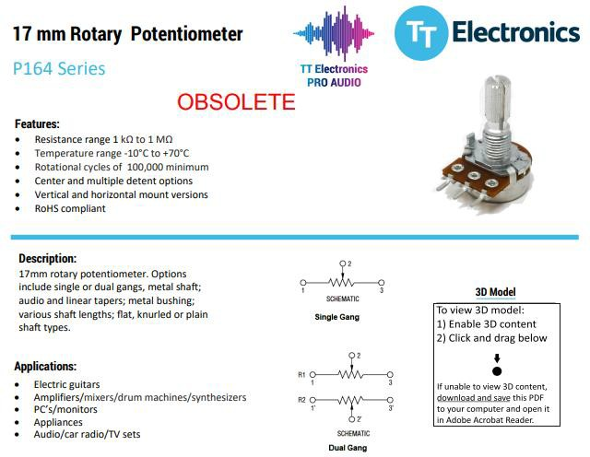

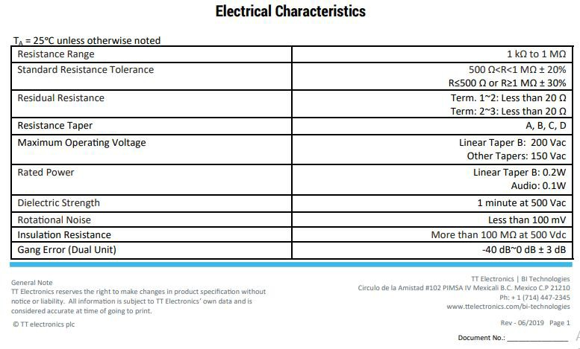

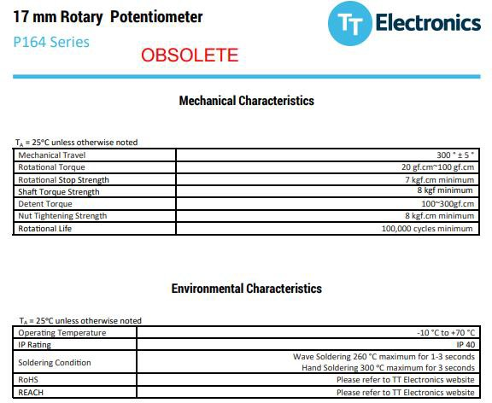

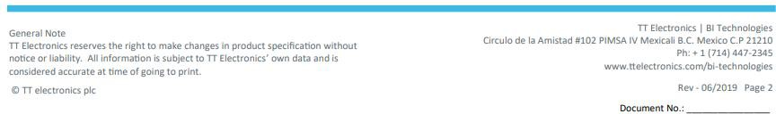

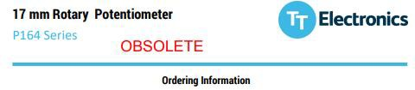

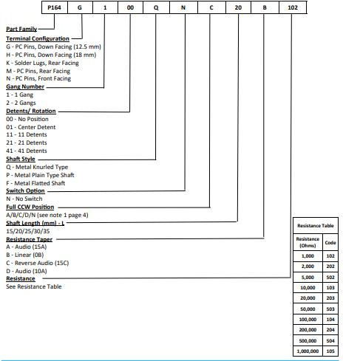



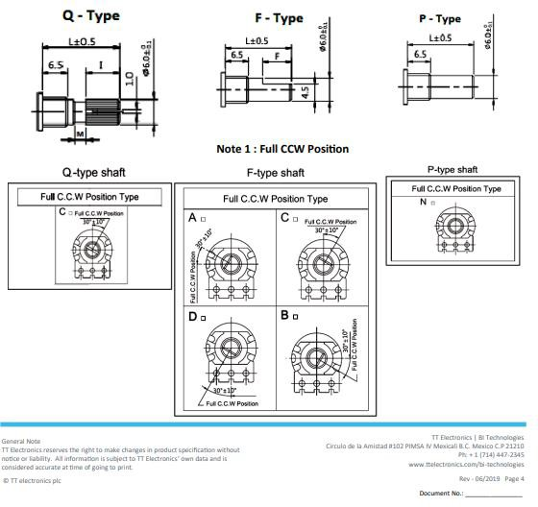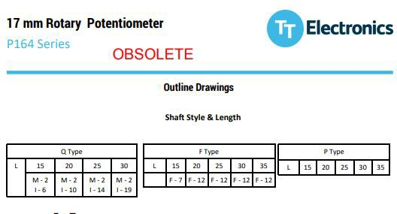

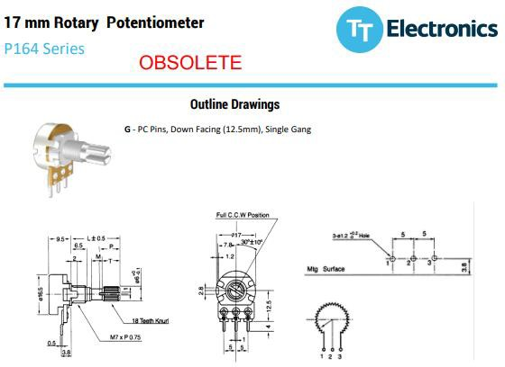

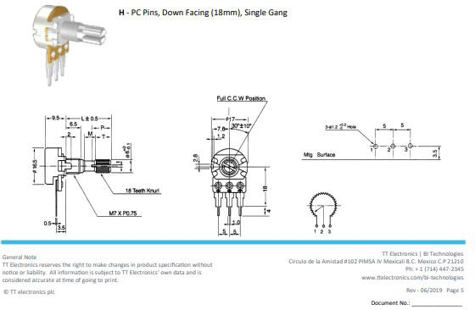

**Pushbutton Data Sheets**

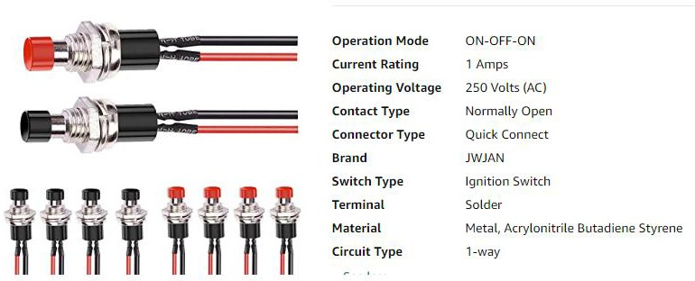

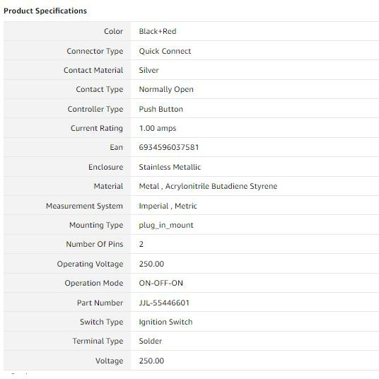

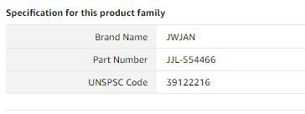

**LED’s Data Sheets**

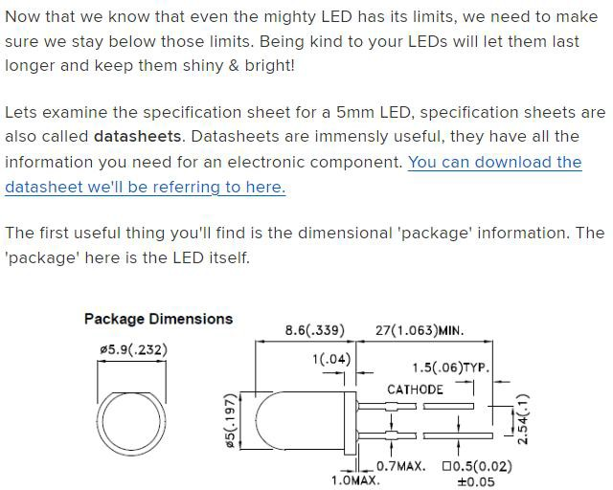

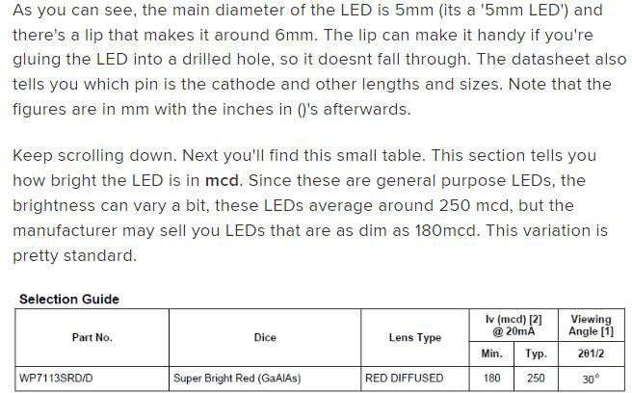

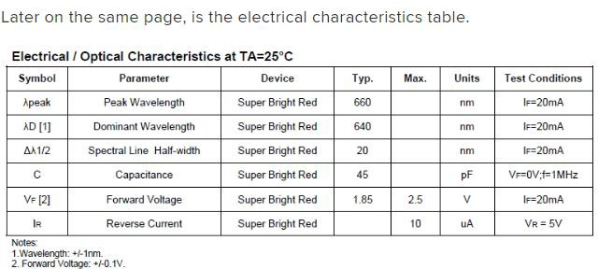

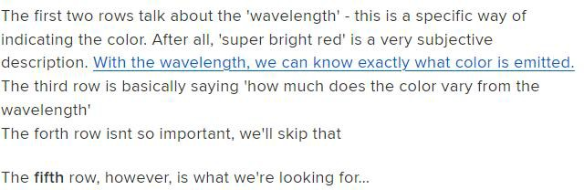

**Buzzer’s Data Sheet**

A buzzer is a small yet efficient component to add sound features to our project/system. It is very small and compact 2-pin structure hence can be easily used on [breadboard](https://components101.com/misc/breadboard-connections-uses-guide), Perf Board and even on PCBs which makes this a widely used component in most electronic applications.

There are two types of buzzers that are commonly available. The one shown here is a simple buzzer which when powered will make a Continuous Beeeeeeppp.... sound, the other type is called a readymade buzzer which will look bulkier than this and will produce a Beep. Beep. Beep. Sound due to the internal oscillating circuit present inside it. But, the one shown here is most widely used because it can be customized with help of other circuits to fit easily in our application.

This buzzer can be used by simply powering it using a DC power supply ranging from 4V to 9V. A simple 9V battery can also be used, but it is recommended to use a regulated

+5V or +6V DC supply. The buzzer is normally associated with a switching circuit to turn ON or turn OFF the buzzer at required time and require interval.

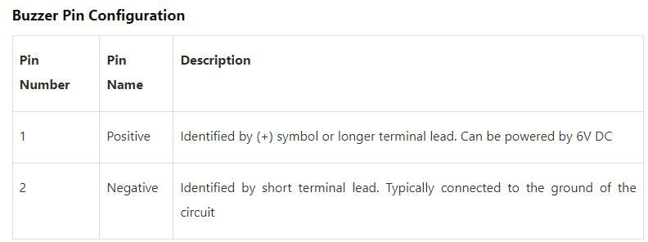

Buzzer’s Features and Specifications

* Rated Voltage: 6V DC
* Operating Voltage: 4-8V DC
* Rated current: <30mA
* Sound Type: Continuous Beep
* Resonant Frequency: ~2300 Hz
* Small and neat sealed package
* Breadboard and Perf board friendly

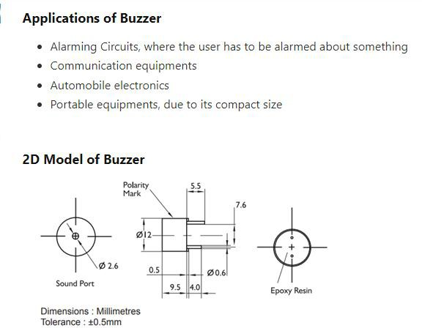

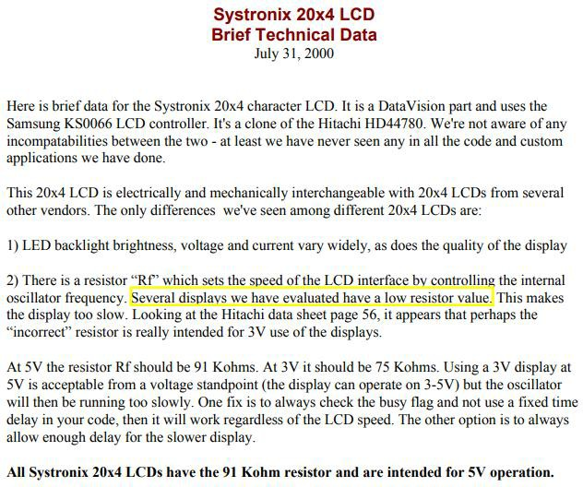



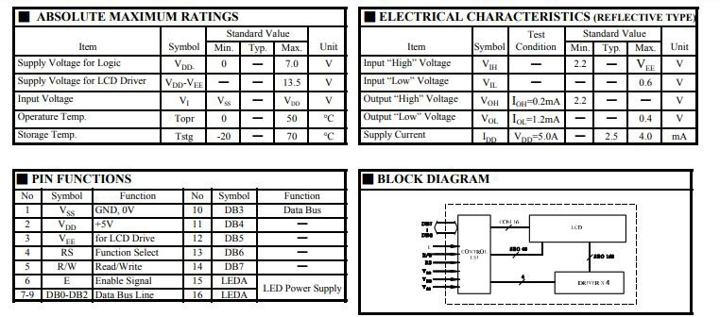

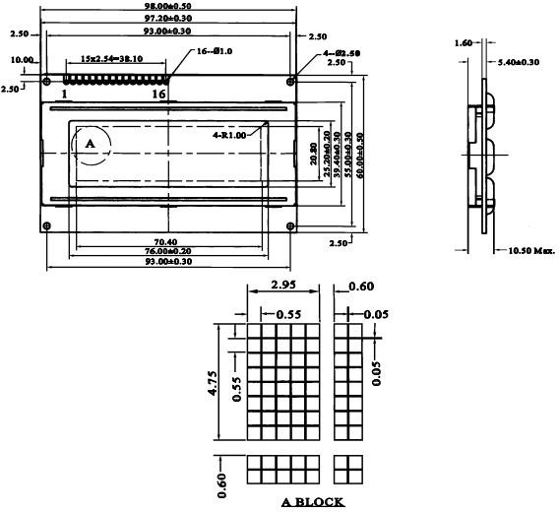

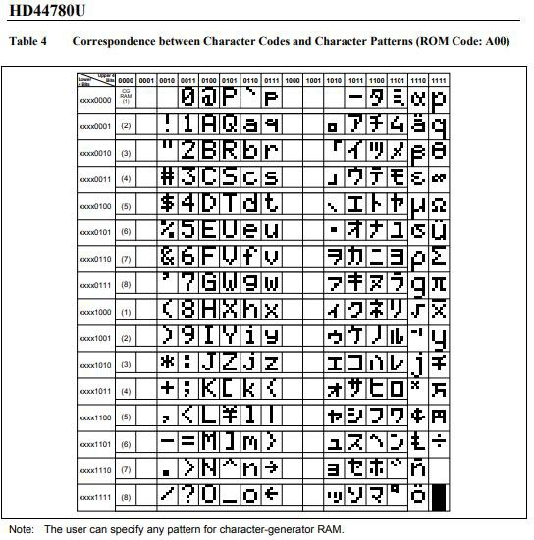

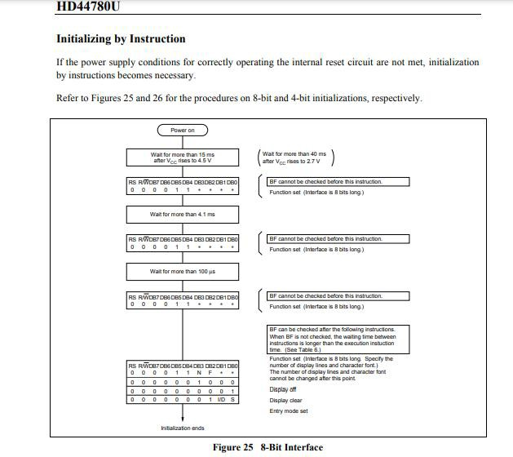

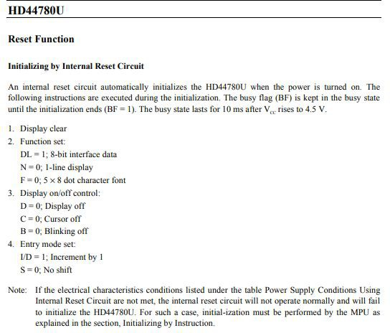

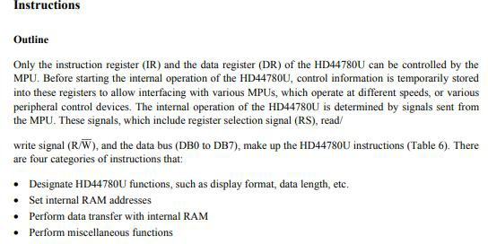

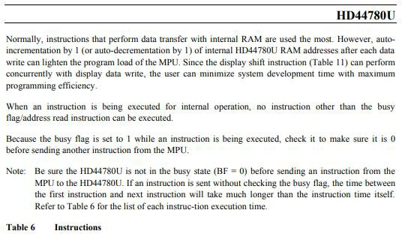

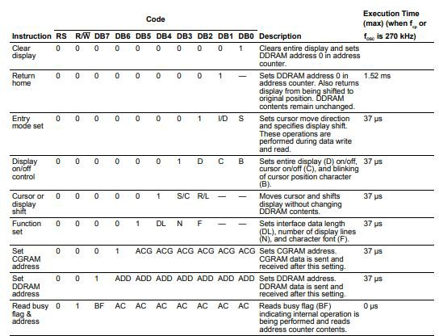

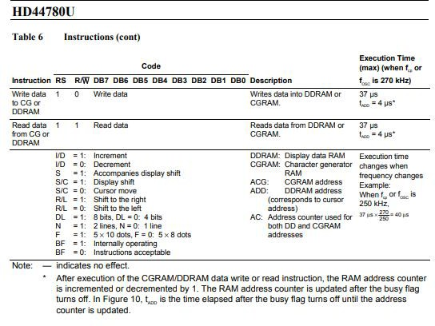

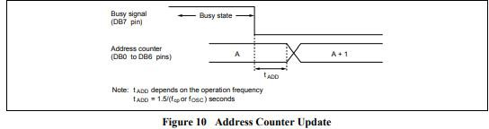

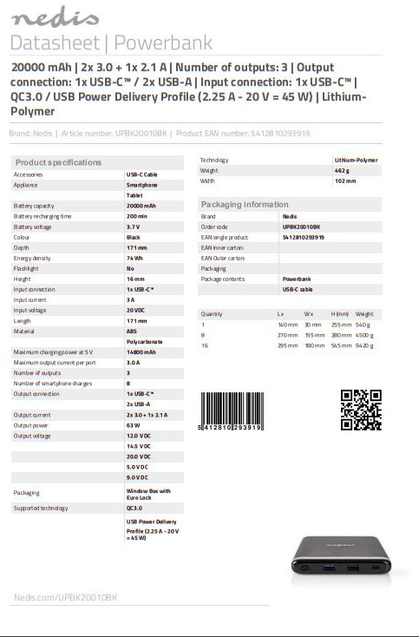

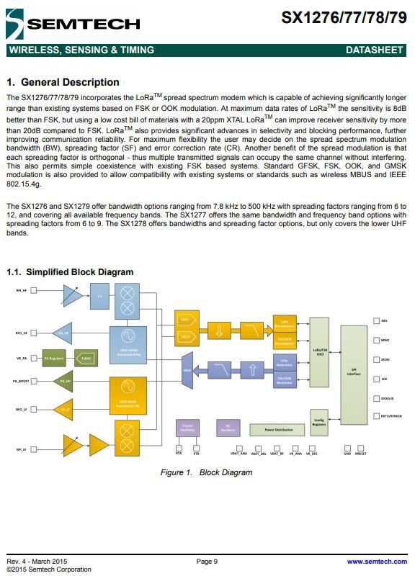

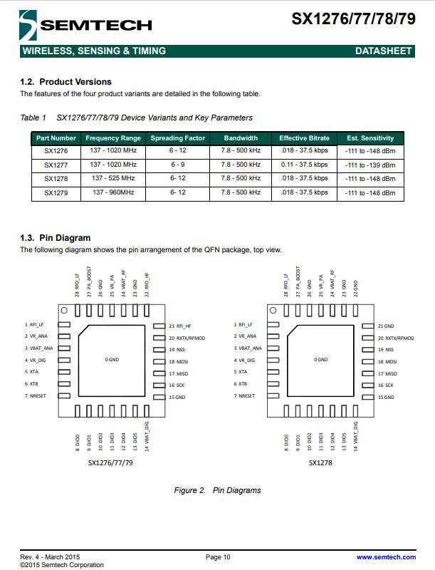

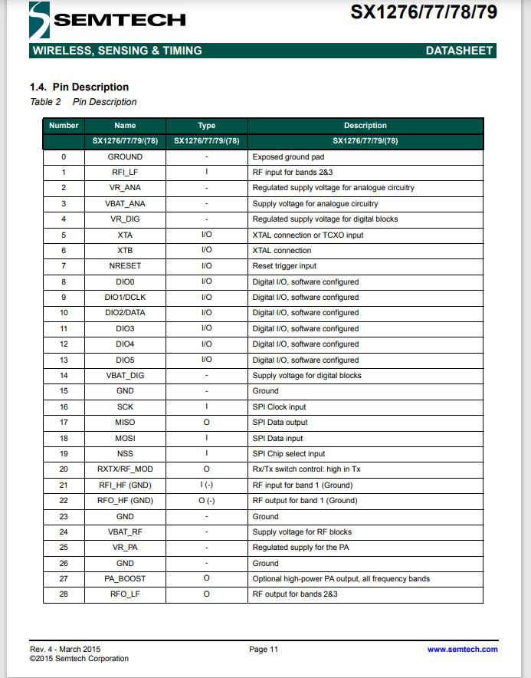

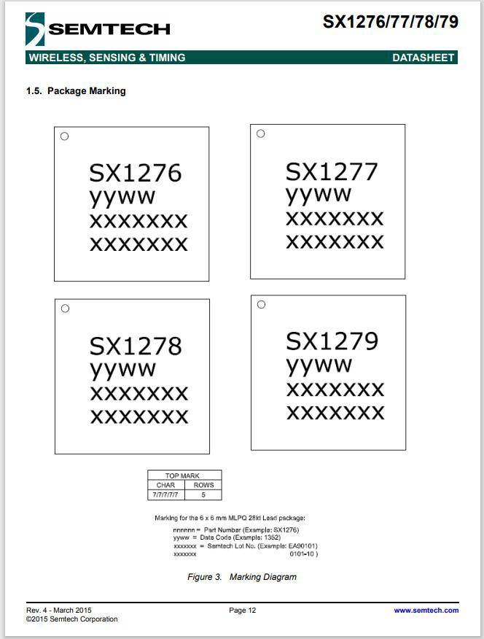

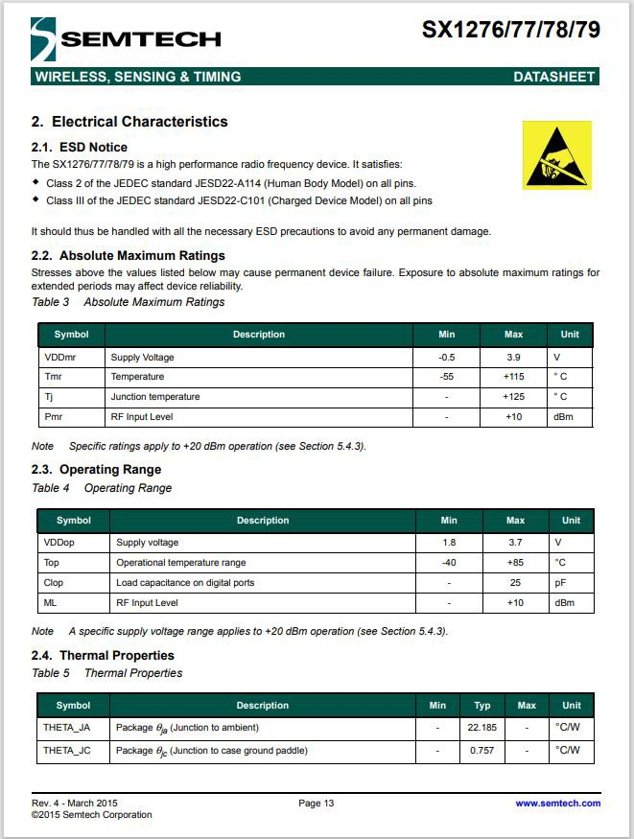

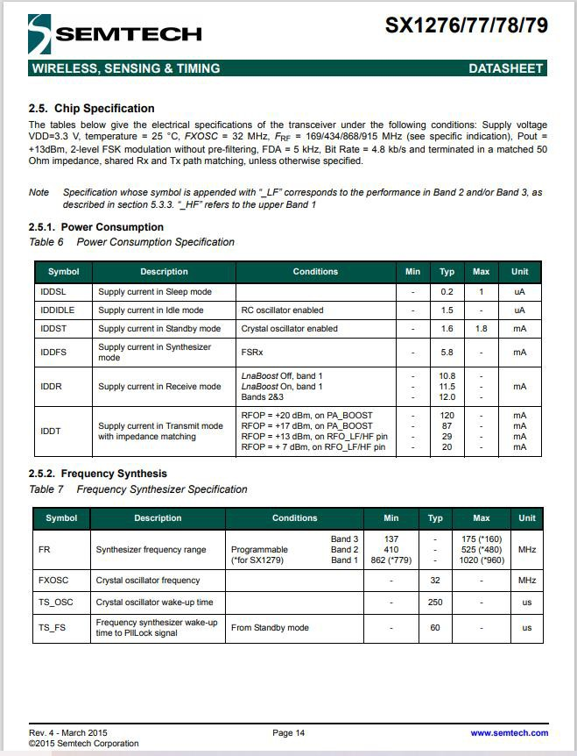

# APPENDIX D

## Programs

**Programs of Wireless Passenger Notification System (PNS) for Terminal Station and Street**

**Final Output**

### // SLAVE NODE //

/\*

LoRa Duplex Slave

\*/

#include <SPI.h> // include libraries

#include <LoRa.h> #include <Wire.h>

#include <LiquidCrystal\_I2C.h> LiquidCrystal\_I2C lcd(0x27,20,4);

int POT = A0;

int pushbutton = 5; int led = 7;

int buzzer = 3;

const int csPin = 7; // LoRa radio chip select

const int resetPin = 6; // LoRa radio reset

const int irqPin = 1; // change for your board; must be a hardware interrupt pin

String outgoing; // outgoing message

byte msgCount = 0; // count of outgoing messages

byte localAddress = 0xBB; // address of this device

byte destination = 0xFF; // destination to send to

long lastSendTime = 0; // last send time

//int interval = 2000; // interval between sends

//----------------

// Generally, you should use "unsigned long" for variables that hold time

// The value will quickly become too large for an int to store

unsigned long previousMillis = 0; // will store last time LED was updated

// constants won't change:

const long interval = 5000; // interval at which to blink (milliseconds)

//--------------------------------

void setup() {

Serial.begin(9600); //

initialize serial

lcd.init(); // initialize the lcd lcd.backlight();

lcd.clear(); lcd.setCursor(1,0);

lcd.print("Passenger Notification"); lcd.setCursor(7,1); lcd.print("System");

pinMode(POT, INPUT); pinMode(pushbutton, INPUT\_PULLUP); pinMode(led, OUTPUT); pinMode(buzzer, OUTPUT);

while (!Serial); Serial.println("LoRa Duplex");

// override the default CS, reset, and IRQ pins (optional)

// LoRa.setPins(csPin, resetPin, irqPin);// set CS, reset, IRQ pin

if (!LoRa.begin(433E6)) { // initialize ratio at 915 MHz

Serial.println("LoRa init failed. Check your connections.");

while (true); // if failed, do nothing

}

|  |  |  |  |
| --- | --- | --- | --- |
|  | | } |  |
| Serial.println("LoRa init succeeded."); |  |  |
| } |  | void sendMessage(String outgoing) | { |
|  |  | LoRa.beginPacket(); | // start |
| void loop() { |  | packet |  |
|  |  | LoRa.write(destination); | // add |
| int value = analogRead(POT)/150; |  | destination address |  |
| lcd.setCursor(0,2); |  | LoRa.write(localAddress); | // add |
| lcd.print("Option Request: " | + | sender address |  |
| String(value)); |  | LoRa.write(msgCount); | // add |
| lcd.setCursor(0,3); |  | message ID |  |
| lcd.print("Accepted Option: "); |  | LoRa.write(outgoing.length()); | // |

if (digitalRead(pushbutton) == HIGH && value != 0){

unsigned long currentMillis = millis(); if (currentMillis - previousMillis >=

interval) {

// save the last time you blinked the LED

previousMillis = currentMillis;

// if the LED is off turn it on and vice- versa:

lcd.setCursor(0,2);

lcd.print("Option Request: " + String(value));

lcd.setCursor(0,3); lcd.print("Accepted Option: ");

String message = String(value); sendMessage(message);

digitalWrite(led, HIGH); //send delay(5000);

digitalWrite(led, LOW); //ready

add payload length

LoRa.print(outgoing); // add payload

LoRa.endPacket(); // finish packet and send it

msgCount++; //

increment message ID

}

void onReceive(int packetSize) {

if (packetSize == 0) return; // if there's no packet, return

// read packet header bytes:

int recipient = LoRa.read(); // recipient address

byte sender = LoRa.read(); // sender address

byte incomingMsgId = LoRa.read(); // incoming msg ID

byte incomingLength = LoRa.read(); // incoming msg length

String incoming = ""; while (LoRa.available()) {

incoming += (char)LoRa.read();

}

}

// parse for a packet, and call onReceive with the result: onReceive(LoRa.parsePacket());

}

if (incomingLength != incoming.length())

{ // check length for error Serial.println("error: message length

does not match length");

return; // skip rest of

function

}

/\*

### //MASTER NODE//

// if the recipient isn't this device or broadcast,

if (recipient != localAddress && recipient != 0xFF) {

Serial.println("This message is not for me.");

return; // skip rest of

function

}

// if message is for this device, or broadcast, print details:

//Serial.println("Received from: 0x" + String(sender, HEX));

//Serial.println("Sent to: 0x" + String(recipient, HEX));

//Serial.println("Message ID: " + String(incomingMsgId));

//Serial.println("Message length: " + String(incomingLength));

//Serial.println("Message: " + incoming);

//Serial.println("RSSI: " + String(LoRa.packetRssi()));

//Serial.println("Snr: " + String(LoRa.packetSnr()));

//Serial.println();

digitalWrite(buzzer, HIGH); lcd.setCursor(17,3); lcd.print(incoming); delay(3000); digitalWrite(buzzer, LOW); lcd.setCursor(17,3); lcd.print(incoming); delay(10000); lcd.setCursor(17,3); lcd.print(" ");

}

LoRa Duplex Slave

\*/

#include <SPI.h> // include libraries

#include <LoRa.h> #include <Wire.h>

#include <LiquidCrystal\_I2C.h> LiquidCrystal\_I2C lcd(0x27,20,4);

int POT = A0;

int pushbutton = 5; int led = 7;

int buzzer = 3;

const int csPin = 7; // LoRa radio chip select

const int resetPin = 6; // LoRa radio reset

const int irqPin = 1; // change for your board; must be a hardware interrupt pin

String outgoing; // outgoing message

byte msgCount = 0; // count of outgoing messages

byte localAddress = 0xBB; // address of this device

byte destination = 0xFF; // destination to send to

long lastSendTime = 0; // last send time

//int interval = 2000; // interval between sends

//----------------

// Generally, you should use "unsigned long" for variables that hold time

// The value will quickly become too large for an int to store

unsigned long previousMillis = 0; // will store last time LED was updated

// constants won't change:

const long interval = 5000; // interval at which to blink (milliseconds)

//

void setup() {

Serial.begin(9600); // initialize serial

lcd.init(); // initialize the lcd lcd.backlight();

lcd.clear(); lcd.setCursor(1,0);

lcd.print("Passenger Notification"); lcd.setCursor(7,1); lcd.print("System");

pinMode(POT, INPUT); pinMode(pushbutton, INPUT\_PULLUP); pinMode(led, OUTPUT); pinMode(buzzer, OUTPUT);

while (!Serial); Serial.println("LoRa Duplex");

// override the default CS, reset, and IRQ pins (optional)

// LoRa.setPins(csPin, resetPin, irqPin);// set CS, reset, IRQ pin

if (!LoRa.begin(433E6)) { // initialize ratio at 915 MHz

Serial.println("LoRa init failed. Check your connections.");

while (true); // if failed, do nothing

}

Serial.println("LoRa init succeeded.");

}

void loop() {

int value = analogRead(POT)/170; lcd.setCursor(0,2); lcd.print("Option Request: "); lcd.setCursor(0,3);

lcd.print("Accepted Option: " + String(value));

if (digitalRead(pushbutton) == HIGH && value != 0){

unsigned long currentMillis = millis(); if (currentMillis - previousMillis >=

interval) {

// save the last time you blinked the LED

previousMillis = currentMillis;

// if the LED is off turn it on and vice- versa:

lcd.setCursor(0,2); lcd.print("Option Request: "); lcd.setCursor(0,3);

lcd.print("Accepted Option: " + String(value));

String message = String(value); sendMessage(message);

digitalWrite(led, HIGH); delay(5000); digitalWrite(led, LOW);

}

}

// parse for a packet, and call onReceive with the result: onReceive(LoRa.parsePacket());

}

void sendMessage(String outgoing) {

LoRa.beginPacket(); // start packet

LoRa.write(destination); // add destination address LoRa.write(localAddress); // add sender address

LoRa.write(msgCount); // add message ID LoRa.write(outgoing.length()); // add payload length

LoRa.print(outgoing); // add payload

LoRa.endPacket(); // finish packet and send it

msgCount++; //

increment message ID

}

void onReceive(int packetSize) {

if (packetSize == 0) return; // if there's no packet, return

// read packet header bytes:

int recipient = LoRa.read(); // recipient address

byte sender = LoRa.read(); // sender address

byte incomingMsgId = LoRa.read(); // incoming msg ID

byte incomingLength = LoRa.read(); // incoming msg length

String incoming = ""; while (LoRa.available()) {

incoming += (char)LoRa.read();

}

if (incomingLength != incoming.length())

{ // check length for error Serial.println("error: message length

does not match length");

return; // skip rest of

function

}

// if the recipient isn't this device or broadcast,

if (recipient != localAddress && recipient != 0xFF) {

Serial.println("This message is not for me.");

return; // skip rest of

function

}

// if message is for this device, or broadcast, print details:

//Serial.println("Received from: 0x" + String(sender, HEX));

//Serial.println("Sent to: 0x" + String(recipient, HEX));

//Serial.println("Message ID: " + String(incomingMsgId));

//Serial.println("Message length: " + String(incomingLength)); Serial.println("Message: " + incoming);

//Serial.println("RSSI: " + String(LoRa.packetRssi()));

//Serial.println("Snr: " + String(LoRa.packetSnr()));

//Serial.println();

digitalWrite(buzzer, HIGH); lcd.setCursor(17,2); lcd.print(incoming); delay(3000); digitalWrite(buzzer, LOW); lcd.setCursor(17,2); lcd.print(incoming);

}

#### For Walk - Testing

**//Slave Node//**

/\*

LoRa Duplex Slave

\*/

#include <SPI.h> // include libraries

#include <LoRa.h> #include <Wire.h>

#include <LiquidCrystal\_I2C.h> LiquidCrystal\_I2C lcd(0x27,20,4);

int Button1 = 3; boolean bflag = false;

const int csPin = 7; // LoRa radio chip select

const int resetPin = 6; // LoRa radio reset

const int irqPin = 1; // change for your board; must be a hardware interrupt pin

String outgoing; // outgoing message

byte msgCount = 0; // count of outgoing messages

byte localAddress = 0xBB; // address of this device

byte destination = 0xFF; // destination to send to

long lastSendTime = 0; // last send time

int interval = 2000; // interval between sends

void setup() {

Serial.begin(9600); // initialize serial

lcd.init(); // initialize the lcd

lcd.backlight(); lcd.clear();

pinMode(Button1, INPUT\_PULLUP); while (!Serial);

Serial.println("LoRa Duplex");

// override the default CS, reset, and IRQ pins (optional)

// LoRa.setPins(csPin, resetPin, irqPin);// set CS, reset, IRQ pin

if (!LoRa.begin(433E6)) { // initialize ratio at 915 MHz

Serial.println("LoRa init failed. Check your connections.");

while (true); // if failed, do nothing

}

Serial.println("LoRa init succeeded.");

}

void loop() {

if (millis() - lastSendTime > interval) { if (digitalRead(Button1) == LOW)

{

String message = "Button Pressed"; sendMessage(message);

}

if (digitalRead(Button1) == HIGH)

{

String message = "Button Released"; sendMessage(message);

}

lastSendTime = millis(); // timestamp the message

interval = random(2000) + 1000; // 2- 3 seconds

}

// parse for a packet, and call onReceive with the result: onReceive(LoRa.parsePacket());

}

void sendMessage(String outgoing) { LoRa.beginPacket(); // start packet

LoRa.write(destination); // add destination address LoRa.write(localAddress); // add sender address

LoRa.write(msgCount); // add message ID LoRa.write(outgoing.length()); // add payload length

LoRa.print(outgoing); // add payload

LoRa.endPacket(); // finish packet and send it

msgCount++; //

increment message ID

}

void onReceive(int packetSize) {

if (packetSize == 0) return; // if there's no packet, return

// read packet header bytes:

int recipient = LoRa.read(); // recipient address

byte sender = LoRa.read(); // sender address

byte incomingMsgId = LoRa.read(); // incoming msg ID

byte incomingLength = LoRa.read(); // incoming msg length

String incoming = ""; while (LoRa.available()) {

incoming += (char)LoRa.read();

Serial.println("error: message length does not match length");

return; // skip rest of

function

}

// if the recipient isn't this device or broadcast,

if (recipient != localAddress && recipient != 0xFF) {

Serial.println("This message is not for me.");

return; // skip rest of

function

}

// if message is for this device, or broadcast, print details: Serial.println("Received from: 0x" + String(sender, HEX));

Serial.println("Sent to: 0x" + String(recipient, HEX)); Serial.println("Message ID: " + String(incomingMsgId)); Serial.println("Message length: " + String(incomingLength)); Serial.println("Message: " + incoming); Serial.println("RSSI: " + String(LoRa.packetRssi())); Serial.println("Snr: " + String(LoRa.packetSnr())); Serial.println();

lcd.clear(); lcd.setCursor(0,0);

lcd.print("Val: " + String(incoming)); lcd.setCursor(0,1);

lcd.println("RSSI: " + String(LoRa.packetRssi())); lcd.setCursor(0,2);

lcd.println("Snr: " + String(LoRa.packetSnr()));

}

}

if (incomingLength != incoming.length())

{ // check length for error

### //MASTER NODE//

/\*

LoRa Duplex Master

\*/

#include <SPI.h> // include libraries

#include <LoRa.h> #include <Wire.h>

#include <LiquidCrystal\_I2C.h>

LiquidCrystal\_I2C lcd(0x27,20,4);

//initialize LCD

const int csPin = 7; // LoRa radio chip select

const int resetPin = 6; // LoRa radio reset

const int irqPin = 1; // change for your board; must be a hardware interrupt pin

int POT = A2;

String outgoing; // outgoing message

byte msgCount = 0; // count of outgoing messages

byte localAddress = 0xBB; // address of this device

byte destination = 0xFF; // destination to send to

long lastSendTime = 0; // last send time

int interval = 2000; // interval between sends

pinMode(POT, INPUT); while (!Serial);

Serial.println("LoRa Duplex");

// override the default CS, reset, and IRQ pins (optional)

//LoRa.setPins(csPin, resetPin, irqPin);// set CS, reset, IRQ pin

if (!LoRa.begin(433E6)) { // initialize ratio at 915 MHz

Serial.println("LoRa init failed. Check your connections.");

while (true); // if failed, do nothing

}

Serial.println("LoRa init succeeded.");

}

void loop() {

if (millis() - lastSendTime > interval) { String message =

String(analogRead(POT)); sendMessage(message); Serial.println("Sending " + message); lastSendTime = millis(); //

timestamp the message

interval = random(2000) + 1000; // 2- 3 seconds

}

// parse for a packet, and call onReceive with the result: onReceive(LoRa.parsePacket());

void setup() {

Serial.begin(9600); // initialize serial

lcd.init(); // initialize the lcd lcd.backlight();

lcd.clear();

}

void sendMessage(String outgoing) { LoRa.beginPacket(); // start packet

LoRa.write(destination); // add destination address LoRa.write(localAddress); // add sender address

LoRa.write(msgCount); // add message ID LoRa.write(outgoing.length()); // add payload length

LoRa.print(outgoing); // add payload

LoRa.endPacket(); // finish packet and send it

msgCount++; //

increment message ID

}

void onReceive(int packetSize) {

if (packetSize == 0) return; // if there's no packet, return

// read packet header bytes:

int recipient = LoRa.read(); // recipient address

byte sender = LoRa.read(); // sender address

byte incomingMsgId = LoRa.read(); // incoming msg ID

byte incomingLength = LoRa.read(); // incoming msg length

String incoming = ""; while (LoRa.available()) {

incoming += (char)LoRa.read();

if (recipient != localAddress && recipient != 0xFF) {

Serial.println("This message is not for me.");

return; // skip rest of

function

}

// if message is for this device, or broadcast, print details: Serial.println("Received from: 0x" + String(sender, HEX));

Serial.println("Sent to: 0x" + String(recipient, HEX)); Serial.println("Message ID: " + String(incomingMsgId)); Serial.println("Message length: " + String(incomingLength)); Serial.println("Message: " + incoming); Serial.println("RSSI: " + String(LoRa.packetRssi())); Serial.println("Snr: " + String(LoRa.packetSnr())); Serial.println();

lcd.clear(); lcd.setCursor(0,0);

lcd.print("Val: " + String(incoming)); lcd.setCursor(0,1);

lcd.println("RSSI: " + String(LoRa.packetRssi())); lcd.setCursor(0,2);

lcd.println("Snr: " + String(LoRa.packetSnr()));

}

}

if (incomingLength != incoming.length())

{ // check length for error Serial.println("error: message length

does not match length");

return; // skip rest of

function

}

// if the recipient isn't this device or broadcast,

# APPENDIX E

## Photo Documentation

**Table E.1 Components of the System**

|  |  |  |
| --- | --- | --- |
| **Component** | **Specification** | **Function** |
| **ARDUINO UNO** | * Microcontroller: ATmega328 * Operating Voltage: 5V * Input Voltage (recommended): 7-12V * Input Voltage (limits): 6- 20V * Digital I/O Pins: 14 (of which 6 provide PWM output) * Analog Input Pins: 6 * DC Current per I/O Pin: 40 mA * DC Current for 3.3V Pin: 50 mA * Flash Memory: 32 KB of which 0.5 KB used by bootloader * SRAM: 2 KB   (ATmega328)   * EEPROM: 1 KB   (ATmega328)   * Clock Speed: 16 MHz | A microcontroller board based on the ATmega328,  Arduino is an open- source, prototyping platform and its simplicity makes it ideal for hobbyists to use as well as professionals. It is connected to the LCD, the LORA  module, the  push button, the  potentiometer, the  LED, and the buzzer. It is the main component that runs the system. |
| **LCD SCREEN** | * Display Format: 20   Characters x 4 Lines   * Dot Matrix (w x h): 5 x 8 Dots * Character Size (w x h): 2.95 x 4.75 mm * Character Pitch (w x h):   3.55 x 5.35 mm   * LCD Driver IC: Sitronix ST7066U (or equivalent) * Interface: 4-bit Parallel and 8-bit Parallel * LCD Module Dimensions (w x h x d): 98 x 60 x 13.6 (MAX) mm * Viewing Area (w x h): 77 x   25.2 mm | The 204 LCD display is essentially a larger version (in terms of number of rows and columns) of the 162 LCD display, which has been used by the researchers in a lot of projects. It can display  20 columns of characters on four rows, making it ideal for presenting vast amounts of text without having to scroll. It displays the Options and the value to be adjusted by the actuator. |

|  |  |  |
| --- | --- | --- |
|  | * Dot Size (w x h): 0.55 x   0.55 mm   * Dot Pitch (w x h): 0.6 x 0.6 mm * Driving Method: 1/16 Duty * Operating Temperature: -20   ~ 70°C |  |
| **LoRa MODULE** | * LoRa Modem * Operating Voltage: 3.3V * Operating Frequency: 433Mhz * Half-Duplex SPI Communication * Modulation Technique FSK, GFSK, MSK,GMSK, LoRa * Packet Size: 256 bytes * Sensitivity: -148db | The LoRa SX1278 works with SPI communication protocol so it can be used with any microcontroller that supports SPI. It is mandatory to use an Ariel (antenna) along with the module else it might damage the module permanently. The module should be powered only with  3.3V and the SPI line can be connected to uP/uC. It was used for the point-to-point communication between the two prototype nodes. |
| **PUSH BUTTON** | * Current Rating: 0.5 Amps * Brand: DIYhz * Switch Style: Metal, Push Button Switch * Material: Plastic, Metal * Actuator Type: Push Button * Controller Type: Push Button * Color: Red | The push button was used to send the signal between the two prototypes. |
|  | * Type : Single Linear (Type B); Features : Knurled Shaft; Shaft Diameter : 6mm / 0.23" * Shaft Length : 13.5mm / 0.53";Thread Dia : 7mm / 0.27";Base Height : 8mm / | The potentiometer was used as the actuator that adjusts the value presented in the LCD. |

|  |  |  |
| --- | --- | --- |
| **POTENTIOMETER** | 0.31"   * Base Diameter : 15mm / 0.6";Material : Metal w Electronic Parts * Weight : 36g;Package : 5 x Potentiometer |  |
| **BUZZER** | * Rated Voltage: 6V DC * Operating Voltage: 4-8V DC * Rated Current: <30mA * Sound Type: Continuous Beep * Resonant Frequency:   ~2300 Hz   * Small and neat sealed package * Breadboard and Perf board friendly | The buzzer served as an indicator when data was transferred. |
| **LED** | * Max. Forward Voltage: 1.8-2.1V * Max. Reverse Voltage: 5V * Max. Forward Current: 220mA * Max. Reverse Current: 10 UA * Foot Type: long foot * Size: 5mm | The LED lights up for every  transmission of data. |

**Table E.2 Software Tools**

|  |  |
| --- | --- |
| **SOFTWARE** | **DESCRIPTION** |
| **ARDUINO IDE** | Arduino IDE is a software application used to program the LCD, LORA module, the indicators, and the actuators. |

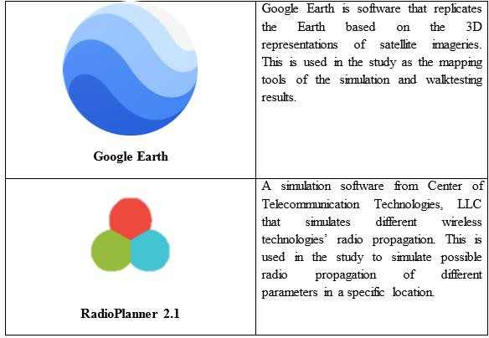

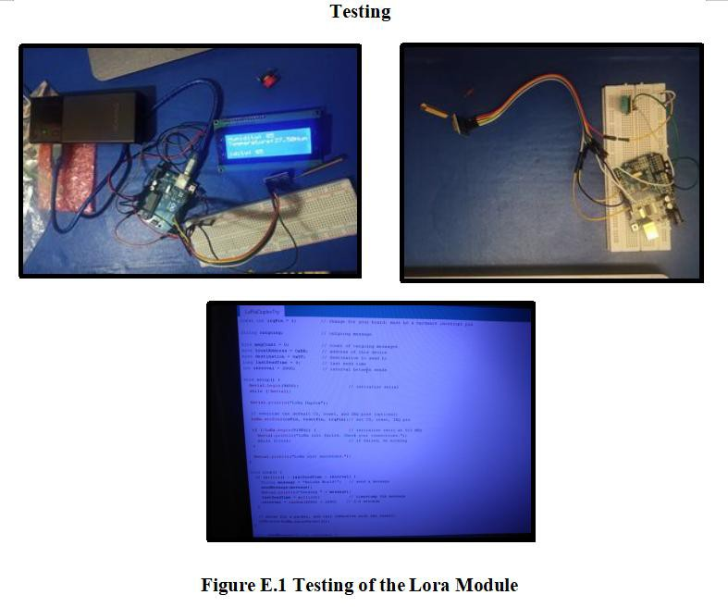

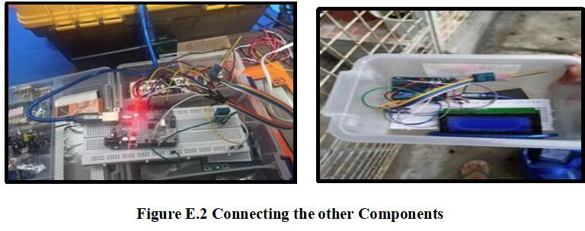

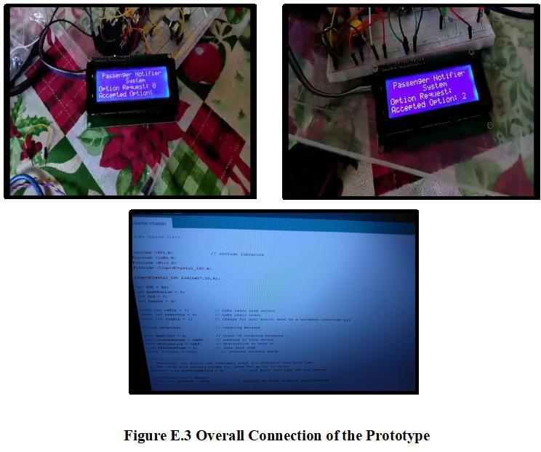

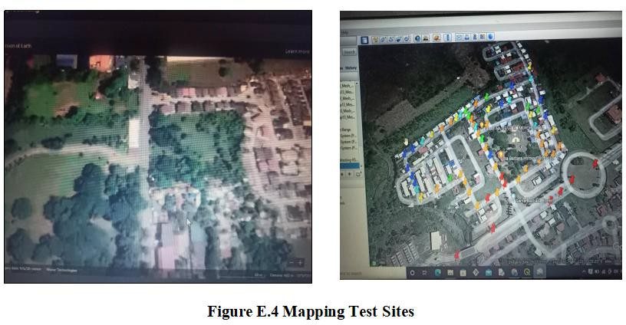

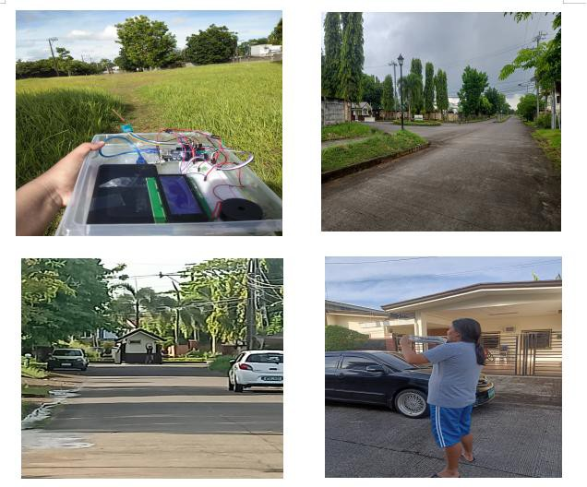

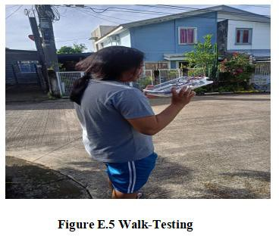

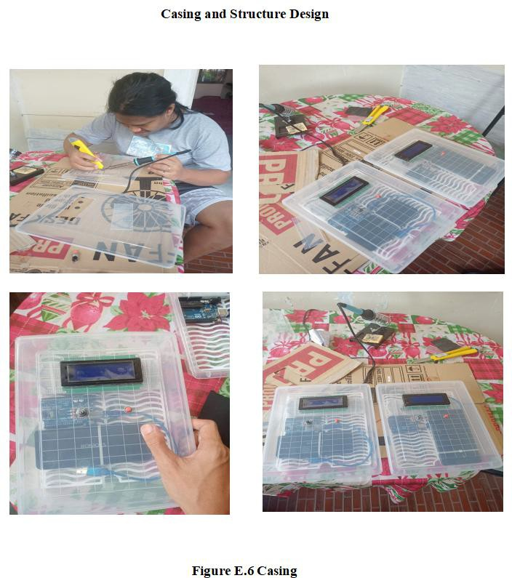

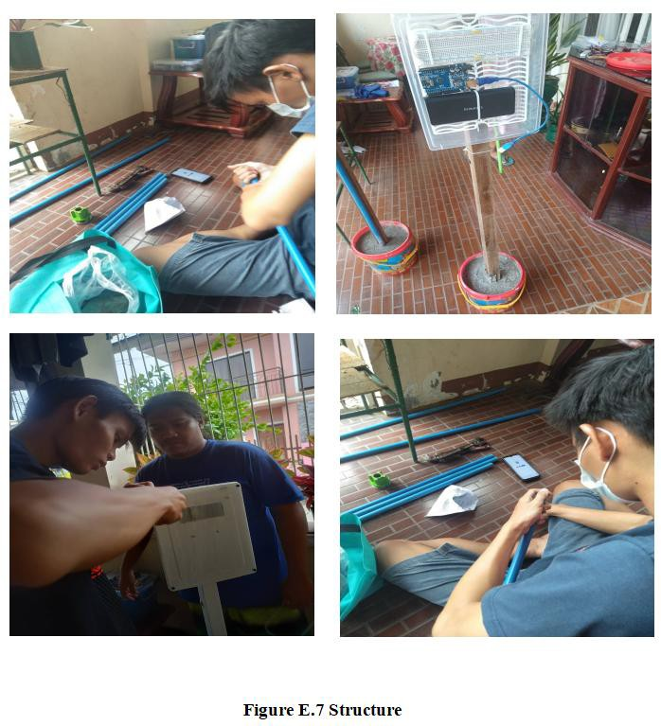

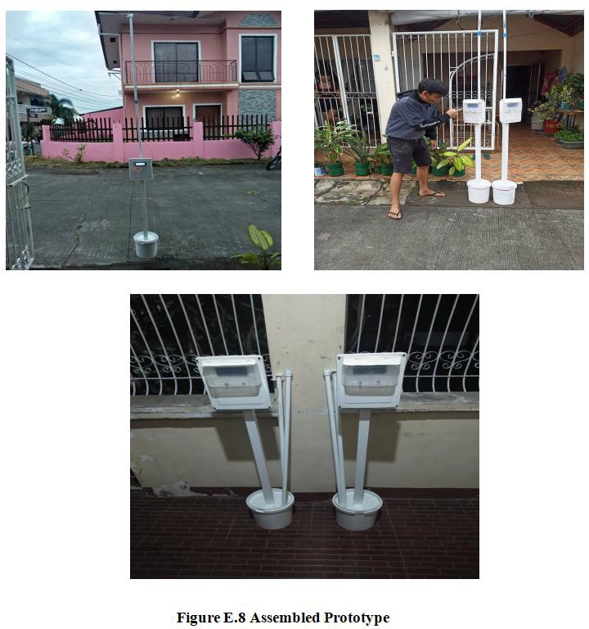

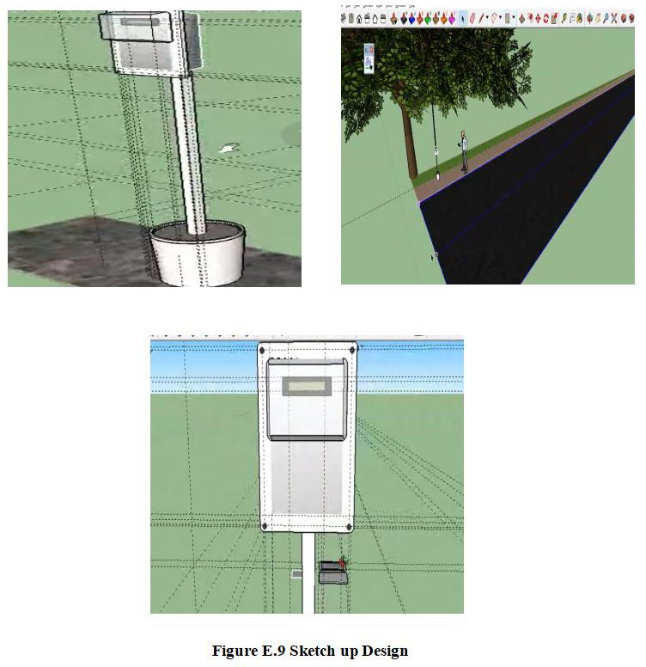

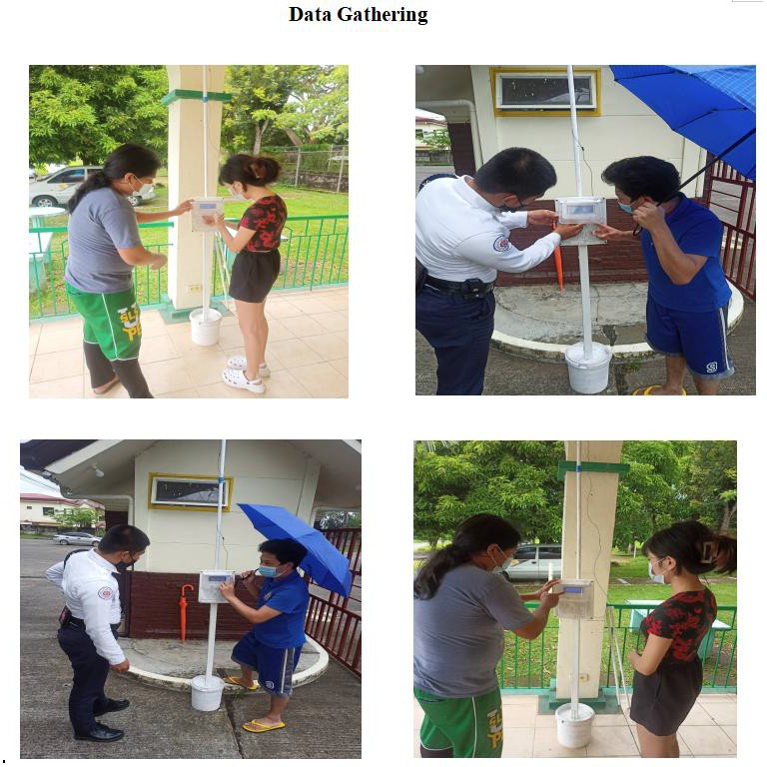

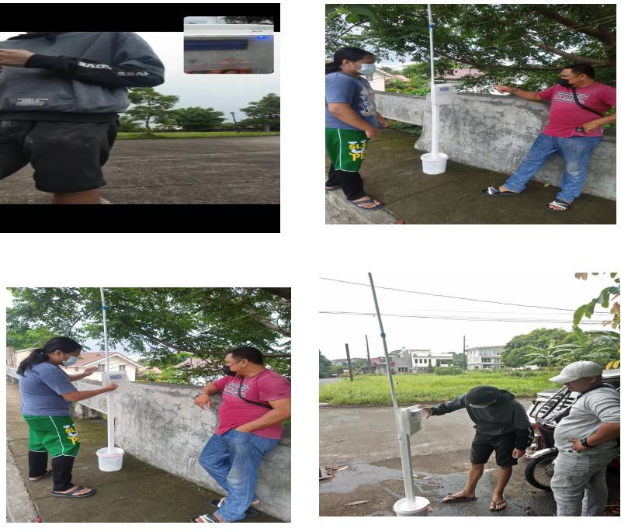

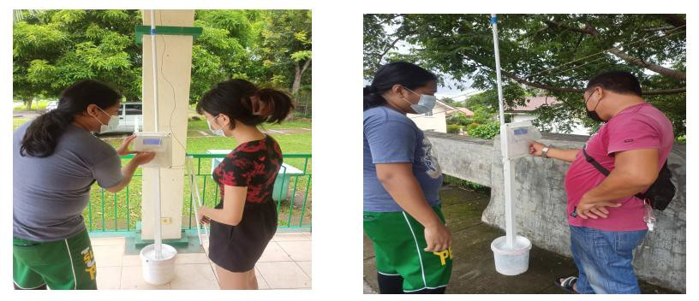

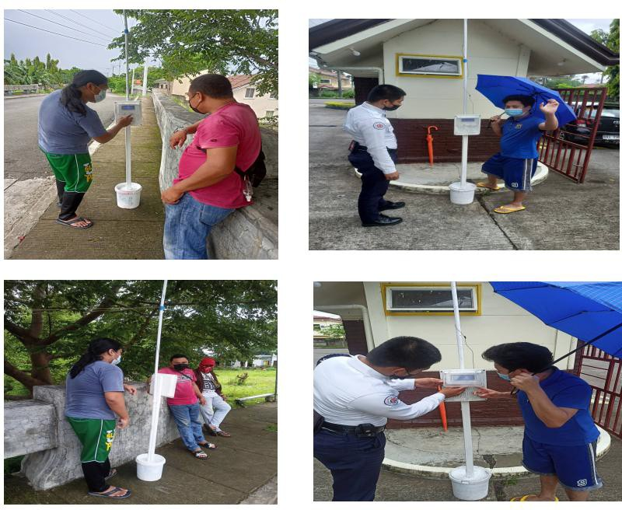



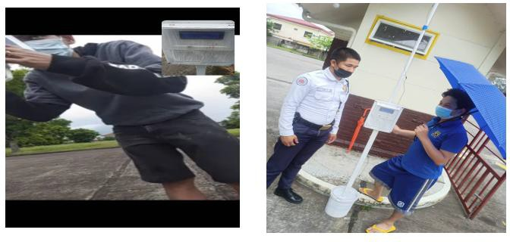

**E.10 Data Gathering from Respondents**

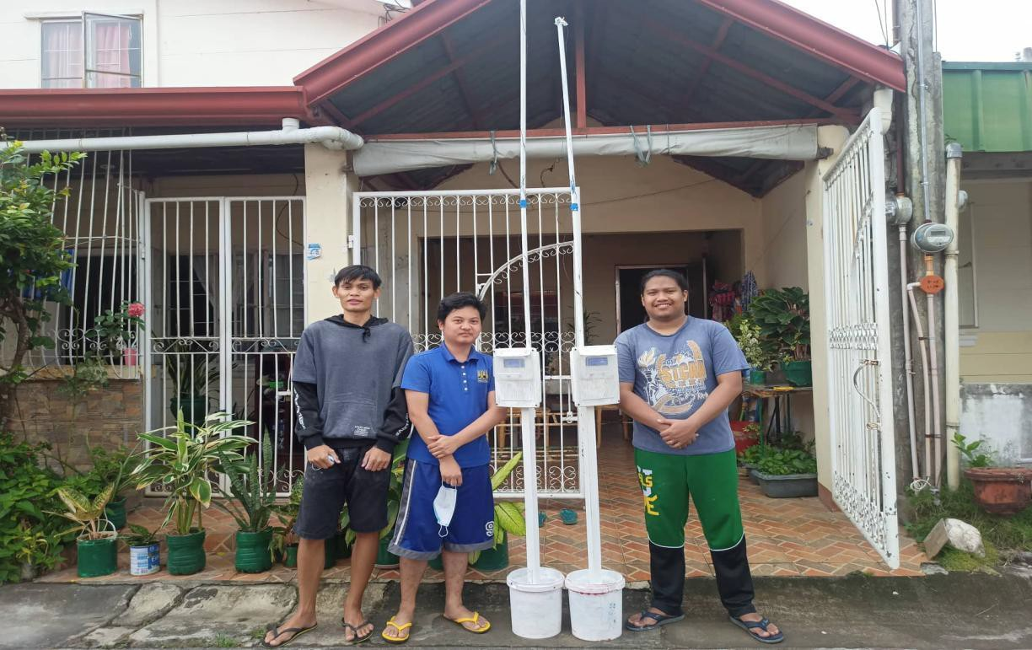

**E.11 Final Output of Prototype**

# APPENDIX F

## Billing Statement

**Table F.1 Total Cost of Components and Materials**

|  |  |
| --- | --- |
| Materials | Cost (PHP) |
| **2 pcs. 2x4 LCD Display I2C** | 430.00 |
| **2 pcs. Arduino UNO R3** | 800.00 |
| **5 meters Solid Wire 22 AWG (red)** | 45.00 |
| **5 meters Solid Wire 22 AWG (black)** | 45.00 |
| **2 pcs 433 MHz LoRa Module Sx1278** | 1200.00 |
| **2 pcs. Casing/Enclosure for Prototype** | 120.00 |
| **30 meters Solid Wire #22 (red & black)** | 240.00 |
| **2 pcs. Push Buttons** | 50.00 |
| **6 pcs. C-Clamp** | 120.00 |
| **2 pcs. 1/2 PVC pipe Schedule 40 (3 Meters)** | 170.00 |
| **12 pcs. Black screw wood** | 18.00 |
| **4 pcs. Coupling PVC adaptor 1/2 blue** | 80.00 |
| **2 pack of Cement (2kg)** | 80.00 |
| **1 sack of Sand** | 100.00 |
| **Spray Paint (Grey)** | 200.00 |
| **1 Liter White Paint** | 100.00 |
| **5 pcs. Glue Stick** | 25.00 |
| **20 pcs. Cable Tie** | 20.00 |
| **3 meter Lead** | 75.00 |
| **2 pcs. PCB Universal (small)** | 50.00 |
| **2 pcs. SW 800 Switch** | 40.00 |
| **2 pcs. Buzzer** | 80.00 |
| **2 pcs. Romoss Powerbank** | 300.00 |
| **2 pcs. Potentiometer** | 80.00 |
| **Jumper Wire** | 100.00 |
| **2x2 Lumber** | 200.0 |
| **2 pcs. Bucket** | 120.00 |
| **Electric Tape** | 90.00 |
| **Scotch tape** | 30.00 |
| **TOTAL** | 5008.00 |

# APPENDIX G

Instruction Manual

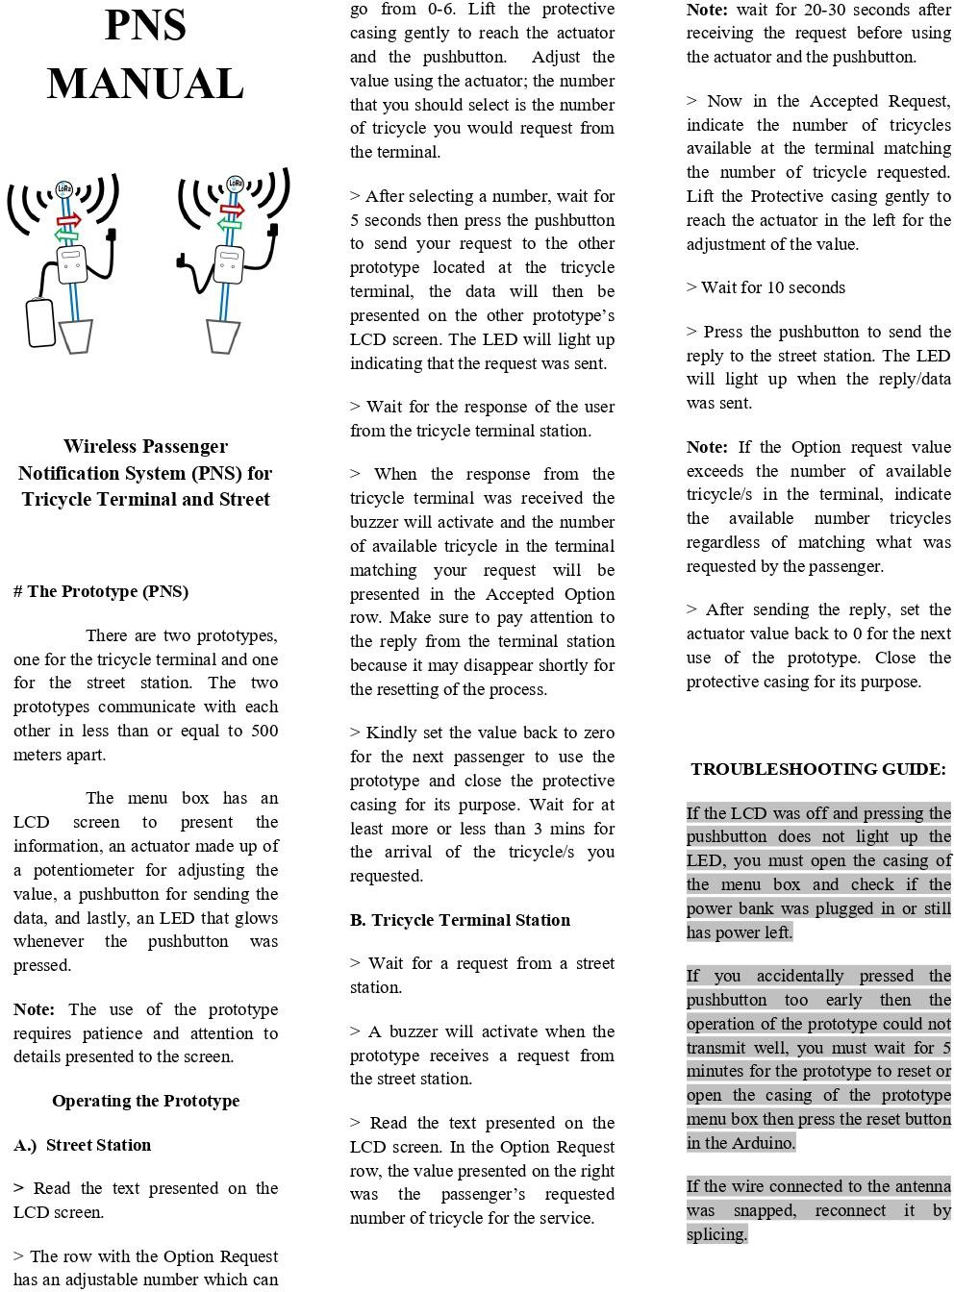

# APPENDIX H

## Radio Planner 2.1 Simulation Results of Different Testing Areas

#### Legend

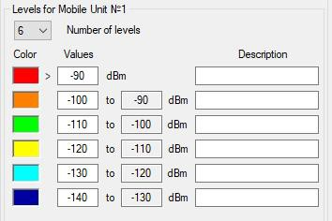

Figure H.1 Legend

#### Testing Area 1 Simulation Result

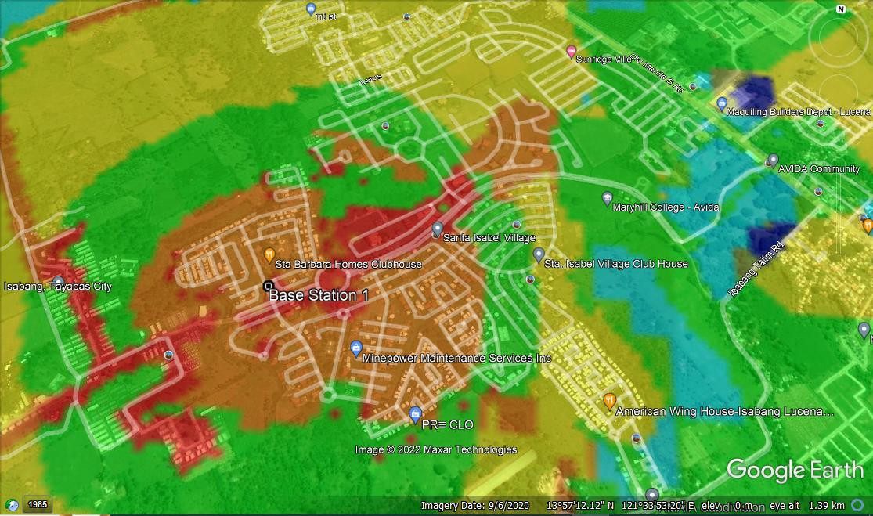

Figure H.2 Coordinates: 13°57'8.53"N, 121°33'41.95"E

#### Testing Area 2 Simulation Result

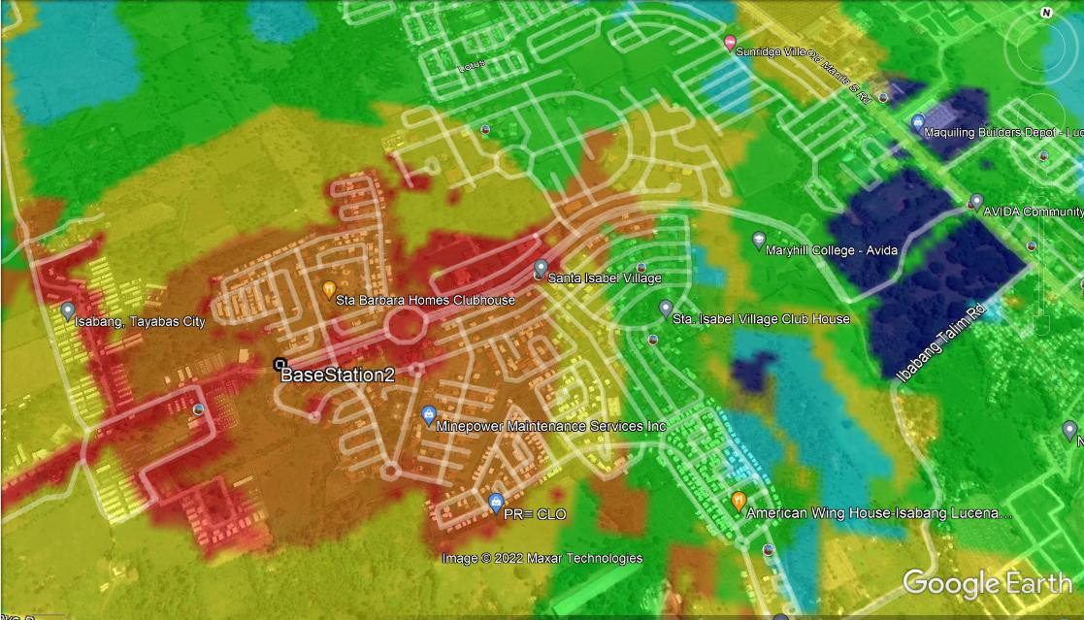

Figure H.3 Coordinates: 13°57'6.18"N, 121°33'40.02"E

#### Testing Area 3 Simulation Result

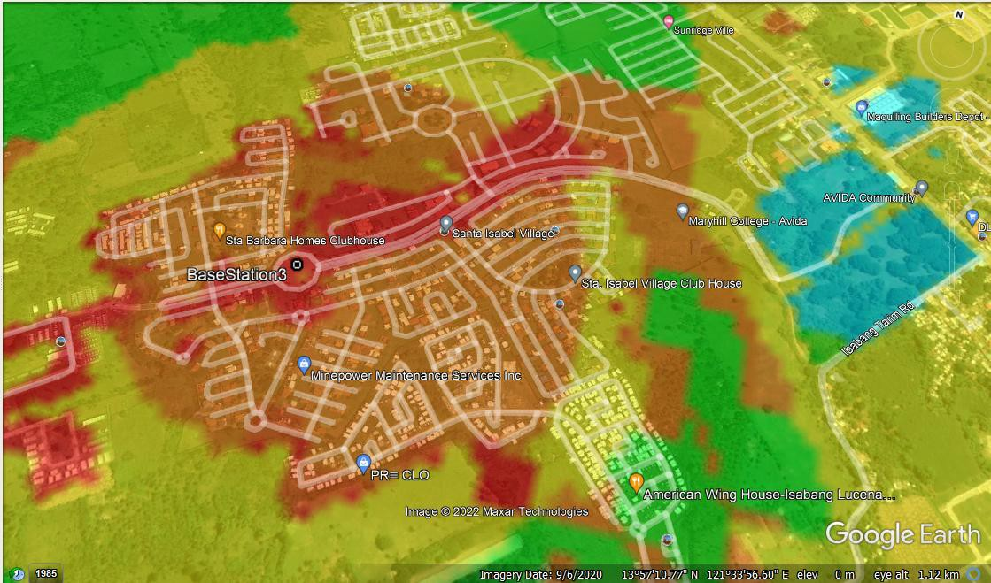

Figure H.4 Coordinates: 13°57'9.83"N, 121°33'46.18"E

#### Testing Area 4 Simulation Result

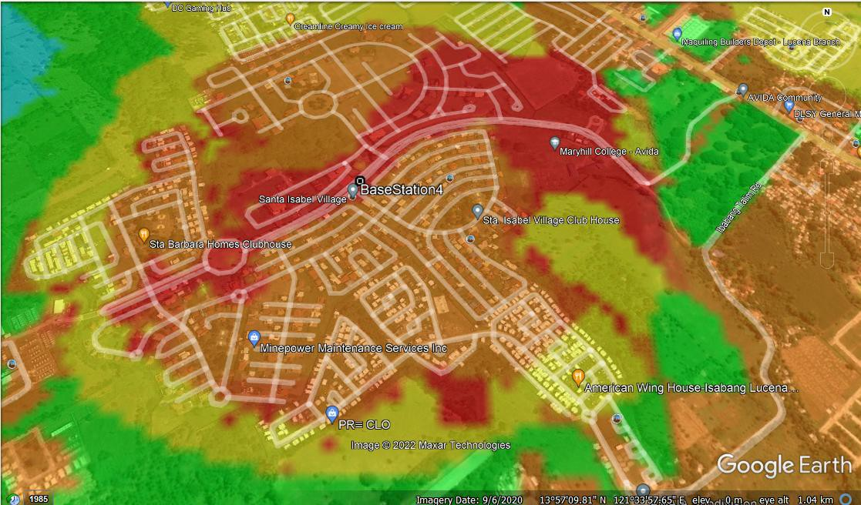

Figure H.5 Coordinates: 13°57'14.68"N, 121°33'53.43"E

#### Testing Area 5 Simulation Result

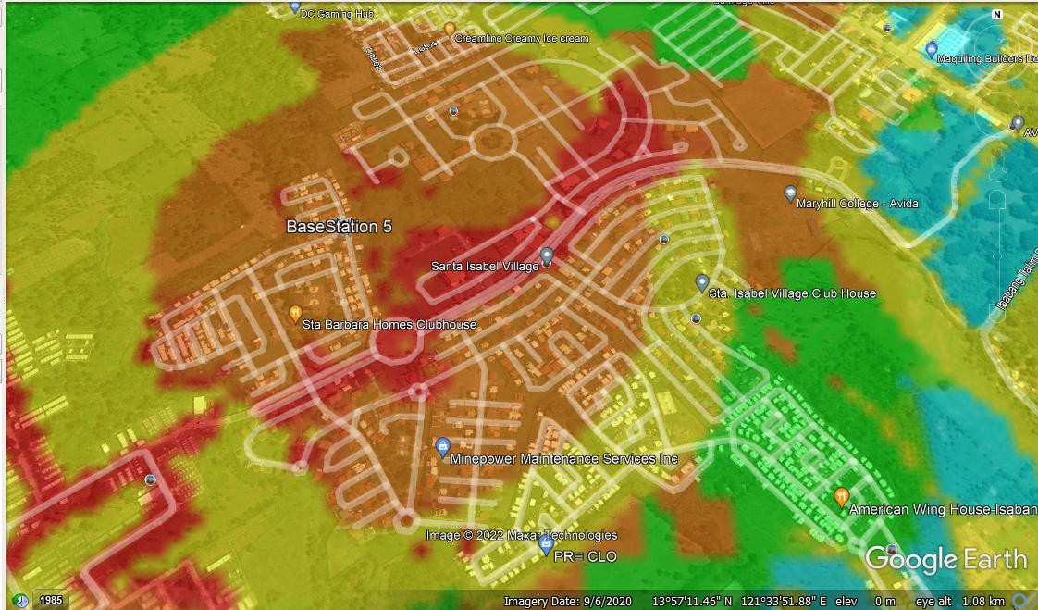

Figure H.6 Coordinates: 13°57'15.55"N, 121°33'43.20"E

#### Testing Area 6 Simulation Result

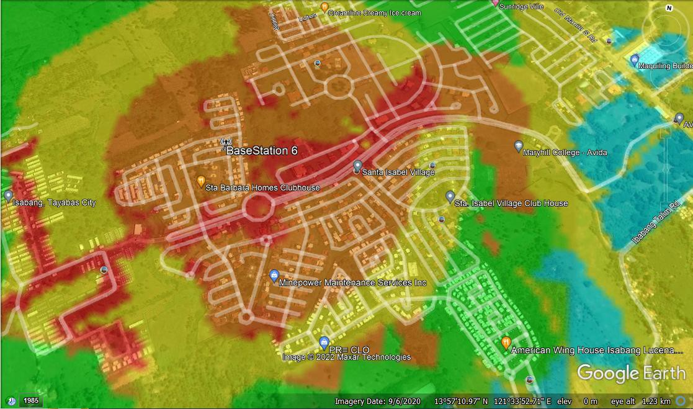

Figure H.7 Coordinates: 13°57'14.19"N, 121°33'42.60"E

#### Testing Area 7 Simulation Result

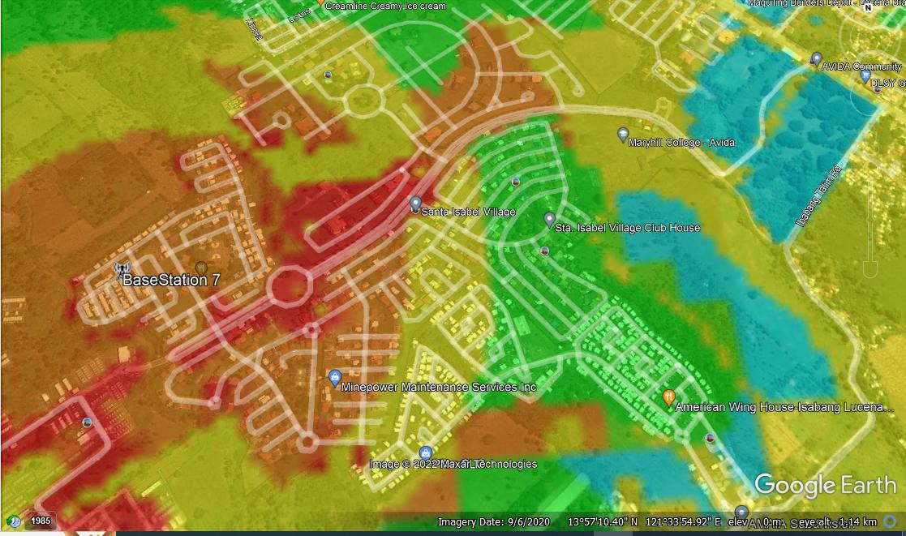

Figure H.8 Coordinates: 13°57'10.93"N, 121°33'37.27"E

#### Testing Area 8 Simulation Result

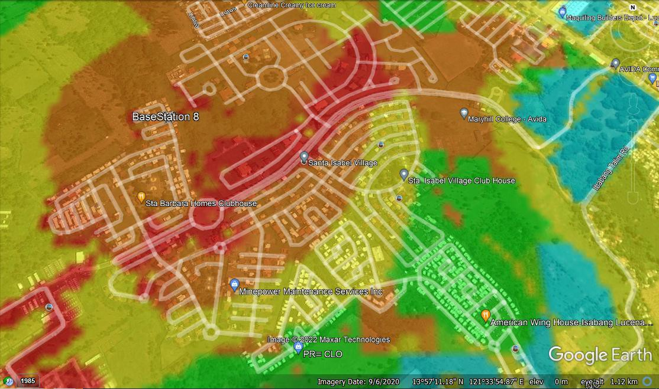

Fgure H.9 Coordinates: 13°57'17.24"N, 121°33'42.66"E

# APPENDIX I

## Walk Testing Result Databases

#### Testing Area 1 Walk Testing Results

Table I.1 Coordinates: 13.95237500 N, 121.56165278 S

|  |  |  |  |  |  |  |  |  |
| --- | --- | --- | --- | --- | --- | --- | --- | --- |
| **Latitude** | **Longitude** | **RSSI** | **SNR** | **Displacement** | **Actual Distance** | **Transmission Time** | **RSSI**  **Color Level** | **SNR**  **Color Level** |
| **13.95253** | 121.5615 | -80 | 7.23 | 22.7 | 22.7 | 1.4 | RED | RED |
| **13.95264** | 121.5615 | -83 | 4.65 | 35.41 | 35.41 | 1.25 | RED | ORANGE |
| **13.95279** | 121.5614 | -91 | -0.252 | 57.19 | 57.19 | 2.06 | ORANGE | GREEN |
| **13.95296** | 121.5613 | -88 | -4.25 | 77.72 | 77.72 | 6 | RED | GREEN |
| **13.95309** | 121.5612 | -87 | -3 | 94.88 | 94.88 | 4.86 | RED | GREEN |
| **13.95323** | 121.5611 | -88 | -1 | 113.18 | 113.18 | 2.45 | RED | GREEN |
| **13.95332** | 121.5611 | -96 | -14 | 125.34 | 125.34 | 10 | ORANGE | LIGHT BLUE |
| **13.95344** | 121.561 | -99 | -7 | 140 | 140 | 7.49 | ORANGE | YELLOW |
| **13.95346** | 121.561 | -93 | 1.23 | 141.38 | 141.38 | 3.45 | ORANGE | ORANGE |
| **13.95357** | 121.5609 | -92 | -0.124 | 153.9 | 153.9 | 5.47 | ORANGE | GREEN |
| **13.95363** | 121.5609 | -100 | -1.42 | 162.09 | 162.09 | 5.34 | GREEN | GREEN |
| **13.95372** | 121.5608 | -102 | -2.43 | 174 | 174 | 6 | GREEN | GREEN |
| **13.95365** | 121.5607 | -125 | -12.43 | 172.71 | 185.71 | 9.5 | LIGHT BLUE | LIGHT BLUE |
| **13.95359** | 121.5607 | -115 | -7 | 173.73 | 196.61 | 8.43 | YELLOW | YELLOW |
| **13.95353** | 121.5606 | -97 | -5.38 | 175.09 | 206.76 | 3.28 | ORANGE | YELLOW |
| **13.95342** | 121.5604 | -98 | -6.38 | 177.43 | 229.49 | 3.79 | ORANGE | YELLOW |
| **13.95331** | 121.5602 | -118 | -11.42 | 186.58 | 257.04 | 6.83 | YELLOW | LIGHT BLUE |
| **13.9532** | 121.5601 | -121 | -14 | 192.61 | 270 | 12.23 | LIGHT BLUE | LIGHT BLUE |
| **13.95309** | 121.56 | -134 | -16 | 201.12 | 288.88 | 15.23 | BLUE | BLUE |
| **13.95301** | 121.5598 | -134 | -15.37 | 210.12 | 294.75 | 14.47 | BLUE | BLUE |
| **13.95279** | 121.5599 | -130 | -12.34 | 194.34 | 268.7 | 17.42 | BLUE | LIGHT BLUE |
| **13.95267** | 121.56 | -134 | -13.64 | 182.7 | 254.9 | 14.87 | BLUE | LIGHT BLUE |
| **13.95257** | 121.5601 | -136 | -15.34 | 172.41 | 238.65 | 14.25 | BLUE | BLUE |
| **13.95248** | 121.5601 | -120 | -11.24 | 165.9 | 222.54 | 11.23 | LIGHT BLUE | LIGHT BLUE |
| **13.95237** | 121.5602 | -112 | -9.4 | 155.06 | 209.01 | 6.76 | YELLOW | YELLOW |
| **13.95248** | 121.5604 | -93 | -10.42 | 129.64 | 178.22 | 7.97 | ORANGE | LIGHT BLUE |
| **13.95263** | 121.5606 | -104 | -5.33 | 112.38 | 159.83 | 5.78 | GREEN | YELLOW |
| **13.95268** | 121.5608 | -96 | -3.42 | 94.69 | 133.14 | 6.34 | ORANGE | GREEN |
| **13.95257** | 121.5609 | -95 | -7.43 | 84.59 | 117.41 | 3.65 | ORANGE | YELLOW |
| **13.95243** | 121.561 | -93 | -10.42 | 72.44 | 84.46 | 5.32 | ORANGE | LIGHT BLUE |
| **13.95224** | 121.5611 | -94 | 0.125 | 58.59 | 74.71 | 1.23 | ORANGE | ORANGE |

|  |  |  |  |  |  |  |  |  |
| --- | --- | --- | --- | --- | --- | --- | --- | --- |
| **13.95234** | 121.5613 | -89 | 2.45 | 40.89 | 57.02 | 1.89 | RED | ORANGE |
| **13.95241** | 121.5614 | -92 | 5.34 | 28.54 | 40.75 | 1.32 | ORANGE | RED |
| **13.9526** | 121.5618 | -92 | 6.42 | 27.08 | 40.29 | 1.08 | ORANGE | RED |
| **13.95275** | 121.5619 | -86 | 7.32 | 47.77 | 61.5 | 1.79 | RED | RED |
| **13.95287** | 121.5621 | -88 | 3.24 | 73.91 | 89.95 | 2.43 | RED | ORANGE |
| **13.95298** | 121.5622 | -89 | -0.13 | 93.03 | 111.25 | 6.86 | RED | GREEN |
| **13.95313** | 121.5622 | -96 | -2.24 | 100.36 | 128.25 | 6.3 | ORANGE | GREEN |
| **13.95327** | 121.5621 | -98 | -1.74 | 111.56 | 144.59 | 8.33 | ORANGE | GREEN |
| **13.95343** | 121.5621 | -121 | -2.45 | 128.53 | 170.15 | 18.42 | LIGHT BLUE | GREEN |
| **13.95362** | 121.562 | -115 | -6.83 | 143.76 | 189 | 10.45 | YELLOW | YELLOW |
| **13.95377** | 121.562 | -104 | -3.53 | 156.4 | 203.36 | 9.35 | GREEN | GREEN |
| **13.95409** | 121.5621 | -103 | -8.87 | 177.6 | 223.15 | 9.64 | GREEN | YELLOW |
| **13.95389** | 121.5616 | -124 | -16.34 | 167.67 | 254.93 | 17.35 | LIGHT BLUE | BLUE |
| **13.95384** | 121.5615 | -136 | -18.23 | 163.4 | 212.76 | 15.86 | BLUE | BLUE |
| **13.95373** | 121.5612 | -115 | -4 | 155.58 | 190.53 | 5.38 | YELLOW | GREEN |
| **13.95347** | 121.5612 | -97 | -6.88 | 134.33 | 151.76 | 1.67 | ORANGE | YELLOW |
| **13.95296** | 121.5624 | -93 | -13.88 | 101.29 | 117.39 | 4.55 | ORANGE | LIGHT BLUE |
| **13.95309** | 121.5625 | -97 | -3.4 | 116.57 | 134.03 | 3.24 | ORANGE | GREEN |
| **13.95334** | 121.5624 | -115 | -12 | 133.92 | 168.32 | 16.78 | YELLOW | LIGHT BLUE |
| **13.9536** | 121.5623 | -134 | -14.66 | 156.58 | 198.01 | 20.23 | BLUE | LIGHT BLUE |
| **13.95389** | 121.5622 | -136 | -10.34 | 178.12 | 230.48 | 25.67 | BLUE | LIGHT BLUE |
| **13.95429** | 121.562 | -122 | -9.67 | 225.64 | 285.52 | 8.57 | LIGHT BLUE | YELLOW |
| **13.95454** | 121.562 | -116 | -9.45 | 245.99 | 307.1 | 3.77 | YELLOW | YELLOW |
| **13.95417** | 121.5617 | -135 | -10 | 200.34 | 263.49 | 14.57 | BLUE | LIGHT BLUE |
| **13.95397** | 121.5612 | -101 | -4 | 183.79 | 214.7 | 5.34 | GREEN | GREEN |
| **13.95385** | 121.561 | -98 | -4.67 | 179.83 | 198.99 | 5.77 | ORANGE | GREEN |
| **13.95194** | 121.5614 | -84 | 8.33 | 59.67 | 75 | 1.23 | RED | RED |
| **13.95163** | 121.5609 | -85 | 6.23 | 134.36 | 153.3 | 2.19 | RED | RED |
| **13.9523** | 121.5623 | -84 | 6 | 66.74 | 71.75 | 2.1 | RED | RED |
| **13.95242** | 121.5624 | -88 | 5.35 | 85.13 | 92.72 | 3.4 | RED | RED |
| **13.95258** | 121.5626 | -85 | 0.14 | 108.04 | 122.03 | 5.69 | RED | ORANGE |
| **13.95281** | 121.563 | -88 | 2.31 | 157.11 | 173.64 | 8.34 | RED | ORANGE |

#### Testing Area 2 Walk Testing Results

Table I.2 Coordinates: 13.95163611 N, 121.56087500 S

|  |  |  |  |  |  |  |  |  |
| --- | --- | --- | --- | --- | --- | --- | --- | --- |
| **Latitude** | **Longitude** | **RSSI** | **SNR** | **Displaceme nt** | **Actual**  **Distanc e** | **Transmissi on Time** | **RSSI**  **Color Level** | **SNR**  **Color Level** |
| 13.95193 | 121.5616 | -90 | 7 | 22.7 | 22.7 | 1 | ORANG E | RED |
| **13.95178** | **121.5613** | **-88** | **6** | **50** | **50** | **1.89** | **RED** | **RED** |
| 13.95189 | 121.5616 | -89 | 8 | 83.78 | 83.78 | 1.45 | RED | RED |
| **13.95202** | **121.5618** | **-89** | **5.79** | **100.51** | **100.51** | **2.51** | **RED** | **RED** |
| 13.95206 | 121.5618 | -89 | 8.75 | 111.08 | 111.08 | 1.18 | RED | RED |
| 13.95221 | 121.5621 | -88 | 7 | 146.27 | 146.27 | 1.14 | RED | RED |
| 13.95233 | 121.5623 | -88 | 7.46 | 166.17 | 166.17 | 1.24 | RED | RED |
| 13.95248 | 121.5624 | -86 | 5.35 | 186.33 | 186.33 | 1.75 | RED | RED |
| 13.95261 | 121.5626 | -83 | 8.5 | 212.95 | 212.95 | 1.22 | RED | RED |
| 13.95271 | 121.5628 | -89 | 5.15 | 240.27 | 240.27 | 3.6 | RED | RED |
| 13.95285 | 121.5631 | -91 | 4 | 273.19 | 273.19 | 2.45 | ORANG E | ORANG E |
| **13.95299** | **121.5633** | **-89** | **5.25** | **302.33** | **302.33** | **5.87** | **RED** | **RED** |
| 13.95303 | 121.5635 | -87 | 1.34 | 326.18 | 326.18 | 3.65 | RED | ORANG E |
| 13.95316 | 121.5637 | -88 | 1 | 344.49 | 344.39 | 4.73 | RED | ORANG E |
| 13.95328 | 121.5639 | -90 | 2.75 | 374.36 | 374.36 | 5.32 | ORANG E | ORANG E |
| 13.95349 | 121.5642 | -89 | 4 | 418.15 | 418.15 | 4.23 | RED | ORANG E |
| 13.95369 | 121.5645 | -88 | 4 | 452.01 | 452.01 | 8.78 | RED | ORANG E |
| **13.95406** | **121.5648** | **-93** | **- 0.25** | **506.02** | **506.02** | **7.2** | **ORANG E** | **GREEN** |
| 13.95448 | 121.5651 | -95 | 2.5 | 558.63 | 558.63 | 10.42 | ORANG E | ORANG E |
| 13.95461 | 121.5653 | -100 | - 1.88 | 576.86 | 586.51 | 12.28 | GREEN | GREEN |
| 13.95506 | 121.5657 | -115 | - 3.55 | 648.77 | 649.83 | 10.48 | YELLO W | GREEN |
| 13.95525 | 121.5661 | -107 | -4 | 694.51 | 701.58 | 12.34 | GREEN | GREEN |
| 13.95546 | 121.567 | -130 | -12 | 783.07 | 801.42 | 22.3 | BLUE | LIGHT BLUE |
| **13.95542** | **121.5672** | **-135** | **-16** | **801.95** | **813.58** | **22.98** | **BLUE** | **BLUE** |
| 13.95546 | 121.5677 | -128 | -15 | 845.76 | 870 | 30.23 | LIGHT BLUE | BLUE |
| 13.95536 | 121.5682 | -145 | -20 | 889.52 | 924 | NaN | BLACK | BLUE |
| 13.95525 | 121.5686 | -145 | -20 | 923.24 | 980.54 | NaN | BLACK | BLUE |
| **13.9542** | **121.5698** | **-145** | **-20** | **1000.09** | **1164.44** | **NaN** | **BLACK** | **BLUE** |

# APPENDIX J

## Plagiarism Result

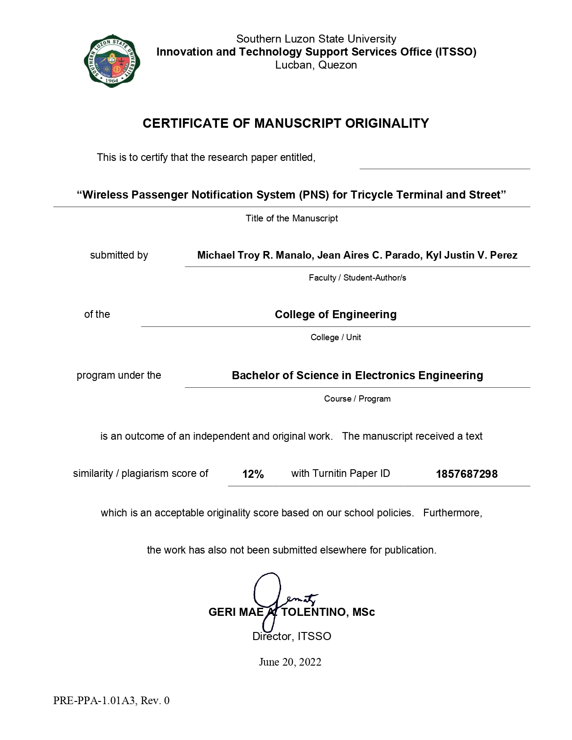

**APPENDIX**

**K**

## English Critic

